Electricity Review
1 – Electricity Basics
- Electricity if loosely defined as the _______________________________ through an electric circuit.
- Electric circuits must always have a ___________________________, a ________________ (which uses the energy and a ______________________ for electrons to flow.
- ______________________ or _________________________ are examples of energy sources.
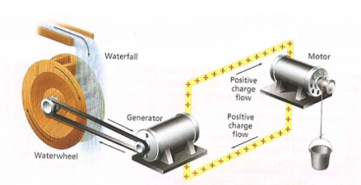

In an electric circuit the battery or generator does work moving electrons to a higher potential and then the charge does work turning the motor, or lighting the bulb, etc.

Electric current: How much _______________ flows by a through a given _______________ in a given time (Coulomb/sec or Amperes).

Where: I =
q =
t =

Example:  A normal household circuit can carry a maximum of 15 amps. How many coulombs’ pass through the circuit each minute? | Example:  A net charge of 45 mC passes through the cross-sectional area of a wire in 15 s. What is the current in the wire?

Potential Difference: the difference in electric potential (V) between the final and the initial location when work is done upon a charge to change its potential energy. (note: we really haven’t studied this… more next chapter!)

Where: ΔV =
q =
w =

Example:  How much work will it take to move 1 electron through a potential difference of 9 volts? (1 e = 1.6x10⁻¹⁹ C) | Example:  If a 20.0 mA current flows through a 5.0 volt circuit in 15 seconds, what is the total work done by the circuit?
Resistance: the opposition to electron flow due to both the shape and properties of the material the electrons are flowing through.
Ohm’s Law: Can basically be summed up as….

Higher Voltage = Higher Resistance =

Where: V =
I =
R =

Example:  You have an air conditioner which operates at 120 V and draws 7.5 A. Find the equivalent resistance. | Example:  A person notices a mild shock if the current along a path through the thumb and index finger exceeds 80.0 μA. Determine the maximum allowable potential difference without shock across the thumb and index finger for the following:  - a dry-skin resistance of 4.0x10⁵ Ω.  - a wet-skin resistance of 2.0x10³ Ω.
Electricity Review
2 – Schematic Diagrams
- A Schematic Diagram is an electric ____________________________.
- It uses standard symbols and is usually drawn in ________________________________.
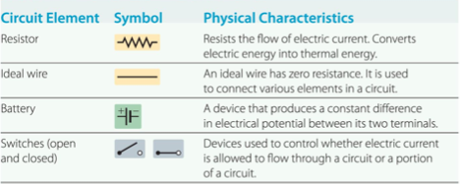
AC vs. DC
- Batteries produce a current, Direct Current (DC) that always flows in the _________________ direction. (We will focus on this!)
- Household outlets supply Alternating Current (AC), which constantly ___________________ direction.
- In North America AC current switches direction ________________________________ (60 Hz).

Conventional Current vs. Electron Flow
Before scientists discovered that subatomic particles such protons, electrons, and neutrons were the building blocks of the atom… they believed that electricity was the result of positive charges moving in a circuit. This flow of positive charges from High Potential (+) to Low Potential (-) was known as Conventional Current. It is now known that the particle moving in an electric circuit is instead the electron. This flow of negative charges from Low Potential (-) to High Potential (+) was known as Electron Flow. Unfortunately… some habits are hard to break and therefore we will focus on Conventional Current in this course.

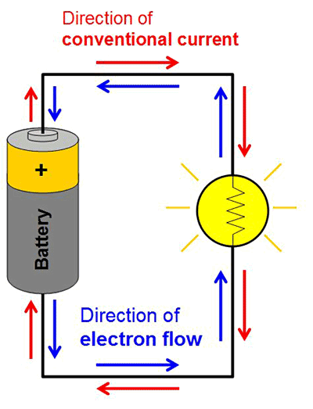

Electricity Review
3 – Circuits

There are three kinds of electric circuits, series, parallel and combination (both series and parallel elements).
Series Circuit
Only one path for the current to flow. (Current is constant everywhere)
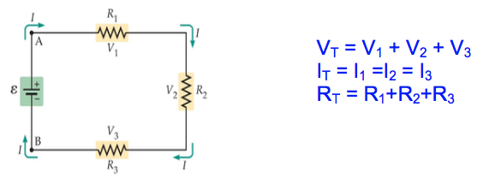

Example:
You have 2 resistors in series. One is 100 Ω and the other is 300 Ω.
Draw the circuit; find the total resistance of the circuit.

If the battery is 8 V what is the current in the circuit?

How many volts are across the 100 Ω resistor?

Parallel Circuit
More than one path for current. (Current is NOT constant everywhere)
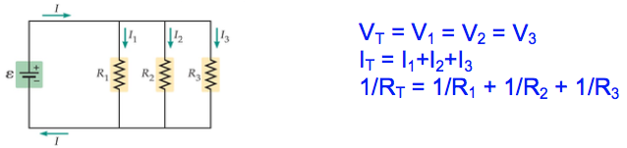

Example:
From the circuit below, find the….

Equivalent (total) Resistance of the circuit.

The current drawn from the battery.

The voltage drop across the 12 Ω and across the 6.0 Ω resistor.

Electricity Review
4 – Power
Power is the __________ as which _________________ is used. The units for Electrical Power are Watt’s.

Where: P =
I =
V =

Note: Using Ohm’s Law we can easily find to other formulas for Power.

Example:  A 40 Watt light bulb and 75 Watt light bulb operate at 120 V. Which bulb has a larger current running through it? | Example:  Most stereo speakers are designed to have a resistance of 8.0 Ω. If the 8.0 Ω speaker is connected to a stereo amplifier with a rating of 100 W, what is the maximum possible potential difference the amplifier can apply to the speakers?

ELECTRIC CIRCUITS review – AP Physics 2

1) As resistors are added in series to a circuit, the current in the circuit

a. increases b. decreases c. remains the same

2) As you plug more appliances into a circuit in your house, the total current in that circuit

a. increases b. decreases c. remains the same

3) Current is the same throughout in a ___________________ circuit.

4) The total resistance is less than the smallest resistor in a _______________ circuit.

5) If one resistor in a parallel circuit is removed, the total current

a. increases b. decreases c. remains the same

- Differentiate between an open and a closed circuit.

- A high voltage transmission line carries 1.0 x10³ A of current at 7.0 x 10⁵ V for a distance of 160 km. The resistance in the wire is 0.30 Ω/km.
- What is the total power transmitted?
- What is the power dissipated due to resistive losses? (note: always use P = I²R)
- What percent of the total power is lost due to resistance?

8) A pocket calculator draws 5.0 x 10⁻⁵ A of current when connected to a 9.0 V battery.
a. What is its power rating?
b. How much energy does it use if it is left on for 20. minutes?

9) What is the voltage of a battery which sends 0.700 A of current through a 15.0-Ω light bulb?

10) A toaster connected to a 120 V outlet uses electrical energy at the rate of 1500 W. What is the resistance of the toaster?

11) A microwave oven draws 15 A when operated on 120 V.
a. Calculate its power output.
b. If it takes 15 minutes to cook a meal, how much energy is used?
c. At 8.0¢ per kilowatt.hour, what is the cost of cooking the meal?

12) A 10.-Ω resistor, a 20.-Ω resistor, and a 30.-Ω resistor are connected in series and placed across a 120-V source.
a. What is the effective resistance of the circuit?
b. What is the total current in the circuit?
c. What is the voltage drop across the 20.-Ω resistor?

- A 10.0-Ω resistor, a 20.0-Ω resistor, and a 30.0-Ω resistor are connected in parallel and placed across a
120.0-V source.
a. What is the equivalent resistance of the circuit?
b. What is the current through the 20.0-Ω resistor?

14) A 15-Ω resistor is connected in series with a parallel arrangement consisting of two 10.-Ω resistors. This entire structure is placed across a 120-V potential difference.
a. What is the total current in the circuit?
b. What is the voltage drop across the 15-Ω resistor?
c. What is the current through one of the 10.-Ω resistors?

15) The following appliances are connected to the 120.-V electrical circuit in a kitchen: a 15.0-Ω electric fry pan, a 25.0-Ω refrigerator, a 20.0-Ω mixer, and a 12.0-Ω toaster. The circuit breaker protecting this circuit trips at a current of 25 A. If all of the appliances are on at the same time, will the circuit breaker trip? Show proof.

- The stockroom has only 20 Ω and 50 Ω resistors.
- You need an equivalent resistance of 45 Ω. How can this resistance be achieved under these circumstances?
- What can you do if you need a 35 Ω resistor?

- Calculate the following quantities for the circuit below: R_{Total}, I_{Total}, I_{c}, V_{a}, V_{d}, I_{e}, and V_{f} .
- What is the current draw from the battery in the diagram below.

- Find the equivalent resistance and current drawn from the battery from the following schematic.

- Find the equivalent resistance and current drawn from the battery from the following schematic.
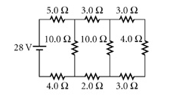
- Find the voltage drawn from the 2.0 Ω resistor.
- What is the power rating across the 4.0 Ω resistor?
- The power supplied to the circuit shown below is 4.00 W. Determine the potential difference across the battery.
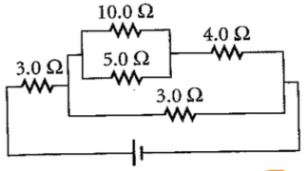

- Your toaster oven and coffee maker each dissipate 1200 W of power. Can you operate them together if the 120 V power source has a circuit breaker rated at 15 A. Explain your answer.

ANSWERS:
- Decreases
- Homes are wired in parallel and therefore adding resistors/loads decreases the overall resistance. Current should increase.
- series
- parallel
- decreases
- Open circuits have incomplete loops and therefore current stops flowing.
- a. 7.0 x 10⁸ W b. 4.8 x 10⁷ W c. 93%
- a. 4.5 x 10⁻⁴ W b. 1.5 x 10⁻⁷ kW-hr
- 10.5 V
- 9.6 Ω
- a. 1800 W b. 0.45 kW-hr c. 3.6¢
- a. 60. Ω b. 2.0 A c. 40. V
- a. 5.45 Ω b. 6.00 A
- a. 6.0 A b. 90. V c. 3.0 A
- yes; I_{total} = 28.8 A
- 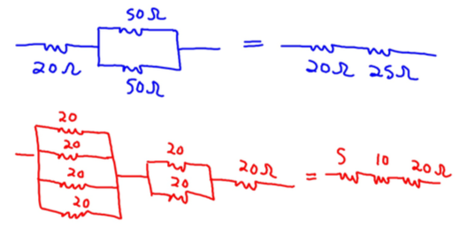
- R_{T} = 7.00 Ω, I_{T} = 2.00 A, I_{c} = 1.50 A, V_{a} = 2.50 V, V_{d} = 4.00 V, I_{e} = 1.00 A, V_{f} = 4.00 V
- 1.6 A
- 12.7 Ω and 0.71 A
- 14 Ω and 2 A
- 0.47 V
- 6.6 W
- 4.5 V
- NO! Current draw will be 20 A, remember households are wired in parallel.
