Mock Exam AP PHYSICS 2 FREE-RESPONSE QUESTIONS
AP PHYSICS 2 SECTION II Time—35 minutes 3 Questions
Directions: Answer all three questions, which are weighted according to the points indicated. The parts within a question may not have equal weight. Show all your work in this booklet in the spaces provided after each part.
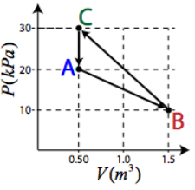
- (10 points) A cylinder filled with an ideal gas is fitted with a movable frictionless piston. Initially, the gas is in state A at 20 kPa, 400K, and 0.5 m³. The gas is taken through a reversible thermodynamic cycle as shown in the PV diagram at right (not drawn to scale).
  - Determine how many moles of gas are in the cylinder.

  - Calculate the temperature of the gas at the following states:
    - State B

    - State C

  - Determine the net work done on the gas during the cycle.

  - Explain whether heat was added to the gas or removed from the gas during the cycle. Justify your answer.
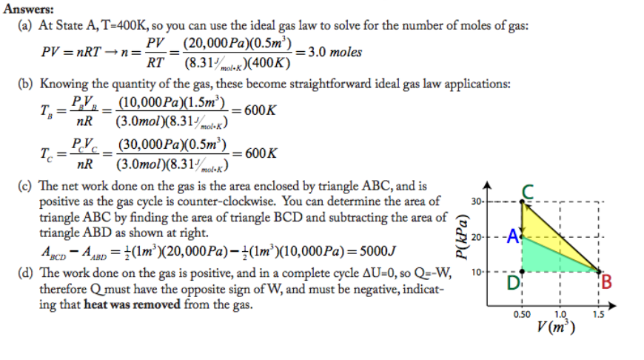

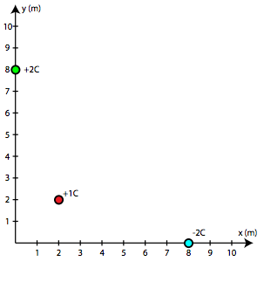
- (10 marks) Three point charges are situated as shown in the diagram at right.
  - Find the magnitude of the electric field at the origin due to the three charges shown.

  - On the diagram at right, draw an arrow to represent the net electric field vector at the origin. Label angle theta in your diagram.

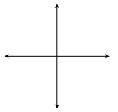

  - Determine the angle theta in your diagram, in degrees.

  - Calculate the electric potential at the origin.

  - If an electron is placed at the origin, what electric potential energy does it possess? Answer in units of electron-volts.

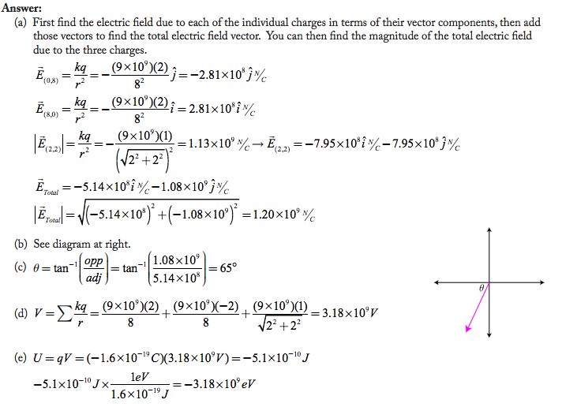

- (10 marks) An experiment is set up such that a beam of monochromatic light passes through a diffraction grating with 3000 lines/cm, creating a diffraction pattern on a screen located 0.1 meter from the grating. The distance between the central maximum and the next nearest bright line on the screen is 1.32 cm.
  - Determine the wavelength of the incident light.

  - What is the energy of each incident photon (in eV)?

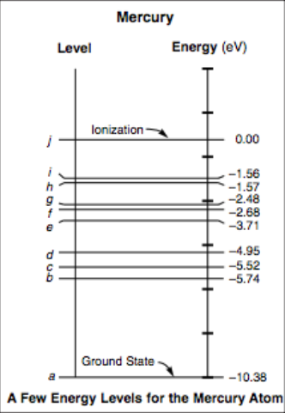
The incident light is created by a filtered mercury arc lamp. A few energy levels of mercury are shown at right.

  - Which electron transition in the lamp is most likely responsible for creation of the photons striking the diffraction grating?

  - The diffraction grating is replaced with a new grating containing 2000 lines/cm. Does the distance between maxima

___ increase
___ decrease
___ remain the same
Explain your reasoning.

