Composition of a Cookie Name: ___________ Blk:___

Suppose that you want to determine the percentage of each ingredient in a cookie. How could you figure it out? Consider the following recipe:
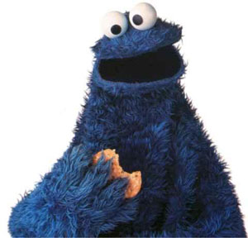
198 g flour
270 g sugar
810 g butter
522 g m&ms

When you mix all these ingredients together, what % of the whole does each ingredient represent?

The above recipe makes exactly 30 cookies. Let’s assume they are all identical in composition, and each cookie weighs 60.0 grams. Determine the mass of each ingredient in one cookie.

