Single and Double Slit – Experiments
Long ago, when people still used words like "thence" and "hither," scientists thought that light was made of particles. About a hundred years ago, at the beginning of the twentieth century, however, scientists began to change their minds. "Light is a wave!" they proclaimed.
Then such physicists as Einstein said, "Actually, light acts as either a particle or a wave, depending on what methods you're using to detect it."² But now, let's stick to the turn-of-the-twentieth-century notion that light is simply a wave.
The way that physicists showed that light behaves like a wave was through slit experiments. Consider light shining through two very small slits, located very close together—slits separated by tenths or hundredths of millimeters. The light shone through each slit and then hit a screen. But here's the kicker: rather than seeing two bright patches on the screen (which would be expected if light was made of particles), the physicists saw lots of bright patches. The only way to explain this phenomenon was to conclude that light behaves like a wave.
Look at Figure 23.12a. When the light waves went through each slit, they were diffracted. As a result, the waves that came through the top slit interfered with the waves that came through the bottom slit—everywhere that peaks or troughs crossed paths, either constructive or destructive interference occurred.
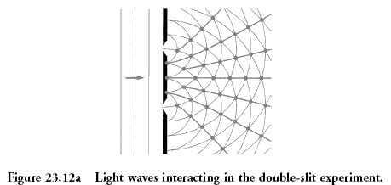 | 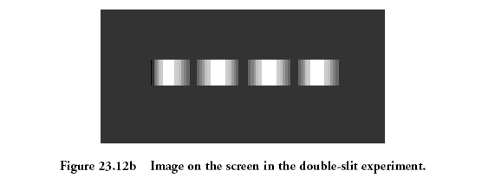

So when the light waves hit the screen, at some places they constructively interfered with one another and in other places they destructively interfered with one another. That explains why the screen looked like Figure 23.12b.
The bright areas were where constructive interference occurred, and the dark areas were where destructive interference occurred. Particles can't interfere with one another—only waves can—so this experiment proved that light behaves like a wave. When light passes through slits to reach a screen, the equation to find the location of bright spots is as follows.
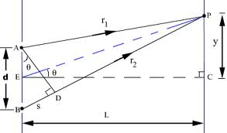
Here, d is the distance between slits, λ is the wavelength of the light, and m is the "order" of the bright spot; we discuss m below. θ is the angle at which an observer has to look to see the bright spot. Usually, the bright spots are pretty close together, and almost directly across from the slits. In this case, the angle θ is small, so we can use the following equation instead. It describes where on the screen you would find patches of constructive or destructive interference.
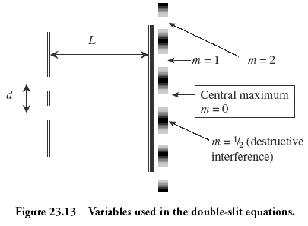
In these equations, x is the distance from the center of the screen wherein you would find the region you're seeking (either a bright region or a dark region), λ is the wavelength of the light shining through the slits, L is the distance between the slits and the screen, and d is the distance between the slits. The variable m represents the "order" of the bright or dark spot, measured from the central maximum as shown in Figure 23.13. Bright spots get integer values of m; dark spots get half-integer values of m. The central maximum represents m = 0.
So, for example, if you wanted to find how far from the center of the pattern the first bright spot labeled m = 1 is, you would plug in "1" for m, If you wanted to find the dark region closest to the center of the screen, you would plug in "¹/₂" for m.

Single Slits and Diffraction Gratings
Once you understand the double-slit experiment, single slits and diffraction gratings are simple.
A diffraction grating consists of a large number of slits, not just two slits. The locations of bright and dark spots on the screen are the same as for a double slit, but the bright spots produced by a diffraction grating are very sharp dots.
A single slit produces interference patterns, too, because the light that bends around each side of the slit interferes upon hitting the screen. For a single slit, the central maximum is bright and very wide; the other bright spots are regularly spaced, but dim relative to the central maximum.
