Intro to Circular Motion

Sir Isaac Newton is credited with the discovery of gravity. Now, of course we know that he didn’t really discover the thing – let’s face it, people knew about gravity for as long as there have been people. Gravity didn’t have to be discovered for crying out loud! Your basic tiny little toddler figures it out in the first few months of life. So what is the big deal with Newton and gravity? Well, what Newton did was to describe gravity, extend its effects from the surface of the earth (which everyone understood) out into space to explain the behavior of the planets (which nobody suspected), and to formulate a mathematical law that accurately described the force of gravity between objects with mass.

Perhaps the greatest success of his theory of gravity was to successfully explain the motion of the heavens – planets, moons, etc.

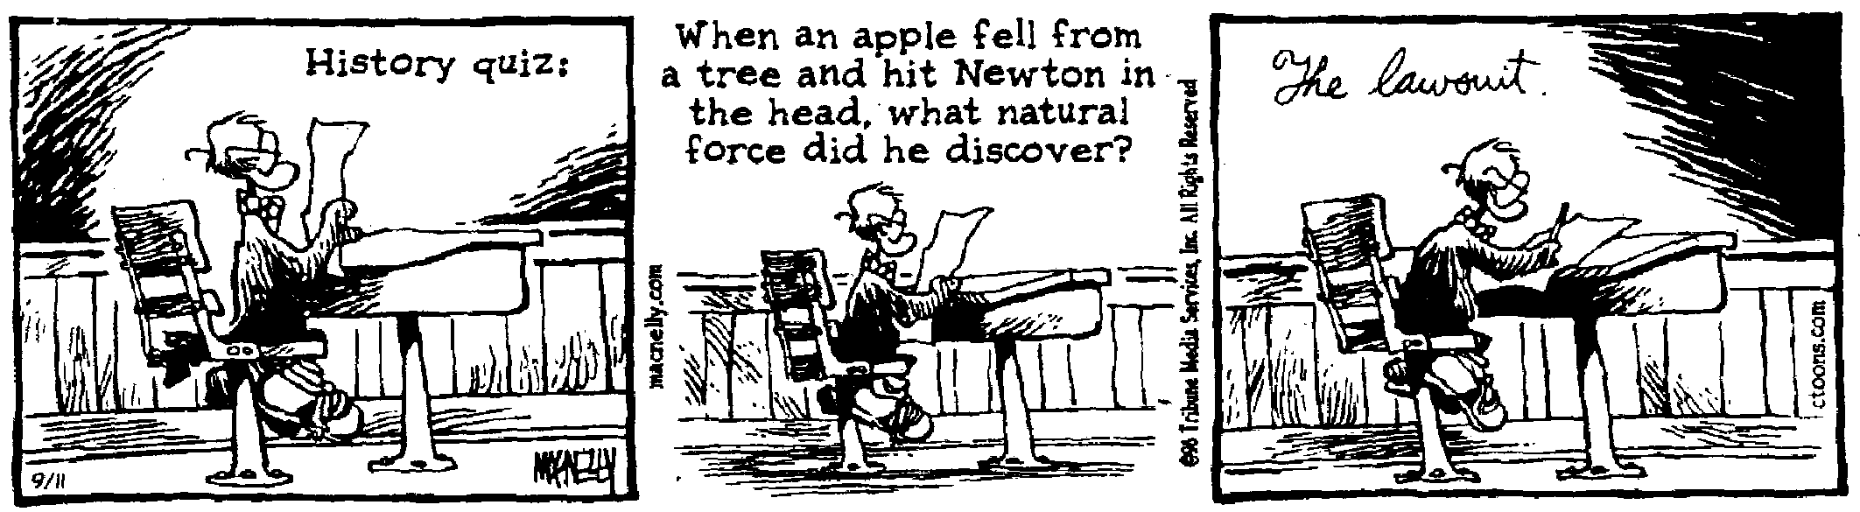
Newton’s theory is very simple. Gravity is a force of attraction between any two objects that have mass. Two objects sitting on a desktop attract each other with a force that we call gravity. They don’t go flying together because gravity is a very weak force and is only significant when one or the other of the masses is enormous – planet size. This is why we aren’t attracted to objects that we pass on our daily wanderings.

The size of the force of gravity is given by this equation:

Newton’s law of gravity
G is the universal gravitational constant.
m₁ is the mass of one of the bodies and m₂ is the mass of the other body.

r is the distance between the two bodies.

The value of G is the same everywhere throughout the universe.

Newton’s law of gravity is an inverse-square Law. This means that the force of gravity gets smaller or larger by the square of the distance. The force is directly proportional to the masses, so if the mass of one of the objects doubles, the force of gravity would double. But if the distance doubled, the force of gravity would decrease by a factor of four. That’s because it decreases by the square of the distance. Inverse-square laws are very common in physics. We’ll see more of them in our explorations.

To give the particulars of the theory:

Universal Law of Gravitation

- Gravitational force is a field force between two particles -- in all mediums.
- Force varies as the inverse square of the distance
- Force is proportional to mass of objects.
- The gravity force acts from the center of the two objects.
- The gravitational force is always attractive.
- The gravitational force cannot be shielded or canceled.

- Question: A girl, Brandy, 42.5 kg, sits 1.50 m from another student who weighs 63.0 kg. What is the force of gravity between them? (This will tell us how attracted they are to each other.)

- Question: Find the mass of the earth. r_{e} = 6.38 x 10⁶ m. We will use a 10.0 kg mass in our solution (not that it matters), the other mass will be that of the earth.
Center of Gravity: A stone resting on the ground is acted upon by gravity. In fact, every atom within the rock is attracted to the earth. The sum of all these forces is the thing that we call weight. Wouldn’t it be a real pain to have to add up every single vector for every single atom in an object in order to find out what it weighed? Well fortunately, we don’t have to do that. Nature sort of does it for us. Basically the vectors all add together to give us one big vector, the weight vector, which is directed down and which acts at a point where all the weight appears to be concentrated. This point is called the center of gravity.

For an object like a uniform sphere, the center of gravity, or CG, is located at its geometric center. Irregular objects, like, say, your average baseball bat would have their CG located closer to the fat end of the bat rather than the center.

The dot represents the CG of the objects in the drawings below:
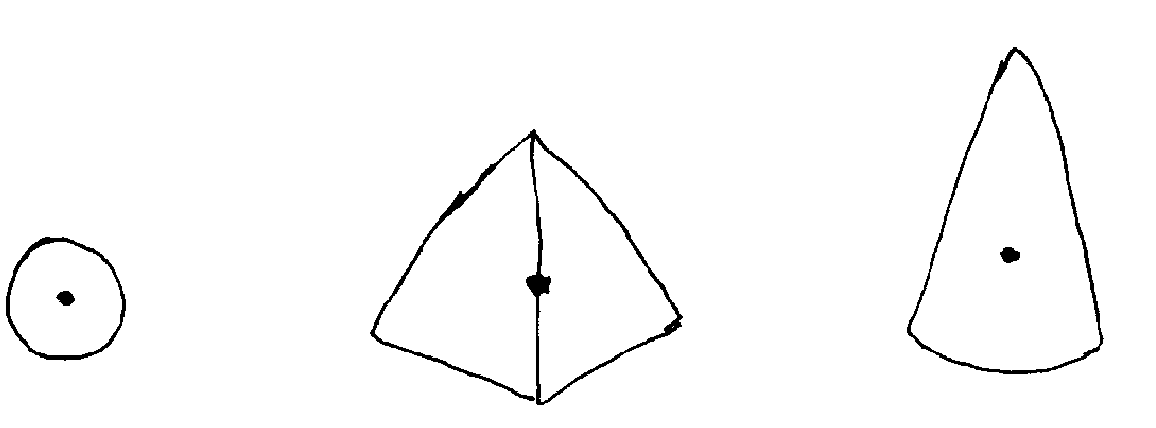

The weight of these objects, e.g., the vector we call weight, is applied at the CG.

When a ball is thrown in the air, it follows a parabolic path. Actually, what follows this parabolic path is the CG of the ball.

This is also true for irregular objects that are thrown. If you throw a crescent wrench so that it spins when you release it, it seems to follow a very erratic path. Its CG, however, traces out a nice smooth parabola.

All irregular objects rotate about their CG when thrown.

Let’s do some more gravity problems.

- Question: You weigh 567 N on earth. How much would you weigh on Mars?

- Question: What is the acceleration of gravity on Venus?

.

