**Unit 3 – Fluids: Quiz 3c**

/5

A glass tube has several different cross-sectional areas with the values indicated below. A piston at the left end of the tube exerts pressure so that the water within the tube flows from the right end with a speed of 8.0 m/s. ***Include a diagram!***

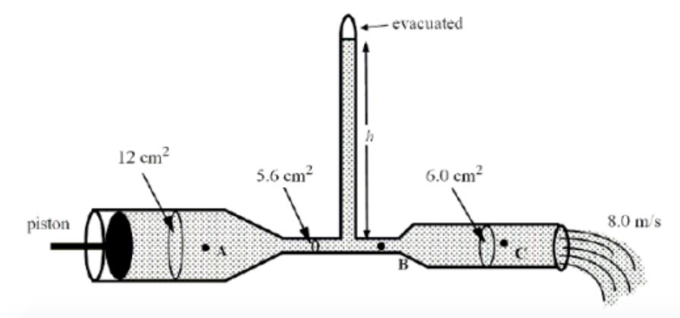

1. What is the speed of the water flowing through point B?
2. What is the total pressure at point B? (***Point C is open to the atmosphere!***)
3. Determine the height of the manometer with the evacuated upper end.Answer:

A glass tube has several different cross-sectional areas with the values indicated below. A piston at the left end of the tube exerts pressure so that the water within the tube flows from the right end with a speed of 8.0 m/s. ***Include a diagram!***



1. What is the speed of the water flowing through point B?



1. What is the total pressure at point B?



1. Determine the height of the manometer with the evacuated upper end.

