**Fluids: Quiz 2a**

/5

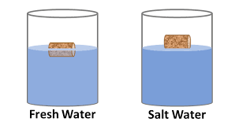

A cork has a volume of 4.25 cm3. The density of cork is 207 kg/m3.

1. Based on the picture above; which is more dense, freshwater or salt water?
2. Draw a FBD to show the forces acting on the cork in freshwater.
3. What volume of the cork is beneath the surface when the cork floats in water (1000 kg/m3)?
4. What applied force is needed to completely submerge the cork in freshwater?

Answer:



A cork has a volume of 4.25 cm3. The density of cork is 207 kg/m3.

1. Based on the picture above; which is more dense, freshwater or salt water?

**SALT Water**

1. Draw a FBD to show the forces acting on the cork in freshwater.

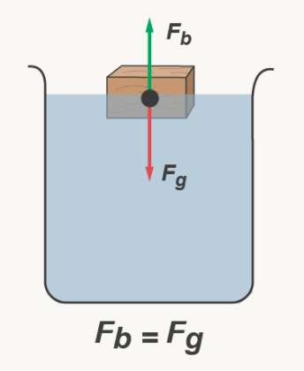

1. What volume of the cork is beneath the surface when the cork floats in water (1000 kg/m3)?



1. What applied force is needed to completely submerge the cork in fresh water?

