**Unit 3 – Fluids: Quiz 1b**

/5

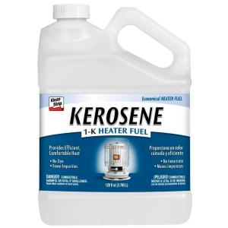A rectangular pool is 8.0 m long, 4.0 m wide, and 2.0 m high and contains kerosene with density 820 kg/m3 to a depth of 1.5 m high. Find…

(a) the hydrostatic pressure on the bottom of the tank.

(b) the hydrostatic force on the bottom.

Answer:

A rectangular pool is 8.0 m long, 4.0 m wide, and 2.0 m high and contains kerosene with density 820 kg/m3 to a depth of 1.5 m high. Find…

(a) the hydrostatic pressure on the bottom of the tank.

(b) the hydrostatic force on the bottom.



