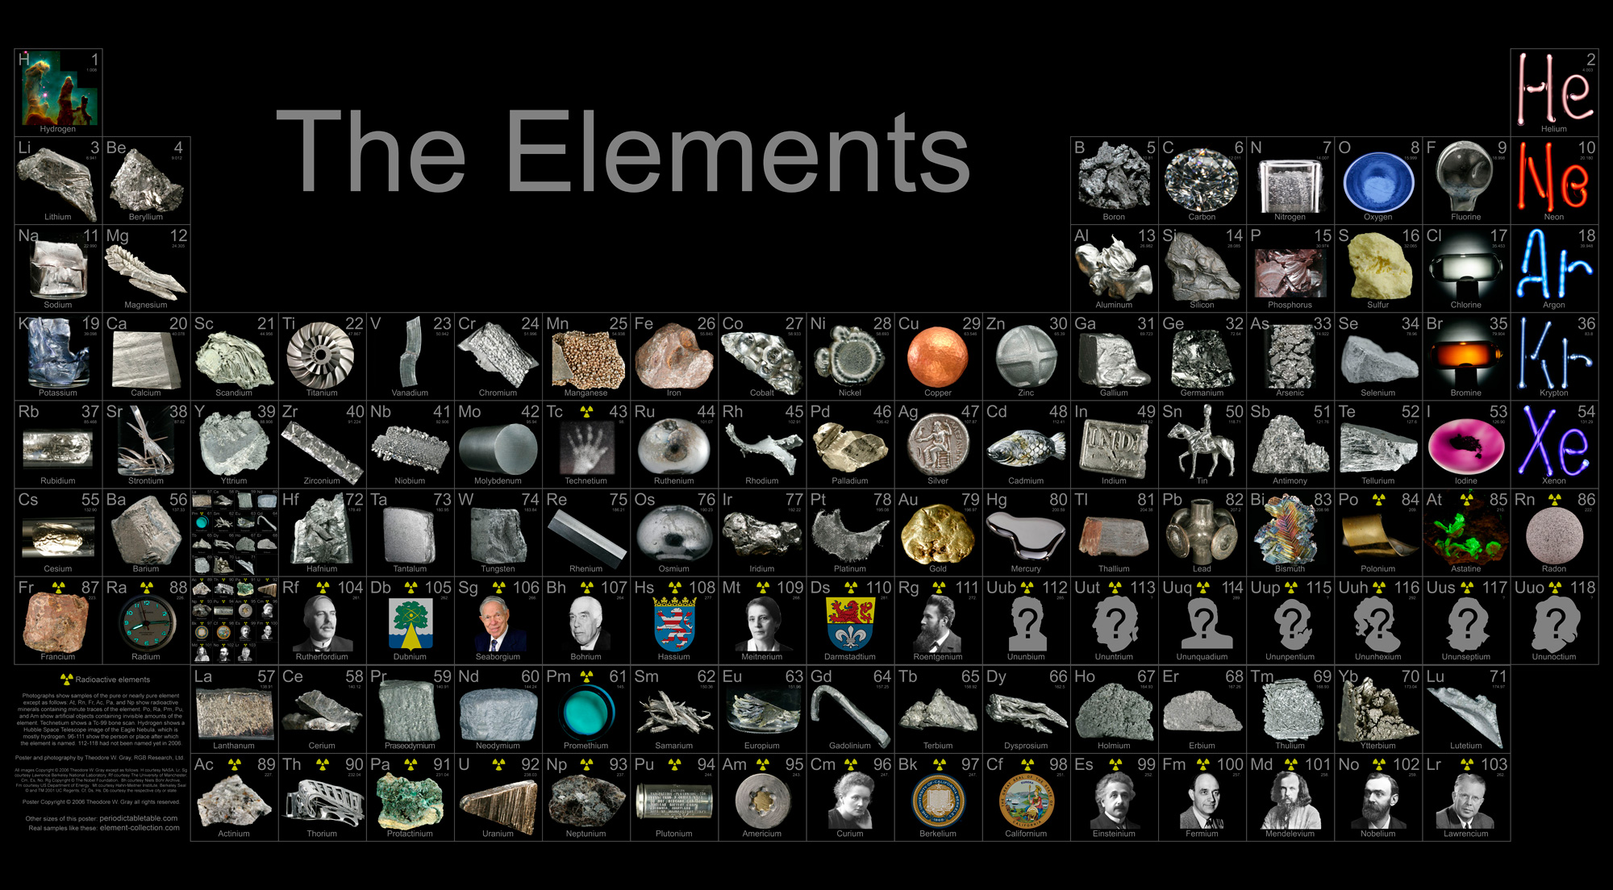
Choosing your Element: (Please write in a different colour!)

CITING YOUR SOURCES
For all of your research for the following questions, make sure to add your sources to the numbered bibliography at the end of this document.
Next to each point use a superscript to indicate which numbered source it comes from in your bibliography.

Your Element: |  | Human Innovation it is used in:
Comparison Element: |  | Function both elements have in the human innovation you chose:

Investigating your Element:
- When and where was your Element first discovered? Who discovered it?

- What are the properties of your element that make it unique and useful? (typical state of matter, melting point, boiling point, strength, hardness, reflective qualities, conductivity, density etc)

- How is your element obtained? Is it produced naturally or synthetically? Where does it come from?

BIBLIOGRAPHY
# | Website title | Web page Title | URL | Date Accessed
1
2
3
4
5
6
7

