Provincial Exam Review: Ecosystems

Biomes

- Identify each of the following as either a biotic or an abiotic factor.
(a) crab (b) ocean temperature (c) lake water
(d) dissolved oxygen (e) tides (f) seaweed
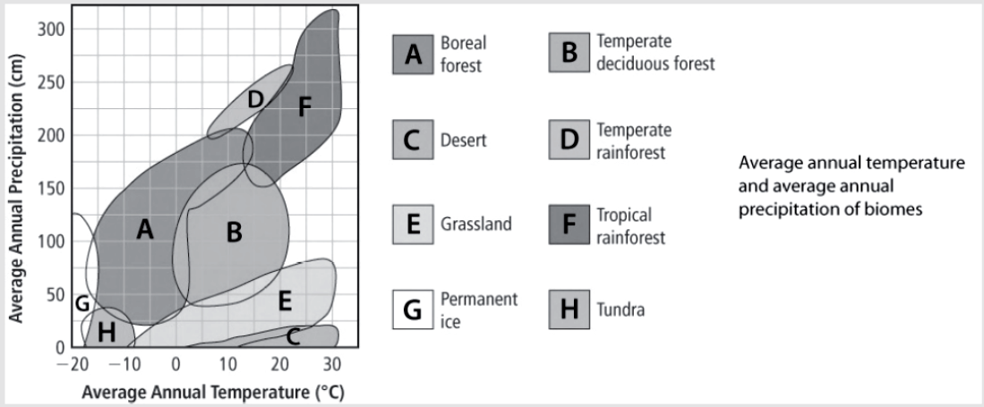
Use the Precipitation and Temperature Graph to answer questions 2 - 7.
- What is the highest average annual temperature that would be found in a grassland biome?
- What is the range (lowest and highest) of annual average temperatures for a temperate deciduous forest biome?
- What is the lowest average annual precipitation in a tropical rainforest biome?
- What is the range (lowest and highest) of annual average precipitation in a boreal forest biome?
- What is the highest average annual precipitation and temperature in a desert biome?
- Which biomes can have both an annual average rainfall of less than 25 cm precipitation and a temperature below 0°C?

Use the Biomes of the World map on page 6 of your Data Pages to answer questions 8 and 9.
- Which factor, latitude or elevation, is likely more responsible for the locations of the permanent ice biome?
- Which factor, latitude or precipitation, is likely more responsible for the locations of the desert biome?

Use the climatographs for Tofino and Osoyoos to answer questions 10 - 19.
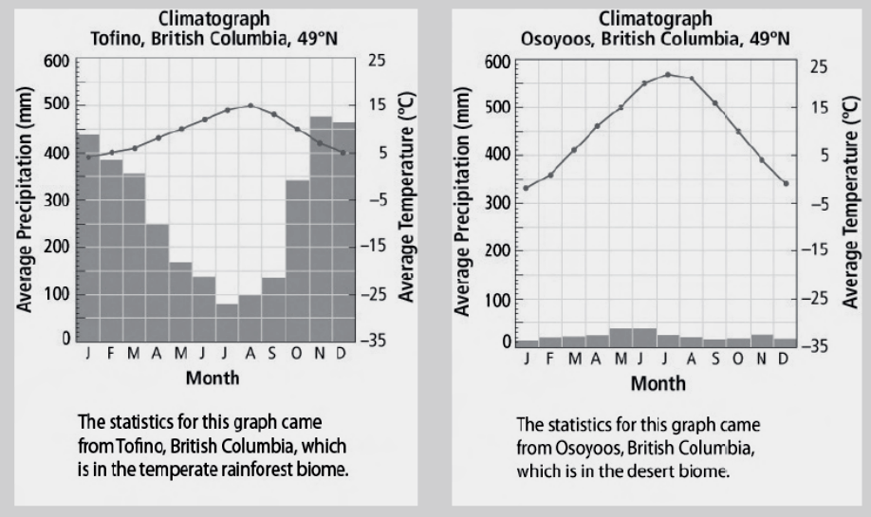

- What does the horizontal axis of a climatograph show?
- Does the line connecting the dots show temperature or precipitation?
- What does the right vertical axis on a climatograph show?
- What is the average temperature of Tofino in October?
- What is the average temperature of Osoyoos in July?
- In which month does Tofino have the lowest average temperature?
- What does the left vertical axis on a climatograph show?
- What is the average precipitation in Tofino in August?
- How much precipitation is received in Osoyoos during its driest month?
- How do the average temperatures compare for the two locations in October?
- What is meant by the term adaptation?
- Identify each of the following characteristics of the common spotted owl as a structural, physiological, or behavioural adaptation.
(a) Its feathers have white spots on a brown background.
(b) It maintains constant blood sugar levels.
(c) It lines its nest with grass.
(d) Its eyes face front to give depth perception.
(e) It places cow dung at the front of its nest to hide from predators.
- Which biome is not found in Canada?
A. boreal forest B. temperate deciduous forest
C. temperate rainforest D. tropical rainforest
- Students made lists of the biotic and abiotic components of their neighbourhood. Which of the following lists describes only abiotic components of their neighbourhood?
A. fungi, flower, water B. temperature, latitude, soil
C. sunlight, moisture, bacteria D. grass, precipitation, latitude
- Snowshoe hares of the boreal forest have fur that changes from summer brown to winter white to camouflage them from predators. What kind of adaptation is this an example of?
A. chemical adaptation B. structural adaptation
C. behavioural adaptation D. physiological adaptation

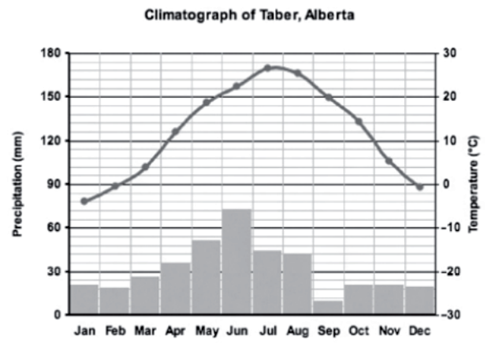
Use the following climatograph of Taber, Alberta, to answer question 25.

- In which biome is Taber, Alberta, located?
A. temperate deciduous forest B. boreal forest
C. grassland D. Desert
- Which feature below is not a biotic component of a boreal forest biome?
A. mammals with thick, insulating coats
B. many marshes, shallow lakes, and wetlands
C. coniferous trees with waxy needles to resist water loss
D. small mammals that burrow in the ground to stay warm
- Which combination of abiotic factors best explains why the regions along the equator receive the greatest amount of precipitation?
A. sunlight and latitude B. sunlight and elevation
C. latitude and ocean currents D. ocean currents and elevation

Use the following graph to identify the biome described in question 28.
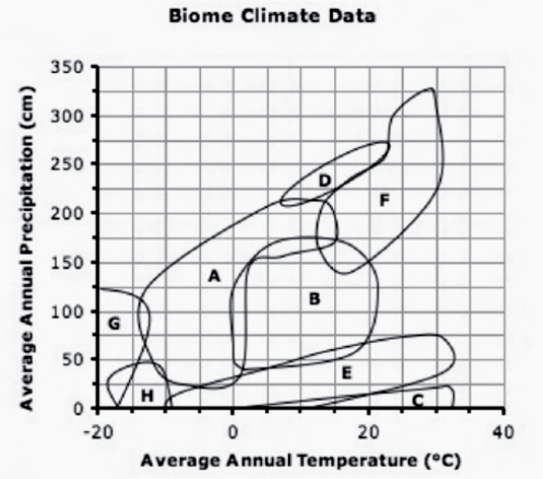
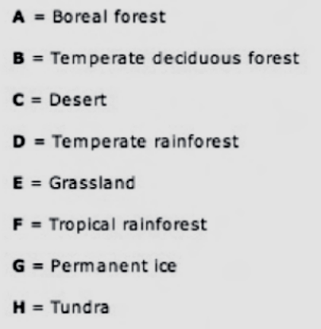

- Which region has high average annual precipitation and an average temperature between 15°C and 30°C?
A. temperate deciduous forest B. temperate rainforest
C. tropical rainforest D. Desert
- Which of the following animal and plant adaptations is a physiological adaptation?
A. Caribou of the tundra biome migrate to food sources in winter.
B. Arctic foxes of the tundra biome have compact bodies and shorter legs and ears, which reduce heat loss.
C. Grasses of the grassland biome have deep roots that form dense mats to collect water when it is available.
D. Plants in the desert biome produce chemicals that protect them from being eaten by animals.
- No trees grow above the tree line in the tundra biome of northern Canada. Which combination of abiotic factors of the tundra biome can best explain the absence of trees?
A. soil, sunlight, temperature B. soil, moisture, ocean currents
C. root growth, sunlight, temperature D. precipitation, elevation, temperature
- Which kind of biome would you expect to find in an area with the characteristics listed below?
• very tall trees
• along the coastline
• bordered by mountains on one side
• average temperature range from 5°C to 25°C
A. tropical grassland B. tropical rainforest
C. temperate rainforest D. temperate deciduous forest

Ecosystems

- Put the following divisions of life on Earth in order from the smallest to the largest:
biome, biosphere, ecosystem, habitat
- What is ecology?
- What is the term for the order of relationships that go from organism to population to community to ecosystem?
- What term refers to how many organisms of a particular species live in an ecosystem?
- What term refers to all the different kinds of species present in an ecosystem?
- Spanish moss grows on cedar trees in the temperate rainforests of British Columbia. The moss benefits from the physical support that a cedar tree provides. The cedar tree is not benefitted by the moss, but nor is it harmed. What relationship exists between the Spanish moss and the cedar tree?
- The hookworm uses its teeth to attach to the wall of a dog’s intestine so that it can feed on the dog’s blood. Explain why the hookworm is considered a parasite.
- The great blue heron feeds on fish while standing in water. Its special role is to stand and fish in deep water where other species of herons with shorter legs cannot fish. What term best describes the great blue heron’s special place within its ecosystem?
- A plant called spotted knapweed grows wild across the rangelands of British Columbia. It is able to release chemicals into the soil that prevent the growth of other types of plants. Does this kind of interaction demonstrate competition, mutualism, predator/prey interaction, or symbiosis?
Use the following graph to answer question 10.
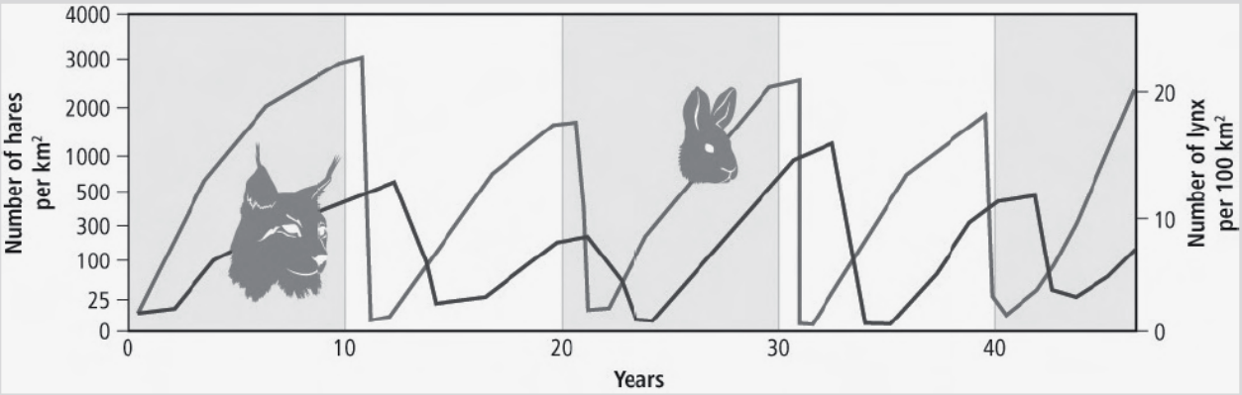

- The lynx is a predator and the snowshoe hare is a prey. In which years did the predator population decrease, likely due to a decrease in the prey population?
- What is the best reason to explain why fewer plants can grow in deep water than can grow in shallow water in a marine ecosystem?
A. There are more predators in deep water.
B. The temperature of the water is colder at deep levels.
C. Water pollution is more concentrated at deep levels than at shallow water levels.
D. The amount of light available for photosynthesis is less in deep water than in shallow water.
- What is the largest division of the biosphere?
A. Biome B. habitat C. ecosystem D. Population
- Barnacles attach to whales and are transported to new locations in the ocean to find new food sources. Whales are not harmed in this process. What type of symbiotic relationship is this an example of?
A. Parasitism B. mutualism C. interaction D. Commensalism
- What is the correct order of the ecological hierarchy, from smallest to largest?
A. ecosystem, population, community, organism
B. organism, community, population, ecosystem
C. organism, population, community, ecosystem
D. population, ecosystem, organism, community
- Which of the following statements about mutualism is false?
A. Mutualism is a symbiotic relationship in which both organisms benefit.
B. In some mutualistic relationships, two species are unable to survive without each other.
C. In one type of mutualism, one species defends another species against attacks in return for food and shelter.
D. One species protects another species from predators by camouflage. The host species is not harmed in the relationship.
Use this graph of the population of moose and wolf to answer question 16.
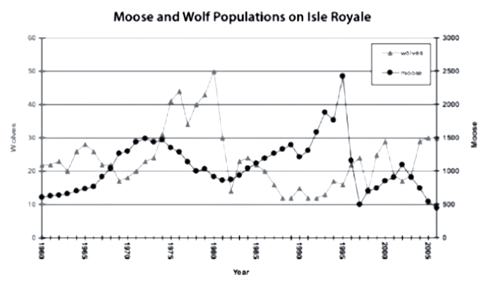
- Isle Royale in Lake Superior has been designated an International Biosphere Reserve. The wolves of Isle Royale have no natural predators and primarily hunt and eat moose. In what years did the prey population increase likely due to a decline in the predator population?
A. 1963 → 1966 B. 1985 → 1988 C. 1978 → 1981 D. 2003 → 2006
- A crab lives on a beach, which is where the crab finds food, shelter and a space to live. For the crab, the beach is an example of what division of the biosphere?
A. Niche B. habitat C. ecosystem D. Community
- Which of the following statements about water is not true?
A. Water anchors plants in place.
B. Without water, no organism would survive.
C. Water carries nutrients from one place to another in an ecosystem.
D. The cells of most living organisms contain between 50 and 90 percent water.
- A biologist wants to introduce a new species (species A) into an ecosystem. Species B already lives in the ecosystem and occupies the same niche as species A. What will be the likely outcome if species A is introduced into the ecosystem?
A. mutualism between the two species B. parasitism of species B by species A
C. commensalism between the two species D. competition between species A & species B
- Which of the following characteristics are common adaptations of predators?
A. I only B. I and III only C. I, II, and III D. II and III only
I | good eyesight
II | mimicry
III | sharp, pointed teeth

Energy Flow

- Plants use sunlight and nutrients to produce carbohydrates. What it the term that describes the role of plants in an ecosystem?
- What does the term energy flow describe about an ecosystem?
- What is the role of a decomposer in an ecosystem?
- Describe each of the following as a producer, consumer, or decomposer (more than one may apply).
(a) breaks down fallen leaves (b) does not need to consume other organisms to live
(c) assists with biodegradation (d) is the first step in energy flow through an ecosystem
(e) may consume another consumer
- Draw a food chain that contains the following five organisms: grass, black bear, earthworm, cougar, rabbit. Label the grass as producer, and label each of the other organisms according to the kind of consumer that they are.
- A fox’s diet can contain beetles, eggs, berries, fish, and mice. What kind of consumer is a fox?
- Which is most likely to occupy the second trophic level in a food chain: a potato, a worm that eats the potato, a bird that eats the worm, or a fox that eats the bird?

Use Figure 2.11 (p. 62) to answer questions 8 and 9.

- Which two members of the food web are omnivores?
- Which two members of the food web are tertiary consumers?

Use the Figure below to answer questions 10 and 11.
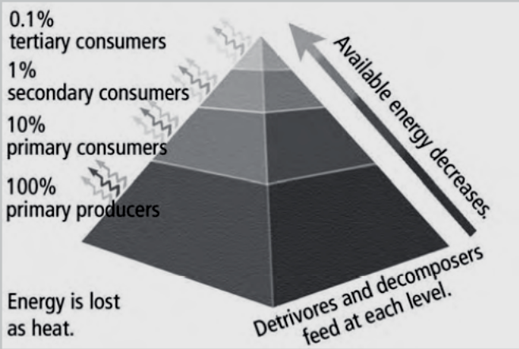

- What type of ecological pyramid is shown here?
- Approximately how much energy is lost from producers to secondary consumers?
- Which of the following statements about biomass is true?
A. Food webs are used to show the available biomass in an ecosystem.
B. Biomass is usually expressed in units of metres per gram or kilogram.
C. Biomass is the total mass of living plants, animals, fungi, and bacteria in a particular area.
D. The biomass of animals on Earth is over 100 times greater than the biomass of plants.
- A field of wheat is an example of which member of a food chain?
A. decomposer B. biodegrader C. consumer D. producer
Use this picture of a food web to answer question 14.
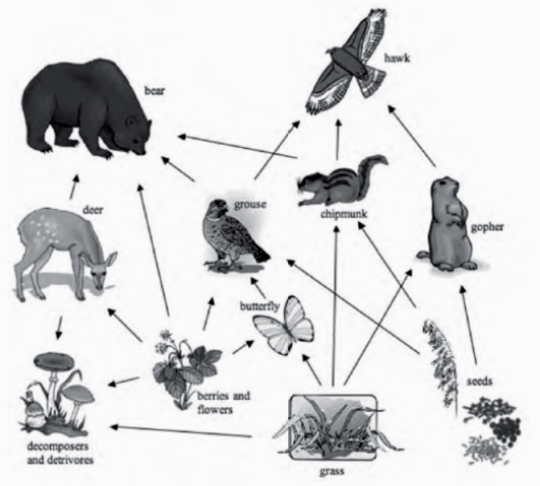
- Which is the best description for the role of the grizzly bear in this food web?
A. Detrivore B. omnivore C. carnivore D. herbivore

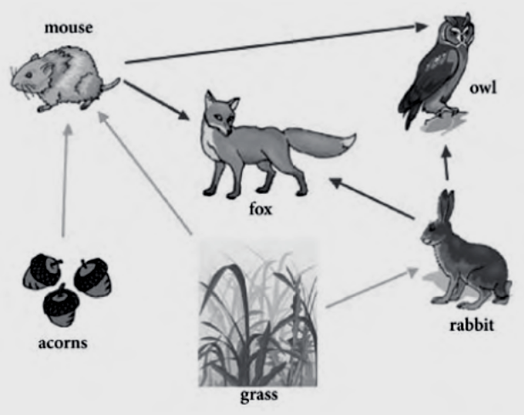
Use this picture of a food web to answer questions 15 and 16.
- Which organisms in this food web are the primary consumers?
A. owl and fox B. rabbit and fox C. acorns and grass D. rabbit and mouse
- At which trophic level is the fox in this food web?
A. First B. second C. third D. fourth

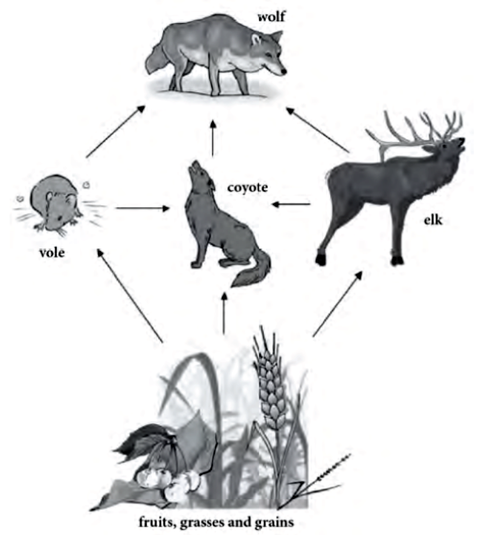
Use this picture of a food web to answer question 17.
- Which is the best description for the role of the wolf in this food web?
A. Herbivore B. omnivore C. carnivore D. top carnivore
- What is the best example of a detrivore from the list below?
A. Earthworm B. green algae C. grasshopper D. spotted frog
- Your teacher asks you to design a diagram to show the models of feeding relationships within an ecosystem. Which type of model should you choose?
A. food web B. food chain C. food pyramid D. ecological pyramid
- What is the best reason for why an ecosystem supports fewer organisms at higher trophic levels than at lower trophic levels?
A. Competition among organisms is more intense at higher trophic levels.
B. Most of the food energy consumed is used for growth and to increase biomass
C. Animals are part of more than one food chain and eat more than one kind of food.
D. There is a huge decrease in energy from lower trophic levels to higher trophic levels.
- At the producer level of a food pyramid, there is 455 000 kcal/m² of energy available. If there is a 90 percent energy loss at each level, how many kilocalories will be incorporated into the bodies of the secondary consumers?
A. 455 kcal/m² B. 4550 kcal/m² C. 45 500 kcal/m² D. 500 500 kcal/m²

Nutrient Cycles

- What does “nutrient” mean?
- What is an example of human activity that can decrease the amount of carbon taken from the atmosphere by plants?
- List four chemical elements that move through the biosphere as part of nutrient cycles.

Refer to The Carbon Cycle, page 5 of your Data Pages, to answer questions 4 - 6.
- How many gigatonnes of carbon are stored in each of the following locations?
(a) the atmosphere
(b) dissolved as organic carbon in the upper levels of the ocean
(c) organic matter in the soil
- Examine the carbon exchange values to answer the following questions.
(a) Is carbon moving faster into the oceans or out of the oceans?
(b) Does agriculture move more carbon into the air or out of the air?
(c) Why does the exchange data for the fossil fuel combustion show carbon moving into the atmosphere but none moving out of the atmosphere?
- How do volcanoes affect the amount of carbon in the atmosphere?
- How is the process of denitrification different from nitrogen fixation and nitrification?
- List three human activities that increase the amount of available nitrogen in the biosphere.
- Excess nitrogen in the ecosystem increases the amount of algal blooms. List two negative effects of algal blooms.
- Unlike carbon and nitrogen, phosphorus is not stored in the atmosphere. Where is it stored?
- Geologic uplift is the process in which mountains form as they are pushed up from below. How does geologic uplift relate to the phosphorus cycle?
- How do phosphates that are present in rocks eventually make their way into animals?
- How do humans add excess phosphorus into the environment?
- The effective cycling of nutrients in an ecosystem primarily depends on which of the following conditions?
A. rapid return of nutrients to deep stores
B. rapid rates of decomposition of organic matter
C. abundant resources of nutrients in the atmosphere
D. balanced rates of production, consumption, and decomposition
- Which of the following chemical nutrients is not cycled between living organisms and the atmosphere?
A. Phosphorus B. nitrogen C. carbon D. Oxygen
- Where is the largest store of carbon found on Earth?
A. in coal deposits B. in terrestrial vegetation
C. in soil and organic matter D. in marine sediments and sedimentary rock
- Which of the following processes does not increase the amount of carbon dioxide (CO₂) in the atmosphere?
A. forest fires B. photosynthesis C. cellular respiration D. decomposing trees
- Listed below are chemical compounds matched with a location where they can be found on Earth. Which of the pairs of chemical compounds and locations is incorrect?
A. nitrate (NO₃⁻): water B. nitrogen (N₂): atmosphere
C. carbonate (CO₃²⁻): atmosphere D. phosphate (PO₄³⁻): sedimentary rock
- Which term describes the process of converting nitrogen gas (N₂) into nitrate (NO₃⁻) or ammonium (NH₄⁺)?
A. Uptake B. nitrification C. denitrification D. nitrogen fixation
- Biologists doing a yearly fish count in a small lake notice that the number of fish in the lake is dramatically less than the year before. They observe the bodies of dead fish near the shoreline. After testing a sample of the water, the biologists realize that the level of dissolved nitrogen has increased dramatically. What else might the biologists notice about the lake?
A. increased oxygen B. increased algae production
C. decreased lake temperature D. decreased algae production
- How do carnivorous animals obtain the phosphorus that they need for growth and development?
A. Plants produce phosphorus through cellular respiration and make it available to animals.
B. Bacteria break down the phosphorus in the soil and make it available to animals.
C. The animals eat other consumers that have obtained phosphorus from plants.
D. The animals eat plants, which have absorbed phosphorus through the soil.
- Which of the following relationships between human activities and nutrient cycles is not true?
A. The clearing and burning of forests increases the amount of phosphate (PO₄³⁻) available to organisms.
B. The burning of fossil fuels for industry increases the amount of nitrogen oxide (NO) in the atmosphere.
C. The use of fertilizers for agriculture increases the amounts of nitrate (NO₃⁻) and phosphate (PO₄³⁻) in water systems.
D. The use of motorized vehicles increases the amount of carbon dioxide (CO₂) in the atmosphere.
- Which of the following processes makes nitrogen available to plants and animals?
I | Nitrogen-fixing bacteria in the soil
II | Nitrogen-fixing cyanobacteria in the water
III | Decomposer bacteria and fungi in the soil
IV | Nitrifying bacteria in the soil
A. I and IV only B. I, II, and III only C. I, III, and IV only D. I, II, III, and IV

Bioaccumulation

- What is bioaccumulation?
- (a) How can the low-level presence of a harmful chemical stored in the body fat of salmons result in dangerously high levels of that same chemical in bears?
(b) What is this process called?
- Bears prey on salmon. The bears take salmon out of the water and into the forest. It has been estimated that bears leave half of the salmon that they catch on the forest floor. Explain why bears are a keystone species in British Columbia.
Use the table below to answer questions 4 and 5.
Table 2.2 Bioaccumulation of DDT in a Food Chain
Consumer | Bioaccumulation (ppm)
Plankton | 0.04
Minnow | 0.94
Adult fish | 2.07
Heron | 3.57
Osprey | 13.80
Cormorant | 26.40
- Approximately how many times more concentrated is DDT in herons than it is in minnows?
- Explain why the concentration of the pesticide DDT is less in plankton than in cormorants.
- List three heavy metals known to be dangerous when released into the environment.
- Poplar trees are sometimes planted in soil contaminated with chemicals. The poplar trees are not harmed by the chemicals, and as they grow they remove the chemicals from the soil and change them into other non-toxic chemicals. What is the term that describes this process?
- Which is the best reason to explain why some synthetic and organic chemicals accumulate in the environment?
A. Synthetic chemicals are metabolized by organisms.
B. Organisms secrete synthetic chemicals as a waste product.
C. The increase in ultraviolet radiation causes chemicals to accumulate in organisms.
D. Synthetic chemicals that cannot be broken down by decomposers will build up in living organisms.
- In which part of an animal would you expect to find the highest level of a synthetic chemical like PCB?
A. Brain B. fat storage C. lung tissue D. blood system
- A biologist studied a sample taken from a squid in a marine food web. She found that the concentration of DDT in this sample was 2.0 ppm. What does a concentration of 2.0 ppm mean?
A. There are 20 particles of DDT mixed with 999 980 other particles.
B. There are two particles of DDT mixed with 999 999 other particles.
C. There are two particles of DDT mixed with 999 998 other particles.
D. There are two particles of DDT mixed with 1 000 000 other particles.
- Sea otters that live off the west coast of Canada primarily eat sea urchins. The sea urchins are one of the main consumers of algae such as kelp. Toxic levels of synthetic chemicals in the sea otter population prevented the sea otters from reproducing, and the population of sea otters began to decrease significantly. As a result, the sea urchins and other herbivores quickly severely reduced the kelp, allowing barnacles and mussels to flourish at the cost of other species in the ecosystem. Which is the best description for the role of the sea otter in this marine ecosystem?
A. keystone species B. indicator species C. top carnivore D. niche species
- Which of the following statements about PCB contamination and orcas is not true?
A. Orcas retain high levels of PCBs in their bodies because PCBs have a long half-life.
B. The presence of high amounts of PCBs in orcas is an example of biomagnification.
C. PCB-contaminated orcas usually give birth to calves that have no PCB contamination.
D. PCBs are synthetic chemicals that were widely used in industrial products.

Use the following picture of a marine food web to answer question 13.
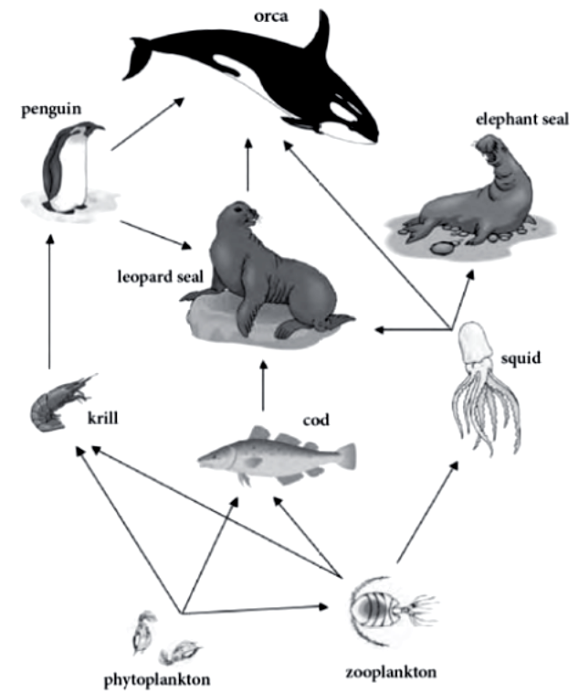
- The squid in this food web was tested and found to have a DDT concentration of 2.0 ppm. Which organism would you expect to have a concentration of 16.0 ppm?
A. Cod B. krill C. zooplankton D. Orca
- Which of the following contaminants have these four characteristics in common?
• potential to bioaccumulate within organisms
• naturally present on Earth
• binds to soil particles
• toxic to animals
A. lead and PCBs B. DDT and PCBs
C. lead, cadmium, and mercury D. cadmium, mercury, and DDT
- After an oil spill near Vancouver Island, the oil company decided to use bacteria to clean up the pollution created by the spill. What type of process is this an example of?
A. Biocleaning B. bioremediation C. bioaccumulation D. Biomagnification
- Which of the following is not an example of how humans can be exposed to heavy metal poisoning?
A. smoking cigarettes B. ingestion of methylmercury
C. skin absorption due to direct contact D. eating shellfish contaminated by a red tide
- Which of the following are natural sources of heavy metals on Earth?
I | volcanic eruptions
II | geothermal springs
III | battery manufacturing
IV | rock weathering
A. I and IV only B. II and III only C. I, II, and IV only D. I, II, III, and IV

Natural Changes to the Ecosystem

- What is natural selection?
- How might random variations in the size of salmon tails cause natural selection to occur?
- What is adaptive radiation?
- How does adaptive radiation make it possible for several different species of finch to live together in the same location without having to compete with each other for food? What is ecological succession?
- In primary succession, organisms such as lichen, which can grow directly on rock, form the first populations in an area. What is the general term for these first organisms?
- What is the difference between primary and secondary succession?
- What is the term given to all the populations that inhabit an area in the final stage of succession?
- What are four examples of factors that can cause a climax community to change?
- Marsupials are mammals that have a pouch in which females raise their young through early infancy. Many marsupials, such as kangaroos and koala bears, live in Australia, where it is believed that they all evolved from a common ancestor. Each species occupies its own ecological niche within Australia. This an example of which type of process?
A. artificial selection B. adaptive radiation
C. primary succession D. ecological succession
- Which of the following statements about natural selection is not true?
A. The finches of the Galapagos Islands are an example of natural selection.
B. The development of antibiotic-resistant bacteria is an example of natural selection.
C. Natural selection occurs when an organism tries to change and adapt to new surroundings.
D. In natural selection, members of a species who have a favourable trait will be more likely to reproduce.
- What do the following events have in common?
• flooding
• tsunami
• drought
• insect infestation
A. They occur only in coastal areas.
B. They result in primary succession.
C. They affect biotic and abiotic factors of mature communities.
D. They have all increased in frequency because of climate change.
- Which of the following statements regarding pioneer species is not true?
A. Galapagos finches are an example of a pioneer species.
B. Pioneer species change the biotic and abiotic environment in a variety of ways.
C. Pioneer species are the first organisms that survive and reproduce in an area.
D. Lichens that grow on rock in areas where glaciers have retreated are an example of a pioneer species.
- An example of natural selection is the increase in the population of dark-coloured moths during the Industrial Revolution in England. During this time, large amounts of ash and soot released into the atmosphere blackened the trees and vegetation near industrial areas, which was the habitat of the moth. Before the Industrial Revolution altered the environment, the light-coloured moth population was much higher than the dark-coloured moth population. Which of the following reasons best explains the increase in the dark-coloured moth population?
A. The colour of the moths alternates every few years between light and dark.
B. The dark-coloured moths were better able to avoid predators through camouflage against the dark-coloured trees.
C. The dark-coloured moths were the moths that were more exposed to pollution, which changed their pigmentation.
D. The light-coloured moths were more susceptible to the environmental impact of the ash and soot in their environment.
- Vegetation gradually takes hold on bare rock formed by cooling lava. What kind of ecological process is happening?
A. secondary succession B. primary succession C. adaptive radiation D. natural selection
- In which of the following locations would you expect the process of secondary succession to occur?
A. on lava after a volcanic eruption
B. in a rocky landscape in the Arctic
C. in an area left from a retreating glacier
D. in an empty field where crops were once grown
- Which of the following statements about flooding is not true?
A. Flooding can cause tsunamis.
B. Flooding can cause widespread disease among humans.
C. Flooding can be part of the normal cycle of an ecosystem.
D. Climate change may have caused an increase in flooding.
- Which of the following statements regarding the mountain pine beetle are true?
I | Pine beetles have a symbiotic relationship with a fungus.
II | Pine beetles only attack older, weaker pine trees.
III | The spread of the pine beetle in British Columbia has decreased spruce, fir, and younger pine populations.
IV | Tree resin can trap beetles.
A. I and II only B. III and IV only C. I, III, and IV only D. I, II, III, and IV

- What is the correct order for the following stages of primary succession, from earliest to latest?
A. II, III, V, IV, I B. III, II, IV, V, I
C. III, II, V, I, IV D. IV, II, III, I, V
I | A mature community develops.
II | The decay of pioneer species creates soil.
III | Lichens begin breaking down rocks and forming soil.
IV | Micro-organisms and insects begin to occupy the area.
V | Sun-tolerant trees begin to grow.

How Humans affect Ecosystems

- What does “sustainable ecosystem” mean?
- Deforestation of tropical rainforests continues to occur. Give two negative effects of deforestation.
- What is soil degradation?
- Name two negative effects of poor agricultural practices on soil.
- List three kinds of human activities that are types of resource exploitation.
- List five ways humans depend on resource exploitation.
- List three ways that resource exploitation can harm the environment.
- What does “overexploitation” mean?
- What is extinction?
- What practices have Aboriginal peoples used to pass ecological knowledge from generation to generation?
- In some areas, a tradition called the spring burn has been used. What positive ecological results can occur from a spring burn?

Use the following information to answer questions 12 and 13.
A large moss-covered rock provides a habitat for a community of organisms. Algae, bacteria, fungi, and insects live on the rock. In an experiment, researchers scraped most of the moss off of the rock. They left one large patch of moss in one region of the rock. They also left six much smaller patches close together in another region of the rock. They repeated the same procedure on six different rocks. After six months, the patches were analyzed and researchers counted the number of distinct species living in each region.

- What do the two regions represent in the experiment?
A. Larger patch: control; Six smaller patches: habitat loss
B. Larger patch: control; Six smaller patches: habitat fragmentation
C. Larger patch: habitat fragmentation; Six smaller patches: control
D. Larger patch: habitat loss; Six smaller patches: control
- Across all six rocks, an average of 40 percent of the species became extinct in the smaller patches. What could the researchers conclude from this experiment?
A. This experiment shows how to create a sustainable ecosystem.
B. Habitat loss does not affect the biodiversity of the rock ecosystem.
C. Many of the species living on the rock were affected by habitat fragmentation.
D. The species were able to move among the smaller patches to obtain the nutrients they needed.
- Which of the following is not a characteristic of a sustainable ecosystem?
A. Biodiversity B. no resource use
C. responsible land use D. ability to sustain ecological process
- Which of the following is an example of a sustainable land use approach in British Columbia?
A. grassland management plans B. urban expansion into farmlands
C. cutting large areas of forest D. draining and drying out wetlands
- Which of the following statements about deforestation are true?
I | Deforestation is a problem only in tropical rainforests.
II | Deforestation reduces the number of plants and animals living in an ecosystem.
III | Deforestation can cause soil erosion.
A. I and II only B. I, II, and III C. II only D. II and III only

- Which of the following statements about land use is not true?
A. Bare fields can cause topsoil erosion.
B. The use of tractors can cause soil compaction.
C. Mine reclamation can cause water contamination.
D. Road construction can cause habitat fragmentation.
Use this picture of an open-pit copper mine, similar to those found in British Columbia, to answer question 18.
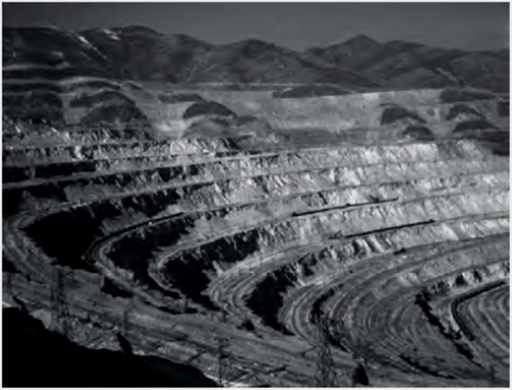
- Which of the following practices is likely to happen after the mine closes?
A. use of plants to decontaminate soil B. use of topsoil to fill in the open pit
C. resource exploitation D. destruction of habitat
- Which of the following is a likely outcome of overexploitation?
A. Biodiversity B. extinction C. sustainability D. ecological succession
- Which of the following is an example of traditional ecological knowledge?
A. soil compaction of agricultural lands
B. the introduction of non-native plant species
C. the overexploitation of the salmon fishery
D. the spring burning of prairie grasslands in Alberta
- Which of the following statements about forest fires is not true?
A. Secondary succession can occur after a forest fire.
B. Forest fires are an example of resource exploitation.
C. Controlled burns of forest fires can improve the diversity of the forest.
D. Forest fire suppression practices have resulted in large numbers of dead or diseased trees.
Foreign Species

- What is the difference between a native species and a foreign species?
- What is the definition of an invasive species?
- What does proliferation mean?
- What are four ways in which introduced species can affect ecosystems?
- What is the major threat to the Garry oak ecosystem today?
- How do gypsy moths harm the Garry oak ecosystem?
- Which of the following characteristics accurately describe most invasive species?
A. I and II only B. I, II, III, and IV C. I, III, and IV only D. III and IV only
I | aggressive competitors
II | low reproduction rates
III | lack natural predators in new habitats
IV | contribute to biodiversity loss
- An invasive predator species is introduced into a new environment. The predator is quickly able to find suitable prey. In a short period of time, the prey population has been dramatically reduced by the new predator. Which of the following best explains how the predator was able to do this?
A. The prey population began to occupy a new niche.
B. The prey population had a high reproduction rate.
C. The invasive predator became a parasite on the prey species.
D. The prey population probably did not have adaptations to escape or fight the new predator.
- What type of impact has the European starling had on native birds in British Columbia?
A. Predation B. competition C. habitat alteration D. disease and parasites
- Which of the following species have these three characteristics in common?
• invasive species
• outcompete native species
• found in British Columbia
A. gypsy moth and grey squirrels B. grey squirrels and American bullfrog
C. gypsy moth and American bullfrog D. grey squirrels and red squirrels
- Which of the following statements accurately describes introduced species?
A. They naturally inhabit the new environment.
B. Native species is another name for introduced species.
C. Many are harmless or beneficial in their new environment.
D. They are always intentionally introduced into a new environment.
- Which of the following are reasons why there has been an increase in invasive introduced species?
I | creation of new niches in ecosystems
II | increased international air travel
III | increase in biodiversity of ecosystems
IV | climate change
A. I, II, and III only B. II and IV only C. III and IV only D. I, II, III, and IV
- Which of the following examples of how Scotch broom alters the habitat in the Garry oak ecosystem is false?
A. interferes with the growth of native species by altering the nutrients in the soil
B. ruins habitat for native birds and butterflies by replacing native shrubs
C. makes trees more vulnerable to infections
D. fixes nitrogen in the soil

Use the following information to answer questions 14 and 15.
Rabbits were introduced to Australia by European settlers. The rabbits quickly multiplied and spread throughout the country, feeding on the native vegetation and destroying food and habitat for many native species. The Australian government decided to use myxoma virus to eradicate the rabbit population. The myxoma virus is from Uruguay, and it causes the fatal disease myxomatosis. It is usually transmitted by mosquitoes or fleas.

- Which of the following best summarizes the actions of the Australian government?
A. the use of an introduced species to control an invasive population
B. the use of a native species to control an invasive population
C. the use of an invasive species to control a native population
D. the use of a foreign species to control a native population
- Initially, the virus killed 90 percent of the rabbit population. In more recent years, the rabbit population has begun to grow again even though the virus is still present in the environment and continues to kill up to 50 percent of the rabbit population annually. What is the best explanation for why the virus currently kills only half of the rabbit population?
A. The rabbit population became a native species.
B. The rabbit population found a new niche to occupy.
C. The rabbit population learned to hide from the virus.
D. Natural selection favoured virus-resistant rabbits that were able to survive and reproduce.

