STUDENT-GENERATED EXPECTATIONS
Hello parents, guardians, and students in Science 8!

This past week, you (students) shared what you felt was fair to expect of each other as we work together in Science this year. Using your feedback, the Gr. 8 Science teachers (Ms. Langlois, Ms. Towers, and Mr. Lawson) combined all of your responses into the following set of expectations:
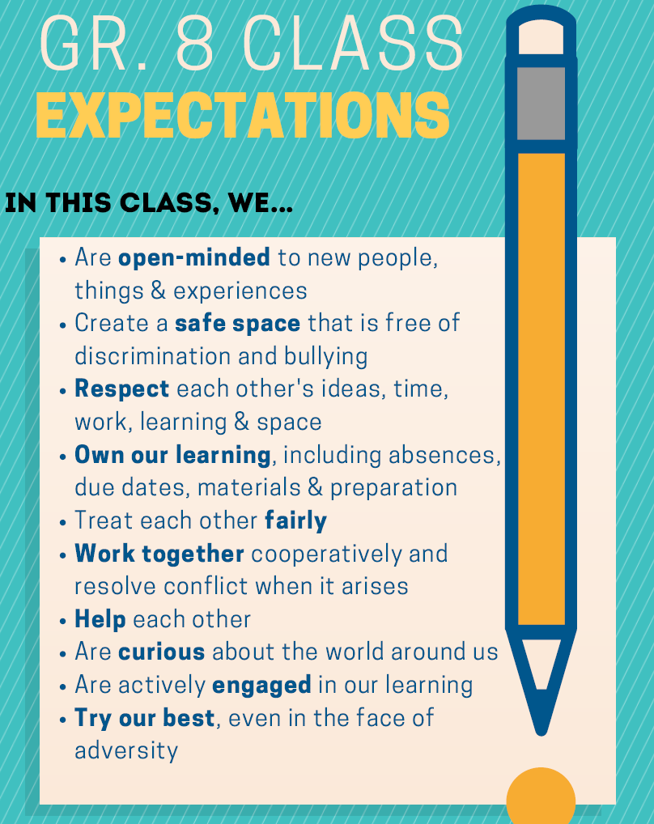
These expectations will only be effective if everyone (teachers, students, and guardians) agrees to support them. If you agree to support these expectations through your thoughts, words, and actions this year, please sign below. Please have a guardian sign as well.
Student Name: | Student Signature:
Guardian Name: | Guardian Signature:

