Atomic Theory and Bonding

- Explain how an atom, an element, and a compound are different from each other.

- What are the electrical properties of the following particles?
(a) protons (b) neutrons (c) electrons

- Where is each particle located in an atom?
(a) proton (b) neutron (c) electron

- What does “atomic number” mean?

- What is the difference between a chemical family and a period in the periodic table?

- List the name and group number of four families of elements.

- How does an atom become an ion?

- How do metals become positive ions?

- How do non-metals become negative ions?

- Where are valence electrons found?

- How many electrons can be in each of the first three shells in a Bohr model of an atom?
(a) Shell 1 (b) Shell 2 (c) Shell 3

- Draw a Bohr diagram showing the number of protons and electrons in an atom of:
(a) carbon (b) chlorine (c) aluminum

- Draw a Bohr diagram showing the number of protons and electrons in each of the following ions.
(a) F– (b) Na⁺ (c) Al³⁺

- Which combinations of elements form ionic bonds in compounds?

- Which combinations of elements form covalent bonds?

- Name seven diatomic elements.

- Draw Lewis diagrams for the following atoms.
(a) O (b) F (c) Na

- Draw Lewis diagrams for the following compounds.
(a) H₂O (b) NH₃
- Which subatomic particles are found in the nucleus of atoms?
A. only protons B. only electrons
C. protons and neutrons D. protons and electrons
- When forming ions, elements on the left side of the periodic table tend to behave in which of the following ways?
A. lose protons B. gain protons C. lose electrons D. gain electrons
- What is the name of the reactive family of elements that form 1− ions?
A. Halogens B. noble gases C. alkali metals D. alkaline earth metals
- What is the atomic number of an atom with 19 protons, 19 electrons, and 21 neutrons?
A. 19 B. 21 C. 38 D. 39
- Which of the following describes an ion of chlorine?
A. 20 neutrons and 17 electrons B. 20 neutrons and 18 electrons
C. 37 neutrons and 17 electrons D. 37 neutrons and 18 electrons
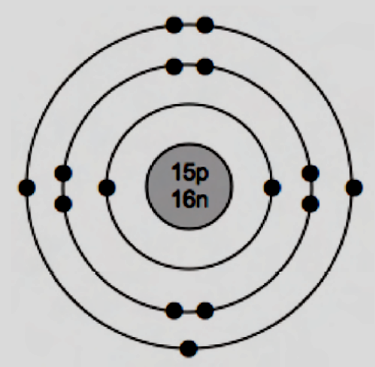

- Identify the atom shown in the Bohr diagram above.
A. Gallium B. sulphur C. oxygen D. Phosphorus
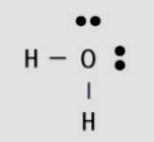
- How many lone pairs and bonding pairs of electrons appear in the Lewis diagram shown below of water?

A. two lone pairs and no bonding pairs B. two lone pairs and two bonding pairs
C. no lone pairs and two bonding pairs D. four lone pairs and four bonding pairs
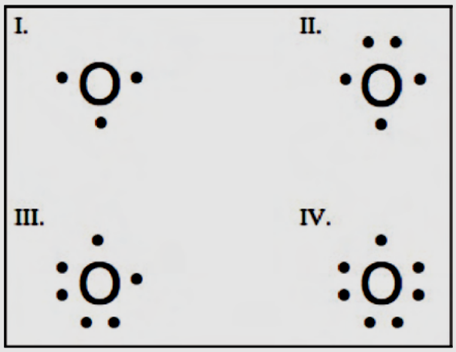
- Which of the following Lewis diagrams represents an oxygen atom?
A. I
B. II
C. III
D. IV

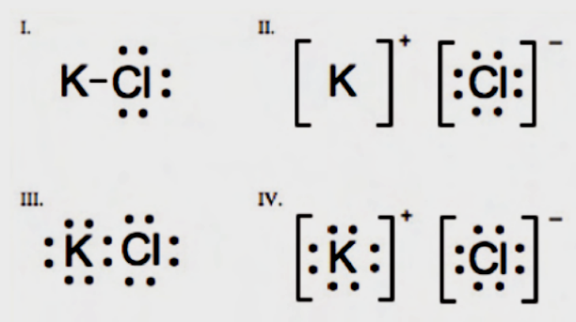
- Which of the following Lewis diagrams represents KCl?
A. I
B. II
C. III
D. IV

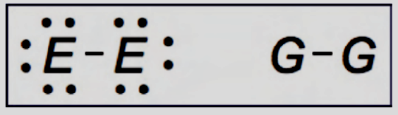
- E and G represent unknown elements from the periodic table. What product could be formed from the two molecules shown below?
A. Water
B. krypton gas
C. hydrogen chloride
D. sodium chloride
Names and Formula’s of Compounds

- Name the following ionic compounds.
(a) Li₃P (b) CaCl₂ (c) ZnO

- Write the formulas of the following ionic compounds.
(a) sodium sulfide (b) magnesium iodide (c) aluminum oxide

- Write the formulas of the following ionic compounds.
(a) copper(I) oxide (b) lead(IV) iodide (c) lead(II) chloride (d) gold(III) sulphide

- Name the following ionic compounds containing a multivalent metal ion. Use a Roman numeral in the metal ion’s name.
(a) Cr₃P₂ (b) MnCl₂ (c) Co₂O₃ (d) FeN

- Write the formulas of the following ionic compounds containing polyatomic ions.
(a) cesium sulphate (b) titanium(IV) hydrogen carbonate
(c) ammonium sulphide (d) ammonium dichromate

- Name the following ionic compounds containing polyatomic ions. The metal ion may need to be written using a Roman numeral.
(a) NaClO₄ (b) Mg₃(PO₄)₂ (c) (NH₄)₂SO₃ (d) CuSO₄

- Give the number of each type of atom indicated by the formula, as well as the total number of atoms. (e.g., MgF₂ has one Mg and two F for a total of three atoms)
(a) K₃PO₄ (b) (NH₄)₂SO₄ (c) nickel(III) carbonate (d) molybdenum(II) nitrate

- Write the formula of each covalent compound.
(a) sulfur trioxide (b) dinitrogen monoxide
(c) tetraphosphorus decasulfide (d) phosphorus pentachloride

- Write the name of each covalent compound
(a) PBr₃ (b) N₂S₃ (c) N₂O₄ (d) OF₂

- Identify each of the following compounds as either ionic or covalent, and name them.
(a) (NH₄)₃P (b) OBr₂ (c) FeF₃ (d) SnS₂

- The compounds below have similar-looking formulas but may have very different names. Classify each compound as ionic or covalent, and then name each compound.
(a) PbO₂ (b) NO₂ (c) SO₂ (d) SnO₂
- What is the formula for aluminum sulfide?
A. AlS B. AlS₃ C. Al₃S₂ D. Al₂S₃
- What is the ionic charge of lead in PbO₂?
A. +1 B. +2 C. +3 D. +4
- Which of the following is the correct name for Fe₂(SO₄)₃?
A. iron(II) sulphate B. iron(II) sulphide C. iron(III) sulphate D. iron(III) sulphide
- Which statement best describes the compound N₂O₃?
A. It is the ionic compound nitrogen oxide.
B. It is the covalent compound nitrogen oxide.
C. It is the ionic compound dinitrogen trioxide.
D. It is the covalent compound dinitrogen trioxide.

- Which of the following is the correct bond type and name for (NH₄)₂S?
A. ionic, ammonium sulphide B. ionic, nitrogen hydrogen sulphide
C. covalent, ammonium sulphide D. covalent, dinitrogen monohydrogen sulphide

- What is the formula for diphosphorus pentachloride?
A. PCl B. PCl₅ C. P₂Cl₅ D. P₅Cl₂

- Which of the following is the correct name for SrCl₂?
A. strontium chloride B. strontium dichloride
C. strontium(II) chloride D. monostrontium dichloride

- What is the name for AuBr₃?
A. gold bromide B. gold tribromide C. gold(III) bromide D. gold(III) bromine

- How many atoms of each of the following elements are present in nickel(III) sulfate?
A. nickel = 2, sulfur = 3 B. nickel = 1, sulfur = 1, oxygen = 4
C. nickel = 3, sulfur = 1, oxygen = 4 D. nickel = 2, sulfur = 3, oxygen = 12

- What is the formula for manganese(II) chloride?
A. MnCl B. MnCl₂ C. Mn₂Cl D. MgCl₂

Chemical Equations

- When does a chemical change occur?
- What are two ways that a chemical reaction can be written?
- State the law of conservation of mass.
- List the total number of each type of atom in the following reactants.
(a) 3 Cl₂ + 2 CrI₃ (b) Pb(NO₃)₄ + 4 NaI
- Balance the following skeleton equations.
(a) ____ Al + ____ Cl₂ → ____ AlCl₃
(b) ____ CH₄ + ____ O₂ → ____ CO₂ + ____ H₂O
(c) ____ Ca(NO₃)₂ + ____ Cu₂SO₄ → ____ CaSO₄ + ____ CuNO₃
(d) ____ Na₂CO₃ + ____ Ni(NO₃)₃ → ____ NaNO₃ + ____ Ni₂(CO₃)₃
- Write skeleton equations for the following chemical reactions and then balance them. Be sure to check your formulas carefully before you begin to balance.
(a) calcium fluoride + potassium → potassium fluoride + calcium
(b) aluminum hydroxide + hydrogen bromide → aluminum bromide + water
(c) chromium(III) iodide + potassium carbonate → chromium(III) carbonate + potassium iodide
(d) hydrogen nitrate + barium carbonate → barium nitrate + water + carbon dioxide
- What coefficient is needed in front of O₂ in order to balance the following equation?
C₃H₈ + __ O₂ → 3CO₂ + 4H₂O
A. 2 B. 5 C. 6 D. 10
- In a chemical reaction, 40.3 g of magnesium oxide is broken down to yield 24.3 g of magnesium and 16.0 g of oxygen. What is this an example of?
A. Dalton’s atomic theory B. the law of constant proportions
C. the law of conservation of mass D. the law of conservation of energy
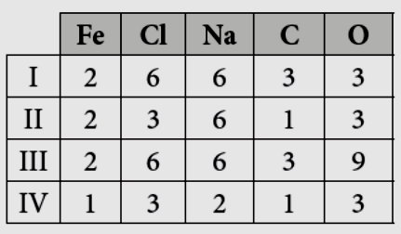
- List the total number of each type of atom found in the following reactants: 2FeCl₃ + 3Na₂CO₃
A. I
B. II
C. III
D. IV

- Which of the following is the correctly balanced equation for the following skeleton equation?
Al + ___ CuCl₂ → ___ AlCl₃ + ___ Cu?
A. Al + CuCl₂ → AlCl₃ + Cu B. Al + 3CuCl₂ → 2AlCl₃ + Cu
C. 2Al + 3CuCl₂ → 2AlCl₃ + 3Cu D. 6Al + 3CuCl₂ → 2AlCl₃ + 6Cu

- Which of the following equations is correctly balanced?
A. Al + Br₂ → AlBr₃ B. Al + 3Br₂ → AlBr₃
C. Al + 3Br₂ → 2AlBr₃ D. 2Al + 3Br₂ → 2AlBr₃

- Rewrite the following word equation as a balanced equation.
Potassium sulfate and lead(II) nitrate react to make potassium nitrate and lead(II) sulfate.
A. K₂S + Pb(NO₃)₂ → 2KNO₃ + PbS B. K₂SO₄ + Pb(NO₃)₂ → 2KNO₃ + PbSO₄
C. 3K₂SO₄ + Pb₃N₂ → 2K₃N + 3PbSO₄ D. 3PSO₄ + Pb₃N₂ → P₃N + 3PbSO₄

- Write the skeleton equation for the following reaction.
Iron(III) bromide reacts with sodium hydroxide to yield iron(III) hydroxide and sodium bromide.
A. FeBr₃ + NaOH → Fe(OH)₃ + NaBr B. FeBr₃ + SOH → Fe(OH)₃ + SBr
C. FeBr + NaOH → FeOH + NaBr D. IBr + NaOH → IOH + NaBr

- Which of the following equations is correctly balanced?
A. C₅H₁₂ + 8O₂ → 5CO₂ + 6H₂O B. C₅H₁₂ + 11O₂ → 5CO₂ + 6H₂O
C. C₅H₁₂ + 11O₂ → 5CO₂ + 12H₂O D. 2C₅H₁₂ + 22O₂ → 10CO₂ + 24H₂O

- In a tightly closed container, a piece of zinc reacts in hydrochloric acid to produce hydrogen gas and a salt solution of zinc chloride. What will happen to the mass of the container?
A. It will increase. B. It will decrease.
C. It will stay the same. D. It will first increase, then decrease.

- Tom has an open cup of vinegar (acetic acid) and adds some sodium carbonate. The mixture bubbles and fizzes. After the fizzing stops, Tom finds the container is lighter (less mass) than it was originally. He thinks it has broken the law of conservation of mass. His lab partner knows the correct answer and states:
A. “You must have made a mistake. Try it again.”
B. “Yes, you found a reaction that breaks the law of conservation of mass!”
C. “There is not enough information here. We must do the experiment again.”
D. “No, the law of conservation of mass is obeyed. Gas was produced, and it escaped into the surrounding air.”

Acids and Bases

- What is the pH range for each of these solutions?
(a) acidic (b) basic
- How many times has the acidity level increased if the pH drops from pH 4 to pH 3?
- How many times has the acidity level increased if the pH drops from pH 6 to pH 2?
- What is the pH of a solution that is neutral?
- What is the colour of each of these acid-base indicators in the following solutions?
(a) methyl orange in stomach acids (b) methyl orange in tomato juice
(c) bromothymol blue in banana juice (d) blue litmus in pure water
(e) red litmus in pure water (f) phenolphthalein in ammonia solution (NH₃)
- Name the following non-oxygen acids.
(a) HCl(aq) (b) HBr(aq) (c) HF(aq)
- Name the following common acids.
(a) H₂SO₄ (b) HNO₃ (c) CH₃COOH(aq)
- Name the following acids containing oxygen and chlorine.
(a) HClO₄(aq) (b) HClO₃(aq) (c) HClO₂(aq) (d) HClO(aq)
- Identify each by their formula as acids, bases, or neither when dissolved in water.
(a) HI (b) KOH (c) NaCl
(d) Ca(OH)₂ (e) MgBr₂ (f ) H₃PO₄
- Which ion is in high concentration in an acidic solution?
- Which ion is in high concentration in a basic solution?
- The concentrations of H⁺ and OH⁻ cannot both be high at the same time. Why not?
- What is the pH of an acidic substance?
A. between 4 and 8 B. greater than 7 C. less than 7 D. equal to 7
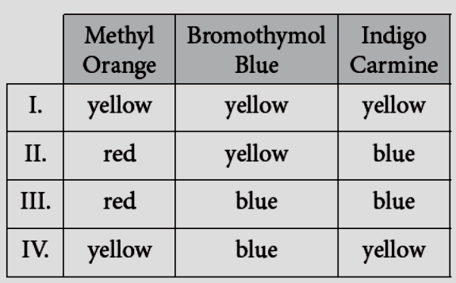
- A sample of grapes is crushed, and the pH is tested using three different indicators. Which set of colours is correct for the grapes?
A. I
B. II
C. III
D. IV
- You have a sample to test in a lab. The sample looks like milk. Choose the two best indicators for testing if the sample is in the same pH range as milk.
A. litmus and phenolphthalein B. methyl orange and methyl red
C. methyl red and bromothymol blue D. phenolphthalein and indigo carmine
- A property of acids is that they react with metals. If you placed a cut lemon and a raw egg on two spots on bare metal, which of the following would you observe?
A. Only the egg would react. B. Only the lemon would react.
C. Both the lemon and the egg would react. D. Neither the lemon nor the egg would react.
- What kind of substance feels slippery, turns red litmus blue, and has a pH > 7?
A. a base, such as NaOH B. an acid, such as HCl
C. a salt, such as MgCl₂ D. a neutral substance, such as HNO₃
- A solution has a pH of 11. Acid is added until pH = 5. Which indicator would be a good choice to know when the solution has reached pH = 5?
A. methyl red B. methyl orange C. phenolphthalein D. indigo carmine
- A substance used in producing plastic is HCl. It is a(n) ___ and is named ___.
A. salt, hydrogen chlorite B. acid, hydrogen chlorate
C. base, hydrogen chloride D. acid, hydrogen chloride
- Which of the following is the correct formula for sulfuric acid?
A. H₂S B. HSO₄ C. H₂SO₃ D. H₂SO₄
- Perchloric acid is used in manufacturing explosives and speeding up chemical reactions. What is the formula for perchloric acid?
A. HF B. HBr C. HClO₄ D. H₂Pe₃
- A sample of bleach was tested with bromothymol blue to determine its pH. What colour will it be, and what does the colour tell you about the pH of bleach?
A. blue, pH > 7 B. blue, pH = 12 C. yellow, pH < 7 D. yellow, pH = 12

Salts

- Identify each of the following as an acid, a base, a salt, a metal oxide, or a non-metal oxide.
(a) Ba(OH)₂ (b) H₂SO₄ (c) NaCl (d) K₂O (e) SO₂
- Which kinds of oxides react with water to form acid precipitation?
- Complete and balance the following neutralization reactions.
(a) ____ HF + ____ KOH →
(b) ____ H₂SO₄ + ____ NaOH →
(c) ____ HNO₃ + ____ Mg(OH)₂ →
- Complete and balance the following reactions between an acid and a metal.
(a) ____ HF + ____ Zn →
(b) ____ H₂SO₃ + ____ Mg →
(c) ____ HCl + ____ Al →
- Why is calcium carbonate sometimes added to lake water?
- Which of the following correctly lists, in order, an acid, a base, and a salt?
A. HCl, NaOH, BaCl₂ B. HNO₃, CaCl₂, NaOH
C. NaCl, MgBr₂, NH₄OH D. Ba(OH)₂, HNO₃, H₃PO₄
- Which reaction is an acid-base neutralization?
A. HCl + Ca → CaCl₂ + H₂ B. CaO + H₂O → Ca(OH)₂
C. HCl + BaCO₃ → BaCl₂ + H₂O + CO₂ D. HNO₂ + Ca(OH)₂ → Ca(NO₃)₂ + H₂O
- Which of the following are produced when Ca + HCl react?
A. CaHCl B. CaH + Cl₂ C. CaCl₂ + H D. CaCl₂ + H₂
- Which of the following completes the reaction below?
SO₃(g) + H₂O(ℓ) →
A. H₂SO₄(aq) B. H₂SO₃(aq) C. HSO₄(aq) D. HSO₃(aq)
- Consider the following reaction. BaO + H₂O →
Determine the formula of the product(s), and indicate if the product is an acid, a base, or a neutral compound.
A. Ba(OH)₂, a base B. Ba(OH)₂, an acid
C. BaO + H₂, neutral compounds D. Ba + H₂O₂, neutral compounds
- Which basic compound could be added to lakes to help deal with acid precipitation?
A. NaCl B. NaOH C. CaCO₃ D. HCl
- Which of the following groups contains only salts?
A. NaCl, HBr B. NH₄OH, LiOH
C. NaCl, Ca(NO₃)₂ D. NaCl, Ca(NO₃)₂, NH₄OH, LiOH, HBr
- Which of the following is a balanced equation for the reaction between an acid and a carbonate?
A. 2CH₃COOH + 2NaOH → 2NaCH₃COO + H₂O
B. 2HCl + CaCO₃ → CaCl₂ + H₂O + CO₂
C. 2HCl + Mg → MgCl₂ + H₂
D. CO₂ + H₂O → H₂CO₃
- Identify the products that complete the following reaction. H₃PO₄ + Ba(OH)₂ →
A. BaPO₄ + H₂O B. Ba₃P₂ + H₂O C. BaH₂PO₄ + H₂O D. Ba₃(PO₄)₂ + H₂O
- Which of the following reactions are written correctly?
A. I and II B. I and III C. II and III D. I , II, and III
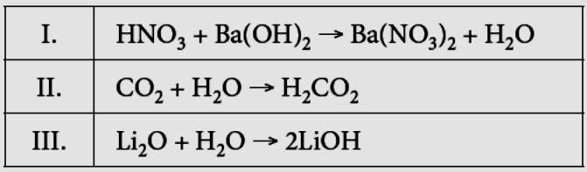
Organic Compounds

- What element must be present for a compound to be considered organic?

- What are three examples of compounds containing carbon that are inorganic?
- The shortened structural formula for pentane, a chemical in gasoline, is CH₃CH₂CH₂CH₂CH₃.
(a) What is pentane’s molecular formula? (b) Draw pentane’s structural formula below.
- Which of the following is not an organic compound?
A. CH₄ B. CO₂ C. C₆H₅COOH D. K₂HC₆H₅O₇
- Which of the following best describes organic compounds?
A. almost all compounds that contain carbon
B. compounds made exclusively by living things
C. compounds made of mostly carbon and oxygen, such as oxides and carbonates
D. any compound that does not include carbon, except compounds such as CO₂, CO, and compounds like Li₂CO₃
- What is a hydrocarbon?
A. another name for the acid H₂CO₃
B. another name for an organic alcohol
C. one of the products of an acid-base neutralization
D. an organic compound that is made of only carbon and hydrogen
- Which of the following is an inorganic compound?
A. C₆H₁₂O₆ B. NO₂ C. CH₃CH₂COOH D. C₄H₁₀
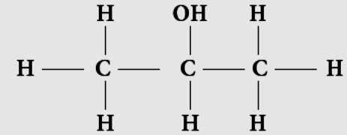
- Consider the following representation of 2-propanol, a kind of rubbing alcohol. What kind of representation is used in the diagram?
A. chemical name B. molecular formula C. structural formula D. space-filling model
- Which of the following is an organic compound?
A. CaH₃ B. H₂CO₃ C. C₃H₈O D. Ca₂CO₃
- CH₃(CH₂)₅CH₃ is an example of what type of compound?
A. an acid B. a salt C. a base D. an organic compound
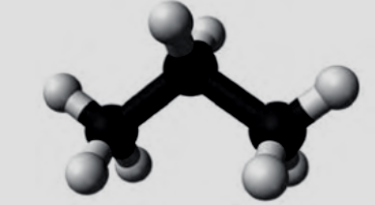
- In the following diagram of propane, light-coloured spheres represent hydrogen atoms and dark-coloured spheres represent carbon atoms. What is the chemical formula of propane?

A. C₈H₃ B. 8C₃H C. C₃H₈ D. 3C₈H
- Ethanol (CH₃CH₂OH) is used in alcoholic beverages and also as a fuel. What kind of compound is ethanol?
A. Inorganic B. organic C. ionic D. Multivalent
- Which of the following is not an inorganic compound?
A. Methane B. carbon dioxide C. barium carbonate D. ammonium chloride

Types of Chemical Reactions

- Complete and balance the following synthesis reactions. Remember to consider the chemical formulas of the products carefully before you begin to balance.
(a) ____ Al + ____ F₂ → (b) ____ K + ____ O₂ → (c) ____ Cd + ____ I₂ →

- Identify whether each of the following chemical equations is a synthesis reaction.
(a) 2Fe + 3CuCl₂ → 2FeCl₃ + 3Cu (b) 2KClO₃ → 2KCl + 3O₂ (c) 2Ni + 3Cl₂ → 2NiCl₃

- Complete and balance the following decomposition reactions. Remember to check for diatomic elements as you write the formulas of the products.
(a) ____ Na₂O → (b) ____ Mg₃N₂ → (c) ____ CsI →

- Identify each reaction as synthesis, decomposition, or neither.
(a) 2AgCl + Cu → CuCl₂ + 2Ag (b) 2Cr + 3F₂ → 2CrF₃ (c) 2NaCl → 2Na + Cl₂

- Complete and balance the following single replacement reactions.
(a) ____ K + ____ NaCl → (b) ____ CuF₂ + ____ Mg → (c) ____ F₂ + ____ CsBr →

- Complete and balance the following double replacement reactions.
(a) ____ Na₃PO₄ + ____ MgI₂ →
(b) ____ SrCl₂ + ____ Pb(NO₃)₂ →
(c) ____ AgNO₃ + ____ Na₂CrO₄ →
- Classify each reaction as synthesis, decomposition, single replacement, or double replacement.
(a) NiBr₂ + ZnSO₄ → ZnBr₂ + NiSO₄ (b) 2Au + Fe₂O₃ → 2Fe + Au₂O₃
(c) 2Pb + O₂ → 2PbO (d) 2TiBr₃ → 2Ti + 3Br₂

- Complete and balance the following neutralization (acid-base) reactions.
(a) ____ HF + ____ NaOH →
(b) ____ HCl + ____ Pb(OH)₂ →
(c) ____ Al(OH)₃ + ____ HClO₄ →
- Complete and balance the following combustion reactions.
(a) ____ CH₄ + ____ O₂ →
(b) ____ C₄H₁₀ + ____ O₂ →
(c) ____ C₄H₈O₄ + ____ O₂ →
- Classify each reaction as synthesis, decomposition, single replacement, double replacement, neutralization, or combustion.
(a) 2KBr → 2K + Br₂ (b) Cu + AgNO₃ → Cu(NO₃)₂ + Ag
(c) 3Ca(NO₃)₂ + 2Na₃PO₄ → 6NaNO₃ + Ca₃(PO₄)₂ (d) 2C₆H₆ + 15O₂ → 12CO₂ + 6H₂O
(e) Ca(OH)₂ + H₂SO₄ → 2H₂O + CaSO₄ (f) 6Mg + P₄ → 2Mg₃P₂
- What type of reaction is the following? 2Al + 3CuCl₂ → 2AlCl₃ + 3Cu
A. Synthesis B. neutralization C. single replacement D. double replacement

- Which equation shows a double replacement reaction?
A. 2Mg + O₂ → MgO B. 2H₂O₂ → 2H₂O + O₂
C. CH₄ + 2 O₂ → CO₂ + 2H₂O D. Na₂CO₃ + CaCl₂ → CaCO₃ + 2NaCl
- KCl reacts with Pb(NO₃)₂. What type of reaction is this?
A. Combustion B. neutralization C. single replacement D. double replacement
- Solid magnesium reacts with nitric acid to produce hydrogen gas and another product. What is the other product that would be formed in this reaction?
Mg + 2HNO₃ → ___ + H₂
A. Mg(NO₃)₂ B. Mg₃N₂ C. MgO D. O₂
- Which of the following balanced equations represents a synthesis reaction?
A. 2LiF → 2Li + F₂ B. Ca + Br₂ → CaBr₂
C. Ba + CuSO₄ → BaSO₄ + Cu D. KOH + HNO₃ → KNO₃ + H₂O
- For a neutralization reaction to occur, which of the following should be added to react with NaOH? NaOH + ___
A. F₂ B. Ca C. HCl D. Mg(NO₃)₂
- What is the missing reactant in this synthesis reaction, and what are the coefficients needed to balance this equation? Na + ___ → NaF
A. Na + F → NaF B. Na + F₂ → NaF₂ C. Na + F₂ → 2NaF D. 2Na + F₂ → 2NaF

- If Na₂O undergoes decomposition, what will the products be?
A. Na + O B. Na + O₂ C. Na₂ + O D. Na₂ + O₂
- If aluminum bromide decomposes, which of the following is the correct balanced formula equation for the reaction?
A. AlBr₃ → Al + Br B. AlBr₃ → Al + 3Br₂
C. 2AlBr₃ → 2Al + Br₂ D. 2AlBr₃ → 2Al + 3Br₂

- Which of the following balanced equations correctly represents the combustion of butene, C₄H₈?
A. C₄H₈ + 6O₂ → 4CO₂ + 4H₂O B. C₄H₈ + O₂ → 8CO₂ + 8H₂O
C. C₄H₈ + O₂ → 4CO₂ + H₂O D. C₄H₈ + O₂ → CO₂ + H₂O

Factors Affecting the Rate of Chemical Reactions

- What happens to the rate of a chemical reaction when the temperature is raised?
- What does cooling do to the frequency at which particles of reactants can collide?
- How does increasing the concentration of an acid result in an increase in reaction rate between the acid and a piece of aluminum metal placed in it?
- Why does blowing on a campfire speed the burning process?
- How does increasing the surface area of a reactant increase reaction rate?
- Why does cutting wood into tiny pieces for a campfire speed the burning process?
- What happens to the rate of a reaction when a catalyst is added?
- What is the purpose of a catalytic converter in a car?
- What is an enzyme?
- When zinc metal is added to hydrochloric acid, it reacts to produce hydrogen gas. Which of the following pairs would react at the greatest rate?
A. a chunk of zinc and dilute HCl B. a chunk of zinc and concentrated HCl
C. powdered zinc and dilute HCl D. powdered zinc and concentrated HCl
- Cement is used in many construction projects. When used in building projects, water is sprayed on the surface of the drying cement. This allows cement to dry evenly both on the surface and in the middle. A strange fact about cement is that, as cement “cures” (what we think of as drying), it undergoes an exothermic reaction. In other words, cement is actually giving off heat energy as it dries, which can speed up drying even more. Which factor affecting the rate of chemical reactions is involved when builders spray water onto drying cement?
A. addition of a catalyst B. change in temperature
C. change in surface area D. change in concentration
- Which of the following is an example of decreasing reaction rate?
A. scrambling an egg
B. adding food colouring
C. putting food in a refrigerator
D. cleaning a clogged drain with concentrated vinegar and baking soda

- In order to start a campfire, wood is chopped into many small pieces, called kindling. Which factor makes it easier to light a fire using kindling instead of large pieces of wood?
A. Temperature B. concentration C. surface area D. Catalyst
- If you have had your gall bladder removed, you may have trouble digesting fats. It is possible in some cases to take an enzyme called lipase, which helps to digest fats. With respect to rates of reactions, which factor is best illustrated by taking lipase?
A. introducing a catalyst B. increasing temperature
C. increasing surface area D. increasing concentration
- Food is digested in your body with the aid of a number of factors that affect the reaction rates. Which of the following affects the rate of food digestion by changing surface area?
A. chewing food B. a body temperature of 37°C
C. enzymes such as lipase and sucrose D. the concentration of HCl in the stomach
- Thinking of factors that affect reaction rate, what first aid treatment should you use when you burn your hand on a hot stove or with hot water?
A. Do nothing, as you have already stopped touching the hot object.
B. Cover the burn with moisturizing cream.
C. Cover your burn in butter or margarine.
D. Run your hand under cold water.
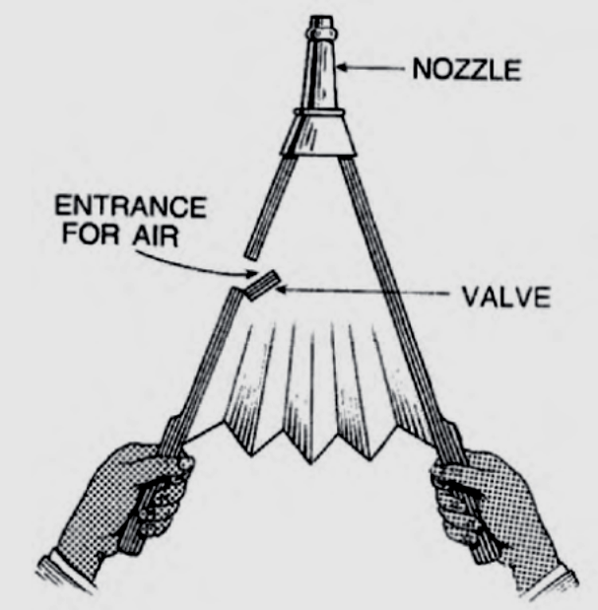
- Blacksmithing is considered to be a fading art. Blacksmiths use heated coal and other materials to work with molten metal to turn the metal into everything from horseshoes to swords and ploughs. Blacksmiths use a tool called a bellows to make the fire hotter. This tool is also often used in homes with fireplaces. Thinking of factors that affect reaction rate, how do you think the use of bellows affects the temperature of the fire?
A. adds a catalyst
B. removes carbon dioxide
C. increases the surface area of the fire
D. increases the concentration of oxygen
- Why does putting food in a refrigerator slow the spoilage of the food?
A. The decreased temperature speeds up the molecules, making the reactions slower.
B. The decreased temperature slows down the molecules making the reactions faster.
C. The decreased temperature slows down the molecules making the reactions slower.
D. Keeping the food in the refrigerator decreases the concentration of oxygen.
- Which of the following is not a factor that affects the rate of reaction?
A. changing the temperature
B. changing the colour of the reactants
C. changing the surface area of the reactants
D. changing the concentration of the reactants

Atomic Theory Isotopes and Radioactive Decay

- Complete the following table on a separate sheet of paper.
Isotope | Mass Number | Atomic Number (number of protons) | Number of Neutrons
Nitrogen-15
Sulphur-30
Neon-22
 |  | 12 | 13
 |  | 4 | 3
 |  | 6 | 6
 | 22 |  | 12
 | 19 |  | 10
- An element is analyzed and found to have a mass number of 37. It contains 20 neutrons in its nucleus. State:
(a) the number of protons (b) the name of the isotope (c) the standard atomic symbol

- For an isotope containing 11 protons and 10 neutrons, state:
(a) the atomic number (b) the mass number
(c) the name of the isotope (d) the standard atomic symbol

- What is radioactive decay?
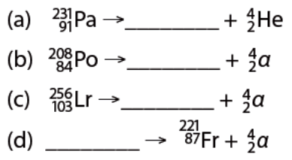
- Identify the missing particle in each of these alpha decay equations.

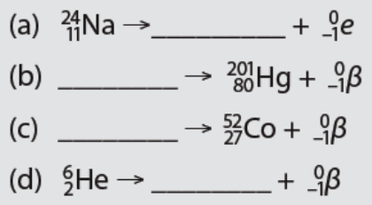
- Identify the missing particle in each of these beta decay equations.

- What is the symbol for a gamma ray in an equation?

- Explain the changes that occur in the nucleus during each of the following.
(a) alpha decay (b) beta decay (c) gamma decay

- Classify each of the following as alpha, beta, or gamma decay.
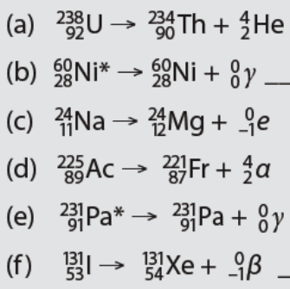

- Which of the following shows alpha radioactive decay?

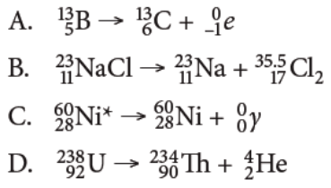
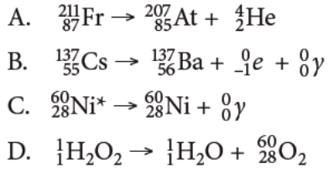
- Which of the following shows beta radioactive decay?

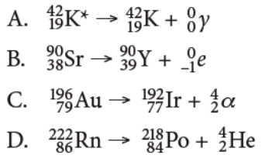
- Which of the following is an example of gamma radioactive decay?

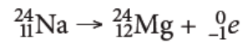
- What type of decay occurs in the following reaction?
A. Alpha B. beta C. gamma D. Decomposition
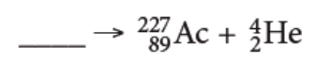
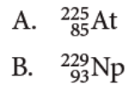
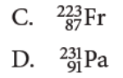
- Which is the correct parent nucleus to give the following products?
- How does each of the isotopes of an atom differ?
A. in the number of protons B. in the number of electrons
C. in the number of neutrons D. in the number of protons, electrons, and neutrons
- How many protons and neutrons are in the following isotope?
A. 17 protons, 17 neutrons B. 17 protons, 20 neutrons
C. 17 protons, 37 neutrons D. 37 protons, 17 neutrons
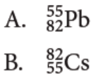
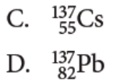
- If an isotope has 55 protons and 82 neutrons, which of the following correctly represents the isotope?

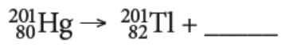
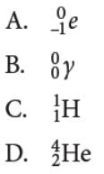
- Which of the following correctly completes the following radioactive decay?

- Which of the following correctly completes the following radioactive decay?
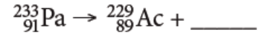

Half-Life

Use this information to answer questions 3 and 4:
Suppose a 64 gram sample of a certain isotope has a half-life of 1000 years.

- What is a half-life?

- How does radioactivity provide a method for determining the age of objects?

- State what length of time has gone by after:
(a) two half-lives (b) four half-lives

- How many grams of the isotope are left after:
(a) 1000 years (b) 2000 years (c) three half-lives

Use the following decay curve for isotope X to answer questions 5 – 9.
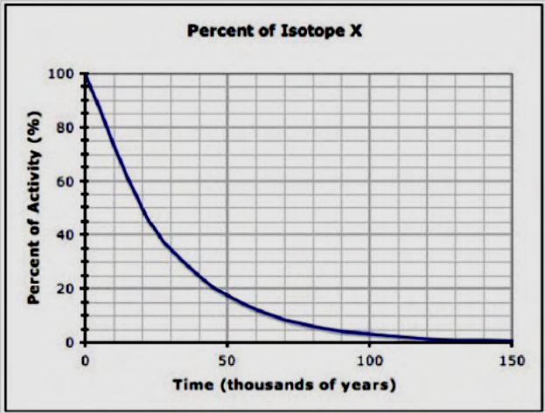

- Estimate the half-life of isotope X.

- What percentage of the original isotope remains after 50 000 years?

- How many years does it take for the isotope to be reduced to about 10 percent of its original quantity?

- How many half-lives have gone by after 60 000 years?

- What is the age of volcanic rock containing element X after two half-lives?

- Uranium-235 is a radioisotope. What is the daughter in the isotope pair in which uranium is the parent?

- What is the half-life of thorium-245?

- Which radioisotope decays faster, uranium-238 or rubidium-87?

- When a sample of volcanic rock is formed it contains potassium-40 but no argon-40. When the rock is analyzed later, it contains equal amounts of potassium-40 and argon-40. How old is the rock?

- What is a half-life?

A. the time required for nuclei to undergo nuclear fusion
B. the time required for nuclei to undergo nuclear fission
C. the time required for half the nuclei in a sample to decay
D. the time it takes for an isotope to react with any other substance to produce a new compound
- The carbon-14 isotope has a half-life of 5730 y. What percent of carbon-14 isotope will be present after 17 190 y?
A. 12.5 percent B. 25 percent C. 50 percent D. 100 percent
- A 10 g sample of potassium-40 undergoes radioactive decay until 2.5 g of potassium-40 is present. How many half-lives have occurred?
A. 0 B. 1 C. 2 D. 3
- Suppose a meteorite is analyzed and found to contain equal amounts of uranium-238 and lead-206. How long ago did the meteorite form?
A. 710 million years B. 1420 million years C. 4.5 billion years D. 9 billion years
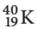
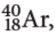
- What is carbon dating?
A. the exact age of a sample of carbon
B. the process of determining the time required to complete the carbon cycle
C. the process of determining the age of an object by measuring the amount of carbon-14 remaining in that object
D. the process of looking for fossils from specific time periods and determining the age of the carbon sample relative to the fossil
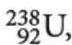
- If a 10 g rock sample of isotope undergoes two half-lives to make daughter isotope
what is the mass of the total sample at the completion of the second half-life?
A. 10 g B. 5.0 g C. 2.5 g D. 1.25 g
- If you start with 100 g of isotope what mass of this parent material will be left after four half-lives?
A. 50 g B. 25 g C. 12.5 g D. 6.25 g
- After three half-lives have passed for carbon-14, a 4.0 g sample remains of the parent isotope. What mass of the parent isotope was originally present?
A. 0.5 g B. 8.0 g C. 16 g D. 32 g

Use the following decay curve to answer question 22.
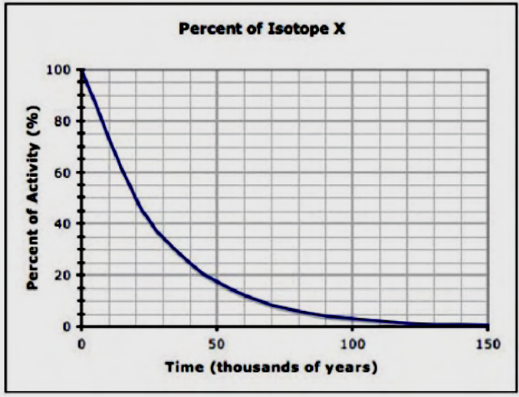

- Scientists have discovered a new isotope (X). Using the data they collected, a graph was produced to show the percentage of the isotope remaining over time. Using this information, what is the half-life of this isotope?
A. 10 000 y B. 20 000 y C. 50 000 y D. 100 000 y

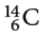
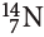
- A 10 g sample of isotope decays for 17 190 years. Use the Common Isotope Pairs chart on page 4 of your Data Pages to find the half life of this radioactive sample. Determine the total mass of daughter isotope that would be produced.
A. 8.75 g B. 7.5 g C. 2.5 g D. 1.25 g

Nuclear Decay

- What is a fission nuclear reaction?
- What two quantities do not change during a nuclear reaction?
- Find the indicated daughter nucleus.
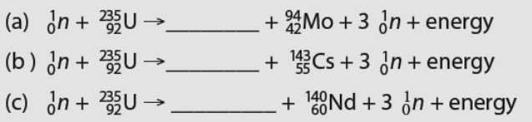

- What happens in a nuclear chain reaction?
- Why are hazardous wastes from nuclear reactors an ongoing issue in society?
- What is nuclear fusion?
- Where does most nuclear fusion occur in our solar system?
- What is nuclear fission?
A. the process in which two low mass nuclei join together to make a more massive nucleus
B. the process of cell division that results in two new cells that are identical to their parent cell
C. the splitting of a massive nucleus into two less massive nuclei, subatomic particles, and energy
D. the process in which a parent cell splits into two daughter cells of approximately equal size, often occurring in single celled organisms.
- What is nuclear fusion?
A. the process in which two low mass nuclei join together to make a more massive nucleus
B. the process of cell division that results in two new cells that are identical to their parent cell
C. the splitting of a massive nucleus into two less massive nuclei, subatomic particles, and energy
D. the process in which a parent cell splits into two daughter cells of approximately
equal size, often occurring in single celled organisms
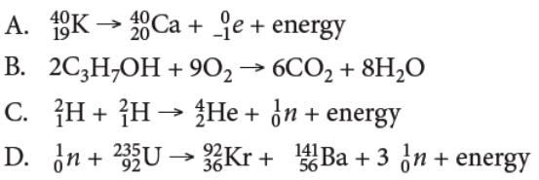
- Which equation represents nuclear fission?

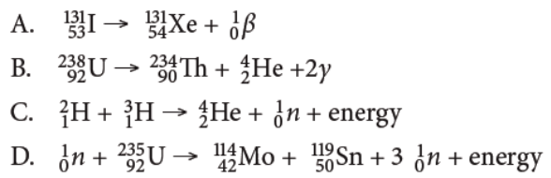
- Which equation represents nuclear fusion?

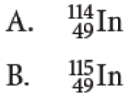
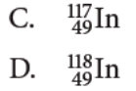
- What is the daughter nucleus to complete the following nuclear fission reaction?

- Which of the following is used to control the rate of the chain reaction that occurs in a nuclear reactor?
A. Add uranium-235 to the reactor.
B. Use fossil fuels (like gas or coal).
C. Insert cadmium rods into the nuclear reactor.
D. Remove cadmium rods from the nuclear reactor.
- Which statement about nuclear fusion is not true?
A. Two lightweight nuclei join together to form a heavier nucleus.
B. A typical reaction showing nuclear fusion is:
C. Lightweight nuclei will not release excess energy if the nucleus generated by fusion is heavier than iron.
D. There are many commercial fusion reactors in the world. Canada has a series of them called CANDU reactors.

- Which of the following statements applies to nuclear fission?
A. Nuclear fission produces clean energy with very little waste.
B. Unstable nuclei release a huge amount of energy when they split.
C. Heavy, unstable nuclei join together into one new, larger nucleus.
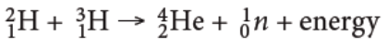
D. A typical reaction for nuclear fission is:

- Which of the following statements applies to nuclear fusion?
A. All fusion reactions release massive amounts of energy.
B. Unstable nuclei release a huge amount of energy when they split.
C. A typical reaction for nuclear fusion is:
D. A fusion reaction is used in modern nuclear weapons to generate most of the energy released in the blast.

