BIOME BASICS – Know your Biosphere Name: __________________
BIOME | LOCATION | CLIMATE | PHYSICAL FEATURES | CLIMATOGRAPH | UNIQUE QUALITIES/  ADAPTATIONS
TUNDRA | Upper northern hemisphere, just below the ice-covered polar seas  60º to 70⁰ north latitude | Precipitation is less than 25 cm annually.  Annual summer average temperatures range from 3oC to 12oC.  Winter temperatures range from -20ºC to -30ºC. | Permanent frost (permafrost)  Poor drainage leads to pools and marshes  Brief periods of 24 hr sunlight during the summer | 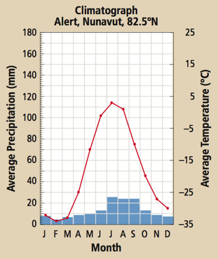 | No trees grow due to short growing season  Animals have compact bodies  Animals grow more slowly and reproduce less frequently  Animals migrate to find food
BOREAL FOREST |  |  |  | 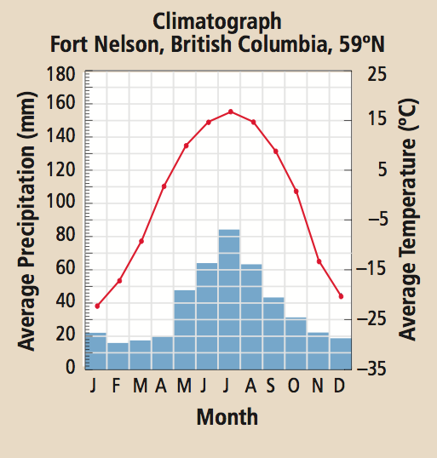
TEMPERATE DECIDUOUS FOREST |  |  |  | 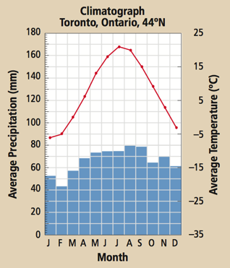
GRASSLAND  (Temperate and Tropical) |  |  |  | 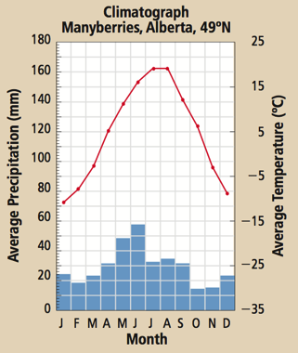

BIOME | LOCATION | CLIMATE | PHYSICAL FEATURES | CLIMATOGRAPH | UNIQUE QUALITIES/  ADAPTATIONS
POLAR ICE  (Permanent Ice) |  |  |  | 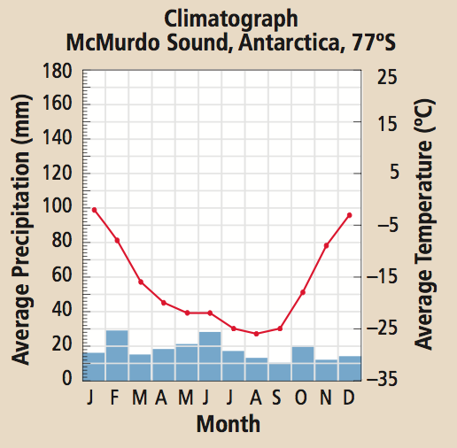
DESERT  (Hot and Cold) |  |  |  | 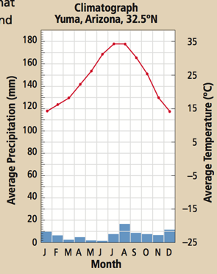
TROPICAL RAINFOREST |  |  |  | 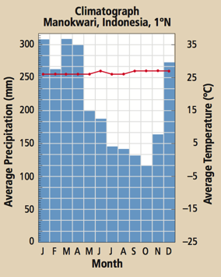
TEMPERATE RAINFOREST |  |  |  | 