Graphing exploration

http://phet.colorado.edu/en/simulation/graphing-lines#related-simulations

Being able to graph motion is an effective way to describe the motion of an object. Slope is a key component to telling what the object is doing.

Learning Goals

Explain how the slope of a graphed line can be calculated

Predict how changing variables in a linear equation will affect the graphed line.

Instructions:
- Click on the link above or cut and paste it into your web browser

.
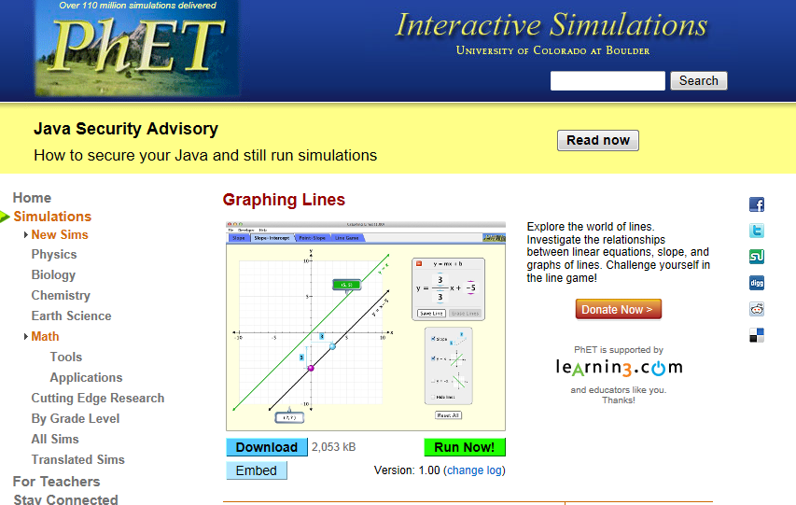

- Click on the green button that says “run now”

You might need to update to Java 7 at this point…. iPads, you may not be able to complete the activity on your device. Please partner up with somebody who can run the Java.

- Make sure that you are on the “SLOPE” tab on the top left of the page.
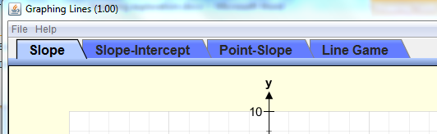

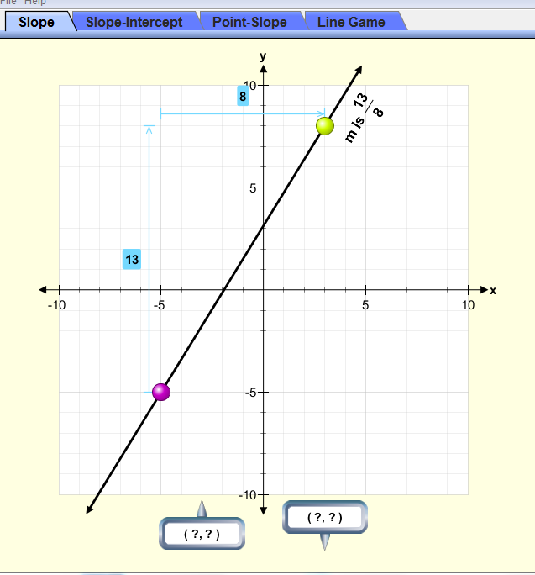
- using you curser, drag the yellow and/or the purple co-ordinate to change the change the steepness of the slope.

- Drag the yellow dot to the co-ordinate (8, 5).

Which of these numbers is the x value?

Which of these numbers is the y value?

- Drag the purple dot to the co-ordinate (-1, -6)

Which of these numbers is the x value?

Which of these numbers is the y value?

- The letter m is designated to represent the slope. According to the simulation, what is the slope of a line that has data points at (8,5) and (-1, -6)?

- Show how this number was calculated:

- What is the slope formula in words and in variables (letters)?

- How many data points do you need on the line to calculate the slope?

- Using words, describe the slope of the line that has data points at (8,5) and (-1, -6)?

- Create a line with a slope of ½ .

What are your co-ordinates?

*Take a screen capture and paste it here:

*one way to take a snapshot of your screen is to go to All Programs Accessories Snipping Tool. Drag the cursor over the area you want to copy. Go to Edit Copy to copy you picture and paste it in the appropriate document.

- Create a line with a slope of 2.

What are your co-ordinates?

*Take a screen capture and paste it here:

- Let’s say that “x” represents time and “y” represents distance.

Create a line that is at (2, 6) and (-1, -6). Copy an image and paste it here.

Describe the line in terms of time and distance.

- What is the slope of the line that has points (2, 6) and (-1, -6)? Show the calculation.

- If “x” is time and “y” is distance, what could the slope be? (HINT: look at the units)

- Using your answer to #16 – describe how a slope of ½ and a slope of 2 would be different would be different from the slope found in #15. Describe your answer in terms of motion of car (of some other object).

- It’s time to play the Line Game! Click on the tab. This is just for fun. Use what you’ve learned in your math classes about the equation of a line to help you. Record your score below. Good luck!

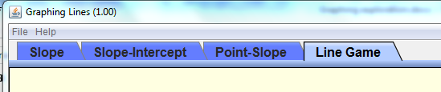

Your top level:____________

Your top score: ___________

