**AP Physics 1 – FR Review Package**

**Kinematics**

**1982B1**The first meters of a 100‑meter dash are covered in 2 seconds by a sprinter who starts from rest and accelerates with a constant acceleration. The remaining 90 meters are run with the same velocity the sprinter had after 2 seconds.

a. Determine the sprinter's constant acceleration during the first 2 seconds.

b. Determine the sprinters velocity after 2 seconds have elapsed.

c. Determine the total time needed to run the full 100 meters.

d. On the axes provided below, draw the displacement vs time curve for the sprinter.

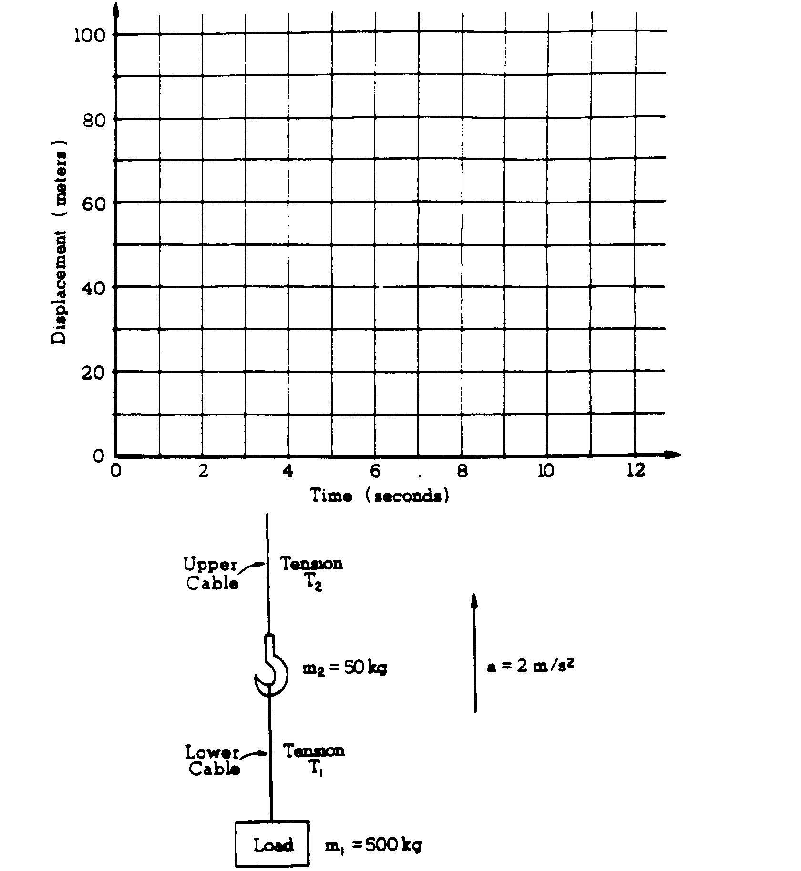



**1993B1** A student stands in an elevator and records his acceleration as a function of time. The data are shown in the graph above. At time t = 0, the elevator is at displacement x = 0 with velocity v = 0. Assume that the positive directions for displacement, velocity, and acceleration are upward.

a. Determine the velocity v of the elevator at the end of each 5‑second interval.

i. Indicate your results by completing the following table.

Time Interval (s) 0–5 5–10 10–15 15–20

v (m/s) _____ _____ _____ _____

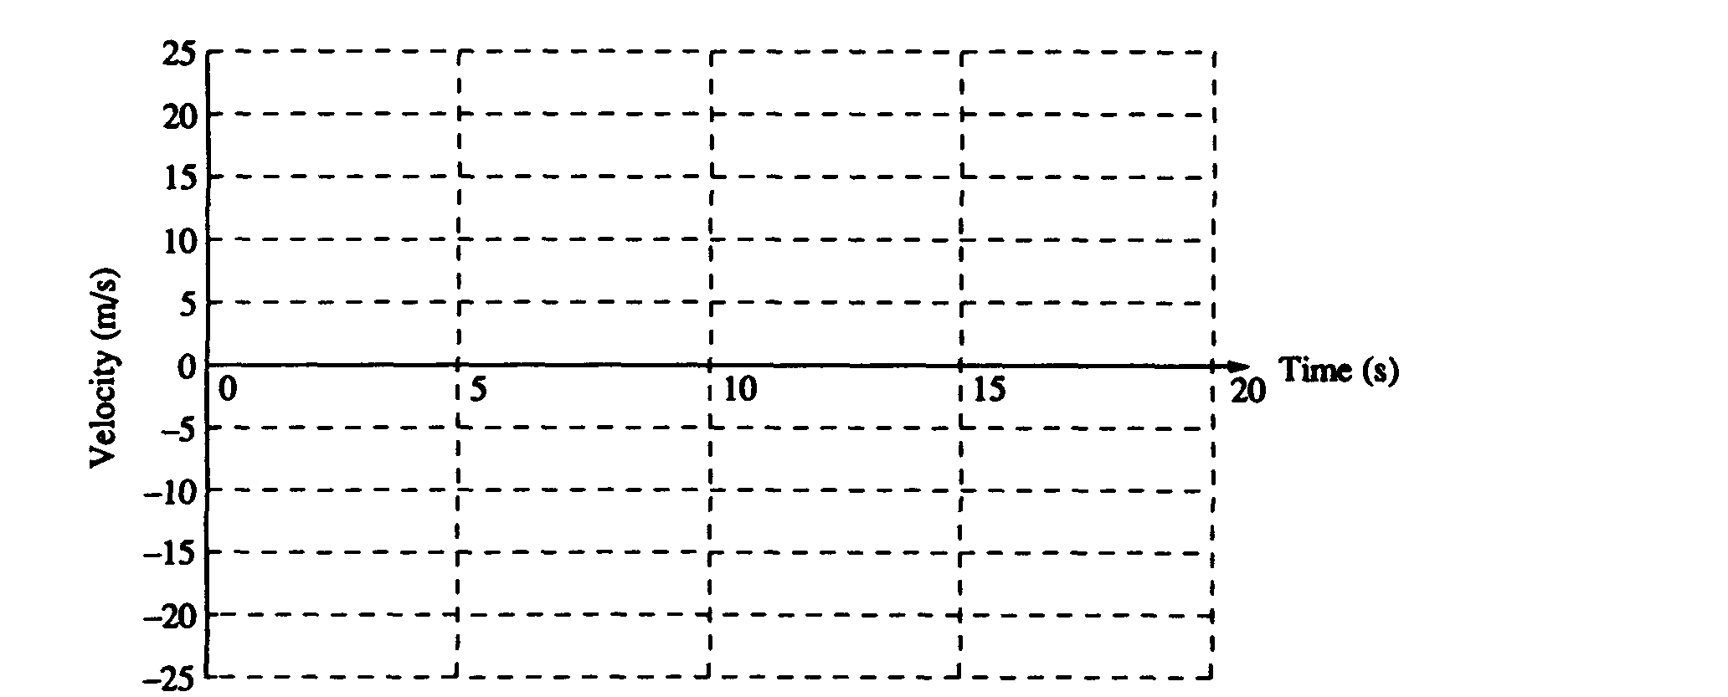

ii. Plot the velocity as a function of time on the following graph.

b. Determine the displacement x of the elevator above the starting point at the end of each 5‑second interval.

i. Indicate your results by completing the following table.

Time Interval (s) 0–5 5–10 10–15 15–20

x (m) _____ _____ _____ _____

ii. Plot the displacement as a function of time on the following graph.

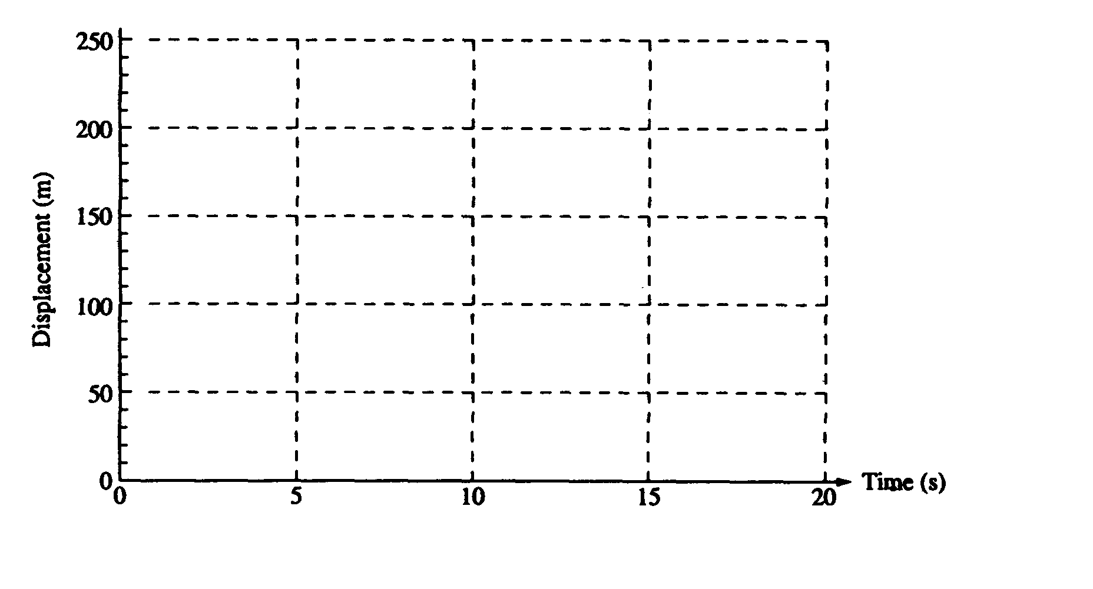

**Dynamics**

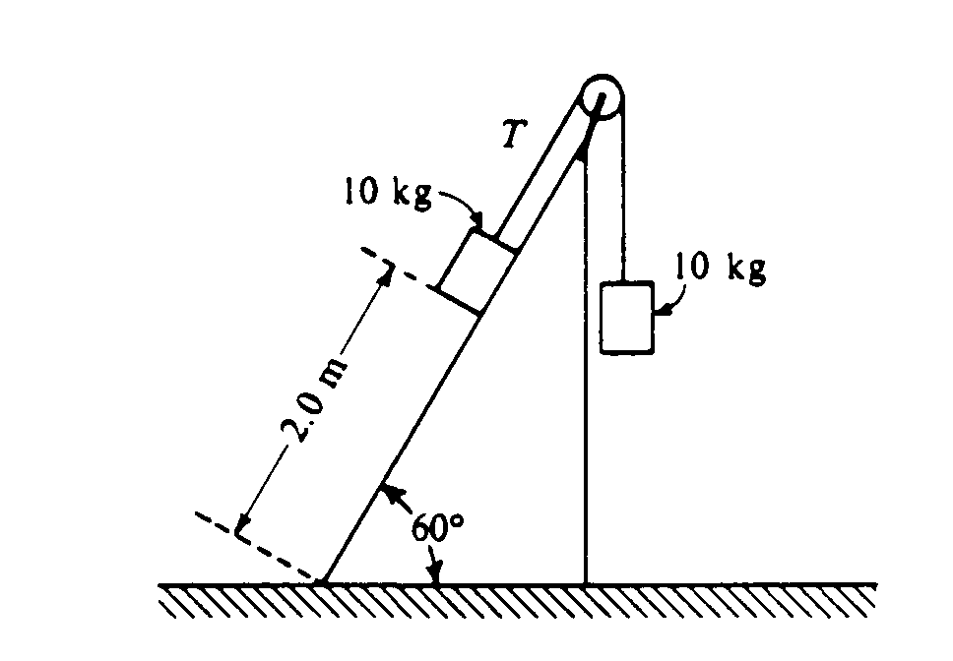

**1985B2** Two 10‑kilogram boxes are connected by a massless string that passes over a massless frictionless pulley as shown above. The boxes remain at rest, with the one on the right hanging vertically and the one on the left 2.0 meters from the bottom of an inclined plane that makes an angle of 60° with the horizontal. The coefficients of kinetic friction and static friction between the left‑hand box and the plane are 0.15 and 0.30, respectively. You may use g = 10 m/s2, sin 60° = 0.87, and cos 60° = 0.50.

a. What is the tension T in the string?

b. On the diagram below, draw and label all the forces acting on the box that is on the plane.

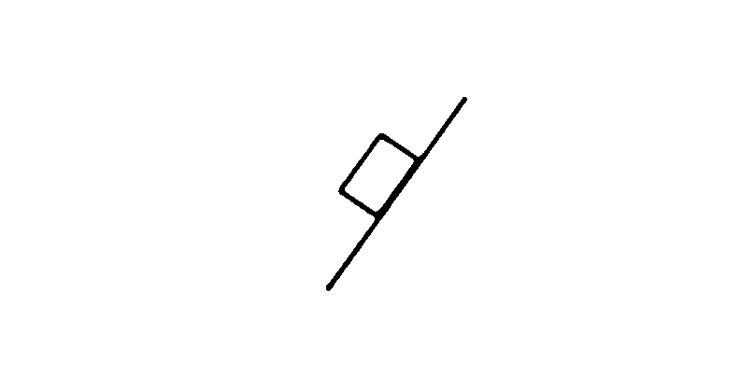

c. Determine the magnitude of the frictional force acting on the box on the plane.

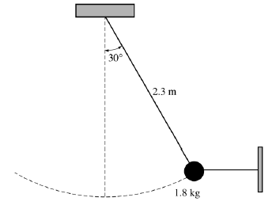

**2005B2**. A simple pendulum consists of a bob of mass 1.8 kg attached to a string of length 2.3 m. The pendulum is held at an angle of 30° from the vertical by a light horizontal string attached to a wall, as shown above.

(a) On the figure below, draw a free-body diagram showing and labeling the forces on the bob in the position shown above.

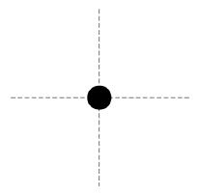

(b) Calculate the tension in the horizontal string.

**Gravitation and Circular Motion**

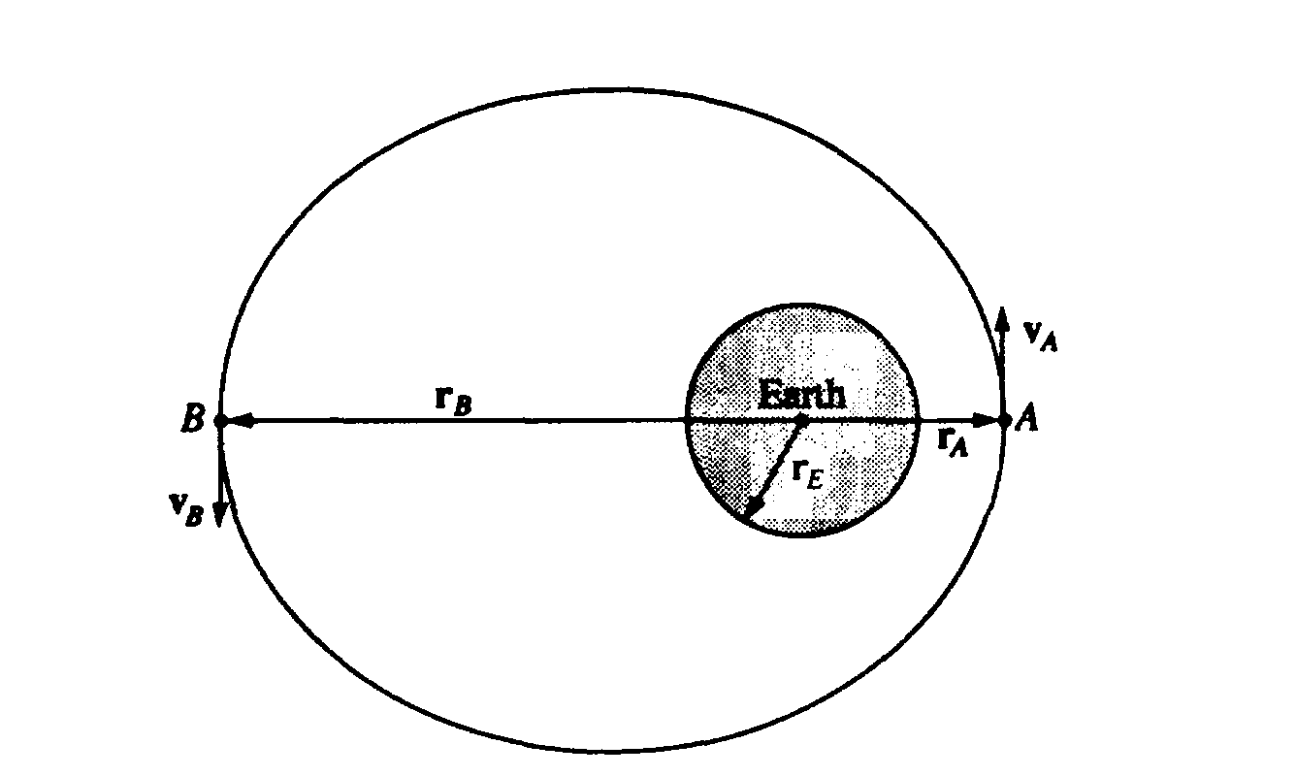

**1992M3** A spacecraft of mass 1,000 kilograms is in an elliptical orbit about the Earth, as shown above. At point A the spacecraft is at a distance rA = 1.2 × 107 meters from the center of the Earth and its velocity, of magnitude vA = 7.1 × 103 meters per second, is perpendicular to the line connecting the center of the Earth to the spacecraft. The mass and radius of the Earth are ME = 6.0 × 1024 kilograms and rE =6.4 × 106 meters, respectively.

Determine each of the following for the spacecraft when it is at point A .

a. The total mechanical energy of the spacecraft, assuming that the gravitational potential energy is zero at an infinite distance from the Earth.

b. The magnitude of the angular momentum of the spacecraft about the center of the Earth.

Later the spacecraft is at point B on the exact opposite side of the orbit at a distance rB =3.6 × 107 meters from the center of the Earth.

c. Determine the speed vB of the spacecraft at point B.

Suppose that a different spacecraft is at point A, a distance rA =1.2 × 107 meters from the center of the Earth. Determine each of the following.

d. The speed of the spacecraft if it is in a circular orbit around the Earth

e. The minimum speed of the spacecraft at point A if it is to escape completely from the Earth

**2001M2** An explorer plans a mission to place a satellite into a circular orbit around the planet Jupiter, which has mass *MJ* = 1.90 × 1027 kg and radius *RJ* = 7.14 × 107 m.

a. If the radius of the planned orbit is *R,* use Newton's laws to show each of the following.

i. The orbital speed of the planned satellite is given by



ii. The period of the orbit is given by



b. The explorer wants the satellite's orbit to be synchronized with Jupiter's rotation. This requires an equatorial orbit whose period equals Jupiter's rotation period of 9 hr 51 min = 3.55 × 104 s. Determine the required orbital radius in meters.

c. Suppose that the injection of the satellite into orbit is less than perfect. For an injection velocity that differs from the desired value in each of the following ways, sketch the resulting orbit on the figure. (J is the center of Jupiter, the dashed circle is the desired orbit, and P is the injection point.) Also, describe the resulting orbit qualitatively but specifically.

i. When the satellite is at the desired altitude over the equator, its velocity vector has the correct direction, but the speed is slightly faster than the correct speed for a circular orbit of that radius.



**Work, Energy, Power and Linear Momentum**

**1974B7** A ski lift carries skiers along a 600 meter slope inclined at 30°. To lift a single rider, it is necessary to move 70 kg of mass to the top of the lift. Under maximum load conditions, six riders per minute arrive at the top. If 60 percent of the energy supplied by the motor goes to overcoming friction, what average power must the motor supply?





**1985B2** Two 10‑kilogram boxes are connected by a massless string that passes over a massless frictionless pulley as shown above. The boxes remain at rest, with the one on the right hanging vertically and the one on the left 2.0 meters from the bottom of an inclined plane that makes an angle of 60° with the horizontal. The coefficients of kinetic friction and static friction between the left‑hand box and the plane are 0.15 and 0.30, respectively. You may use g = 10 m/s2, sin 60° = 0.87, and cos 60° = 0.50.

a. What is the tension T in the string?

b. On the diagram below, draw and label all the forces acting on the box that is on the plane.



c. Determine the magnitude of the frictional force acting on the box on the plane.

The string is then cut and the left‑hand box slides down the inclined plane.

d. Determine the amount of mechanical energy that is converted into thermal energy during the slide to the bottom.

e. Determine the kinetic energy of the left‑hand box when it reaches the bottom of the plane.

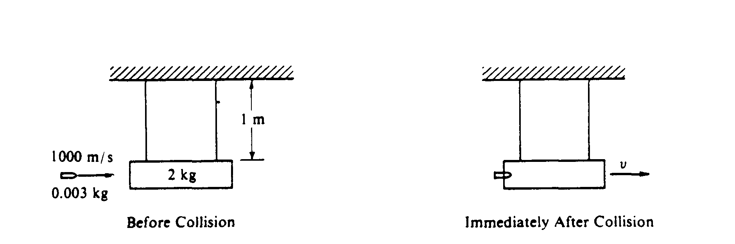

**1985B1** A 2‑kilogram block initially hangs at rest at the end of two 1‑meter strings of negligible mass as shown on the left diagram above. A 0.003‑kilogram bullet, moving horizontally with a speed of 1000 meters per second, strikes the block and becomes embedded in it. After the collision, the bullet/ block combination swings upward, but does not rotate.

a. Calculate the speed v of the bullet/ block combination just after the collision.

b. Calculate the ratio of the initial kinetic energy of the bullet to the kinetic energy of the bullet/ block combination immediately after the collision.

c. Calculate the maximum vertical height above the initial rest position reached by the bullet/block combination.

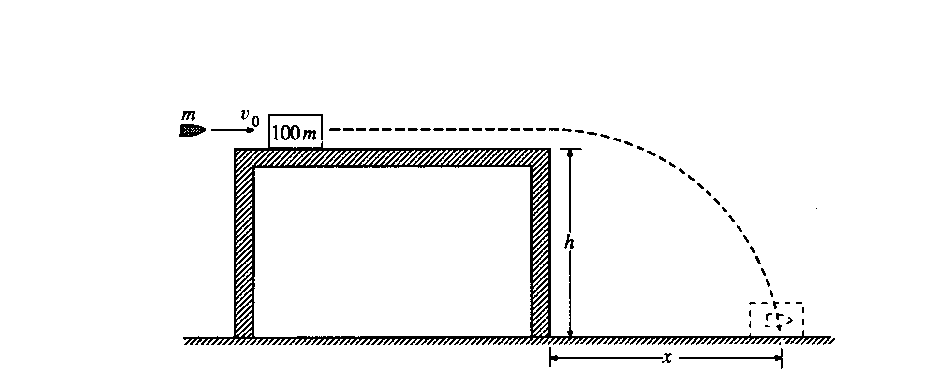

**1990B1.** A bullet of mass m is moving horizontally with speed vo when it hits a block of mass 100m that is at rest on a horizontal frictionless table, as shown above. The surface of the table is a height h above the floor. After the impact, the bullet and the block slide off the table and hit the floor a distance x from the edge of the table. Derive expressions for the following quantities in terms of m, h, vo, and appropriate constants:

a. the speed of the block as it leaves the table

b. the change in kinetic energy of the bullet‑block system during impact

c. the distance x

Suppose that the bullet passes through the block instead of remaining in it.

d. State whether the time required for the block to reach the floor from the edge of the table would now be greater, less, or the same. Justify your answer.

e. State whether the distance x for the block would now be greater, less, or the same. Justify your answer.

**Torque and Rotational Motion**

**C2008M2**



The horizontal uniform rod shown above has length 0.60 m and mass 2.0 kg. The left end of the rod is attached to a vertical support by a frictionless hinge that allows the rod to swing up or down. The right end of the rod is supported by a cord that makes an angle of 30° with the rod. A spring scale of negligible mass measures the tension in the cord. A 0.50 kg block is also attached to the right end of the rod.

(a) On the diagram below, draw and label vectors to represent all the forces acting on the rod. Show each force

vector originating at its point of application.



(b) Calculate the reading on the spring scale.

(c) Calculate the magnitude of the force exerted by the hinge on the rod

**1982B2**

The diagram below shows a beam of length 20.0 m and mass 40.0 kg resting on two supports placed at 5.0 m from each end.

5.0 m

N1

N2

20.0 m

5.0 m

X

A person of mass 50.0 kg stands on the beam between the supports. The reaction forces at the supports are shown.

(a) State the value of N1 + N2

(b) The person now moves toward the X end of the beam to the position where the beam just begins to tip and reaction force N1 becomes zero as the beam starts to leave the left support. Determine the distance of the girl from the end X when the beam is about to tip.

**Simple Harmonic Motion, Waves, and Sound**

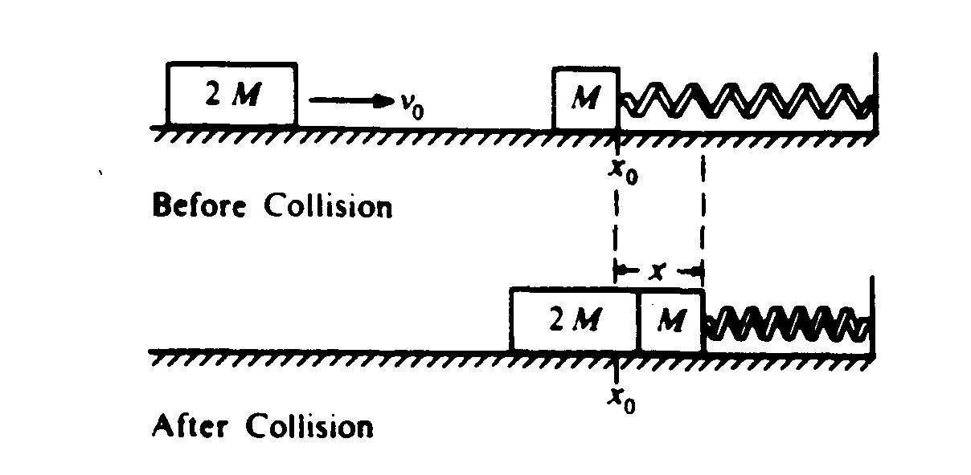

**1983B2** A block of mass M is resting on a horizontal, frictionless table and is attached as shown above to a relaxed spring of spring constant k. A second block of mass 2M and initial speed vo collides with and sticks to the first block Develop expressions for the following quantities in terms of M, k, and vo

a. v, the speed of the blocks immediately after impact

b. x, the maximum distance the spring is compressed

c. T, the period of the subsequent simple harmonic motion



**1998B5** To demonstrate standing waves, one end of a string is attached to a tuning fork with frequency 120 Hz. The other end of the string passes over a pulley and is connected to a suspended mass M as shown in the figure above. The value of M is such that the standing wave pattern has four "loops." The length of the string from the tuning fork to the point where the string touches the top of the pulley is 1.20 m. The linear density of the string is 1.0 x 10–4 kg/m, and remains constant throughout the experiment.

a. Determine the wavelength of the standing wave.

b. Determine the speed of transverse waves along the string.

c. The speed of waves along the string increases with increasing tension in the string. Indicate whether the value of M should be increased or decreased in order to double the number of loops in the standing wave pattern. Justify your answer.

d. If a point on the string at an antinode moves a total vertical distance of 4 cm during one complete cycle, what is the amplitude of the standing wave?

D

1980B2. The electrical device whose symbol is shown above requires a terminal voltage of 12 volts and a current of 2 amperes for proper operation.

**a.** Using only this device and one or more 3‑ohm resistors design a circuit so that the device will operate properly when the circuit is connected across a battery of emf 24 volts and negligible internal resistance. Within the dashed‑line box in the diagram below, draw the circuit using the symbol for the device and the appropriate symbol for each 3‑ohm resistor.

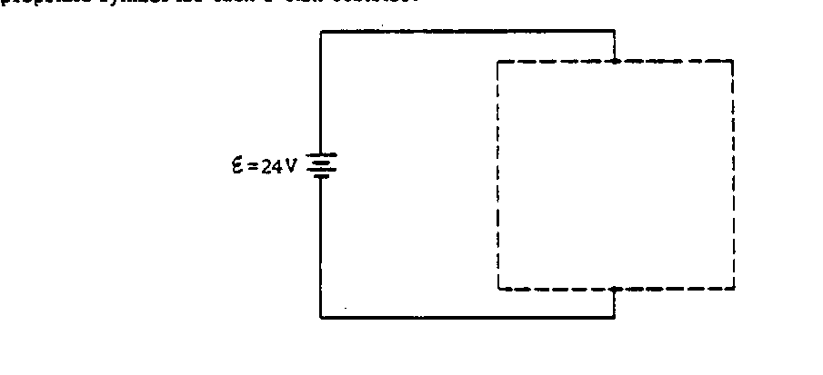

b. Using only this device and one or more 3‑ohm resistors, design a circuit so that the device will operate properly when connected to a source that supplies a fixed current of 6 amperes. Within the dashed‑line box in the diagram below, draw the circuit using the symbol for the device and the appropriate symbol.

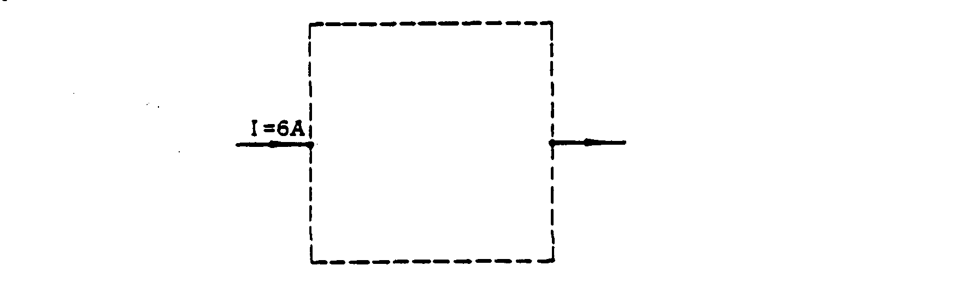

c. Calculate the power dissipation In each 3‑ohm resistor used in the circuit in part b..

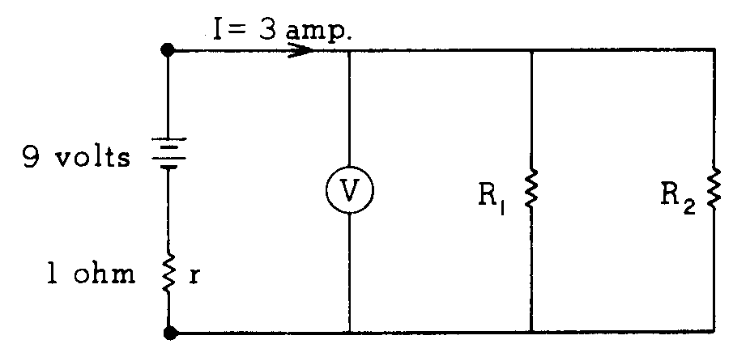

**1976B3** In the circuit shown above, the current delivered by the 9-volt battery of internal resistance 1 ohm is 3 amperes. The power dissipated in R2 is 12 watts.

a. Determine the reading of voltmeter V in the diagram.

b. Determine the resistance of R2.

c. Determine the resistance of R1.