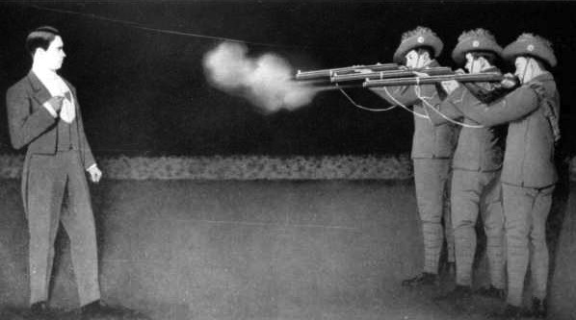
To Catch a Bullet
S. Kent, O. Brennan, A.B.S. Stirton, E.C.A. Golightly

Abstract
Catching a bullet has been the focus of much debate and fascination for decades. It is featured in various science fiction stories, and has even been adopted by various magicians over the years to entertain. However, no one has ever successfully managed to catch a bullet. How much faster and stronger would a person have to be to catch a bullet?

Let’s examine a scenario where the shooter was standing 15 feet (4.572m) away from the catcher, firing a 9x19mm round from a Glock 17. Assume the catcher has the fastest reaction time of any living human and catches the bullet between their thumb and forefinger, otherwise known as a pinch grip.

- If the muzzle speed of the gun is 360 m/s how long would it take to reach the catcher? | - The fastest known human reaction time is 100 ms. How many times faster would the catcher need to be in order to catch the bullet?  - At what distance away from the shooter could the catcher theoretically catch the bullet?

For the minimum strength required to catch the bullet, the problem must be looked at more in depth. When the thumb and the index finger grab the bullet (0.00804 kg), it must come to a complete stop in the time it takes to pass through the fingers (0.016 m).

- Based on the velocity of 360 m/s find the acceleration of the bullet as it is caught. | - Find the force required to stop the bullet.

Unfortunately the bullet is not being stopped by direct force but instead by friction. This means that the force applied perpendicular to the bullet by the fingers (F_{N}) is decreased by the frictional coefficient between the bullet and fingers. Frictional coefficient between aluminum and skin is 0.42.

- Find F_{N} by using the Force required to stop the bullet and the coefficient of friction. | - A well above average pinch force exerted by a human being is 25.3 pounds (112.7 N). Find how much stronger humans would need to be in order to stop the bullet.

