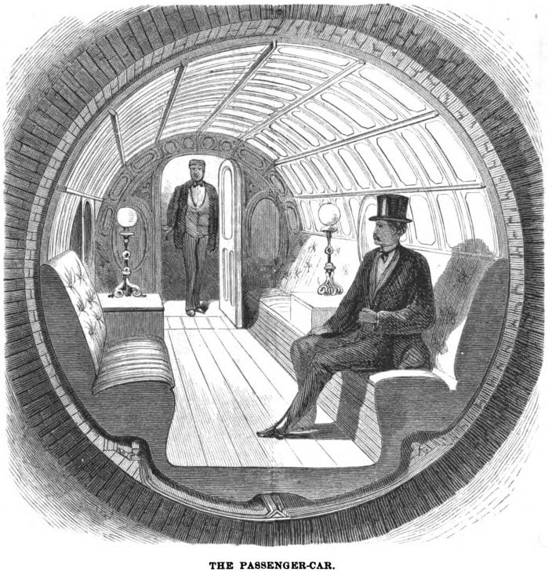
A New Form of Public Transport: The Pneumatic Tube Train
By R. A. Boadle, E. Wigfield, A. S Dulay

Abstract
Public transport via a system of pneumatic tubes is discussed and the physical principles surrounding its operation are outlined. The safety considerations inherent in such a design are briefly assessed and initial safe operating parameters are suggested.

In 1882 Albert Robida published his speculative science fiction novel ‘The Twentieth Century’ in which he discussed a novel form of public transport- the pneumatic tube train. The concept of a train driven by compressed air or a vacuum has been popular amongst many other authors over the years and sparked the imagination of engineers who attempted to implement such systems, although without much success. In the 21st century public transport is of particular interest as the world faces climate change, in part due to damaging gases emitted by more personal forms of transport such as cars. This article discusses the physical principles behind a vacuum driven pneumatic tube train similar to that proposed by Robida 127 years ago.

The Tube Train
Taking a simple model, based upon Robida’s sketches, the pneumatic tube train would consist of a long tube within which a cylindrical carriage sits, as is shown in figure 1. To ensure the carriage remained on course it would travel along a set of rails.

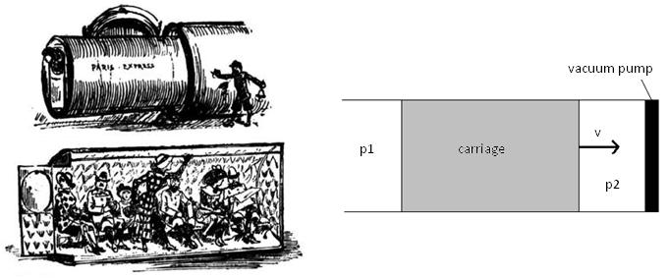
figure 1: Left, Robida’s original sketch. Right, diagram of proposed pneumatic tube train.

The pressures either side of the carriage are different, p₁ is kept at atmospheric pressure whilst p₂ is decreased using the vacuum pump. The difference in pressures drives the carriage forwards.

- Create a FBD in the space to the right to allow the tube train to accelerate below.

- From your FBD create a F_{net} for the unbalanced forces.

It is important that the tube train adheres to certain safety regulations with regards to the acceleration involved. According to a study into safe g forces for roller coasters, the maximum g force recommended is 2g, therefore a reasonable ideal acceleration for the tube train would be 1g or 9.81m/s². Given that a person should be able to comfortably stand within the carriage, the internal diameter should be at least 2m; including a wall thickness of 15cm this gives a cross sectional area of 4.15m². It is important to keep in mind Robida’s ideal mass for his tube train was 2500 kg.

- Calculation p₂ needed to allow the train to accelerate at 1g. (Assume the coefficient of friction (μ) for steel on steel is 0.6) | - Convert your value for p₂ from Pascal’s to atmosphere’s (atm).
- Assuming a reasonable safe acceleration… how fast would the train be going (in km/hr) after 1.0 km? | - How long would it take to travel by tube train from Vancouver to Montreal and arrive safely at a complete stop? Assume the train traveled the shortest possible distance…. A straight line and could never have an acceleration greater than 1.0g or -1.0g.

As an alternative to other forms of public transport, this idea shows potential! In fact Elon Musk is currently working on the Hyperloop!

The Hyperloop, detailed by the SpaceX and Tesla Motors CEO Elon Musk in a 57-page alpha white paper in August 2013, is a transportation network of above-ground tubes that could span hundreds of miles. With extremely low air pressure inside those tubes, capsules filled with people would zip through them at near supersonic speeds. Musk published the paper encouraging anyone interested to pursue the idea, since he’s kinda a busy guy.

