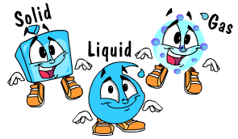 | Science 8  State of Matter  Measuring Mass and Volume | Name:  Date:  Block:
Now that we understand the KMT, we can talk about DENSITY. Density requires knowledge of mass and volume.
MASS:
- measured in grams (g) or kilograms (kg)

Mass is different from WEIGHT
WEIGHT: Force of ______________________________pulling on an object.
- Measured in _______________________.
- The weight of objects is ________________________on the moon since the moon’s gravity is $\frac{1}{6}$ that of the Earth’s.

MEASURING MASS USING A TRIPLE BEAM BALANCE
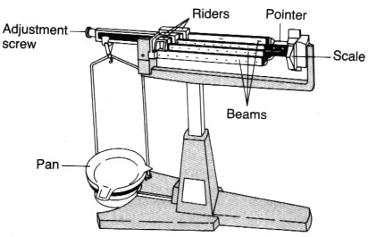
There are various types of laboratory balances. The triple beam balance you use may look somewhat different from the one in the Figure below, however all beam balances have some common features.

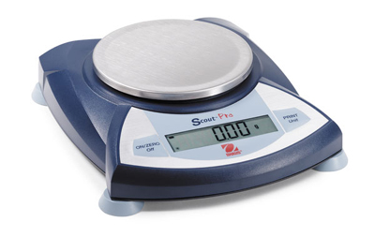

DIGITAL/ELECTRONIC BALANCE

TRIPLE BEAM BALANCE

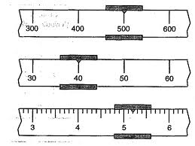
Practice Question:
What is the mass indicated by the triple beam balance on the left?

VOLUME:
Volume:
- Measured in , , ,
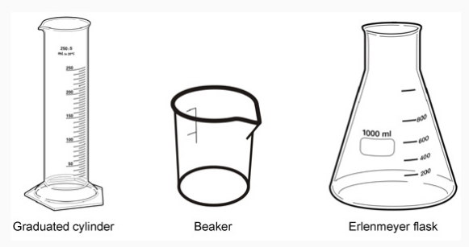
- 1 cm³ = 1 mL ; 1m³ = 1000L
Measuring Volume:
A. Volume of LIQUIDS:
  - use a graduated cylinder or beaker
  - read at eye level
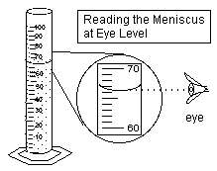
  - read from bottom of meniscus (curved surface of water)

Practice Question: What is the volume in this diagram? ---------->

B. Volume of RECTANGULAR SOLIDS:
Volume = length • width • height
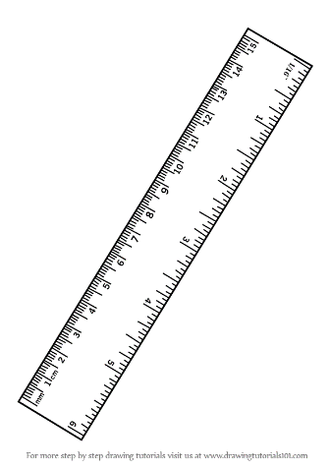
V = l • w • h
Example:
2cm
2cm
1.5cm
V = l • w • h
V=

C. Volume of IRREGULARLY SHAPED SOLIDS:
Use displacement of water technique
- Measure a specific volume of water
- Measure volume of water with object submerged in it
- Subtract volumes to find volume of object

Volume of object = (Volume of object in liquid) - (Volume of liquid alone)

