|  |  |  |
| --- | --- | --- |
| **soliqgas** | **Science 8**  **State of Matter**  **Kinetic Molecular Theory** | **Name:**  **Date: Block:** |

**WHAT IS MATTER?**

***Matter***: anything that has and

**Mass:**

* Usually measured in _____________ (g) or _____________________(kg)

**Volume:**

* Usually measured in _______________(L) , _________________________(mL), or ______________________(cm3)

**DEMO #1: MARSHMALLOW MADNESS**

Which parts of the demonstration were matter? Which weren’t? Write in the space below each column.

MATTER NOT MATTER?

*So, is everything matter?*

There are some aspects of our universe that are present, but that do not take up space or have mass.

*For example:*  - -

All of the above are examples of ____________________.

**Everything in the universe is either or !**

**DEMO #2: ALUMINUM & COPPER (II) CHLORIDE**

**Make Observations**

BEFORE COMBINATION: AFTER COMBINATION:

**Make an Inference** about what happened:

Which parts of the demonstration were matter? Energy? Write in the space below each column.

MATTER ENERGY?

Practice:

|  |  |
| --- | --- |
| 1. **What has more mass?** Circle your choice.    1. A basketball or a bowling ball    2. A helium balloon or a glass marble    3. A kitten or an adult cat | 1. **What has more volume?** Circle your choice.    1. A basketball or a bowling ball    2. A helium balloon or a glass marble    3. A kitten or an adult cat |

**STATES OF MATTER**

There are three main states of matter:

, , and

*(There is also a fourth state of matter, called _________________________. You’ll explore that later on.)*





|  |  |  |  |
| --- | --- | --- | --- |
|  | **Do they have a fixed volume?**  *(“fixed” = set, unchanging)* | **Do they take the shape of their container?** | **Example substance** |
| **SOLIDS** |  |  |  |
| **LIQUIDS** |  |  |  |
| **GASES** |  |  |  |

**Homework:**

1. Start a **key words list** for this unit in **google docs**.  
    *Define the terms* ***matter****,* ***mass,*** *and* ***volume.*** *Write the definition beside each word.*
2. Find **2** examples of each state of matter at home. Write them in the space below:

SOLIDS AT HOME LIQUIDS AT HOME GASES AT HOME

**THE KINETIC MOLECULAR THEORY (KMT)**

Matter is made up of that can’t be seen with the naked eye. The particles are always .

The **kinetic molecular theory** describes how these particles behave in each of matter and of state as well.

It’s called the **KINETIC** Molecular Theory, because **KINETIC** energy = energy of ______ ______________________

*(remember, the particles are always !)*

**The Main Points of the Kinetic Molecular Theory (KMT):**

1. All matter is made up of .
2. There is between the particles.
3. Particles are to one another.
4. 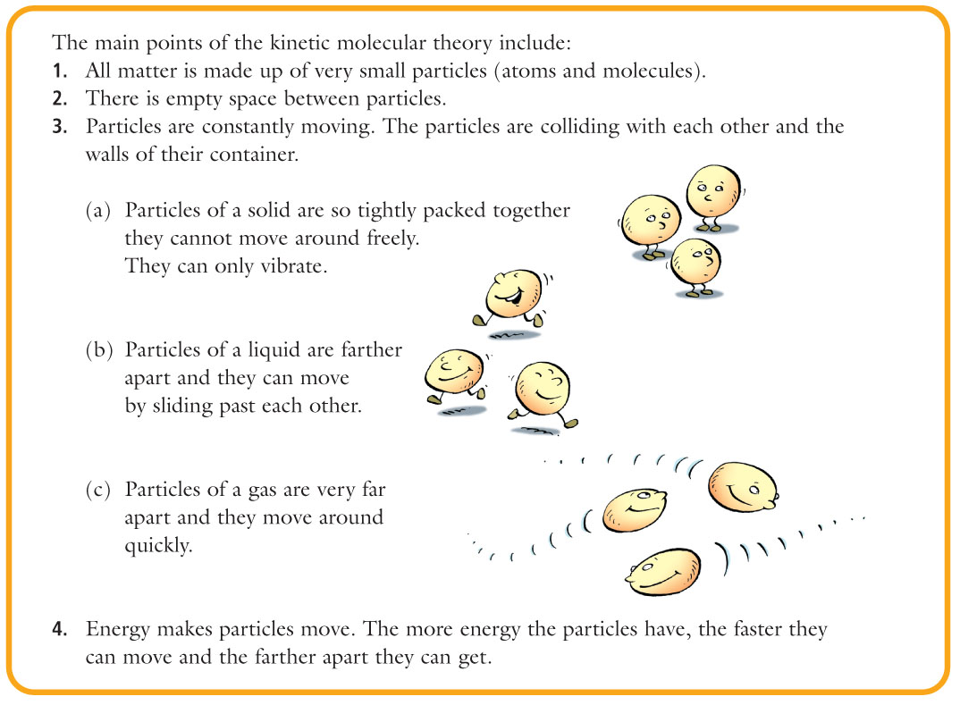Particles are constantly , and they collide with and the   
    .
5. makes particles move. The more energy particles have, the   
    they move and the they get.

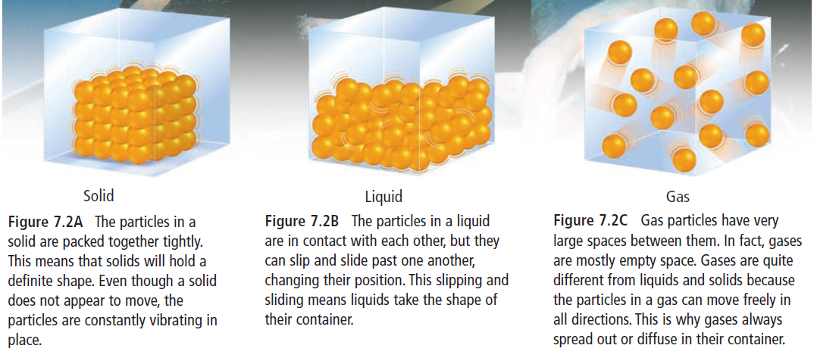

|  |  |  |  |
| --- | --- | --- | --- |
|  | **SOLID** | **LIQUID** | **GAS** |
| **Takes the shape of its container?**  **(yes/no)** |  |  |  |
| **Fixed volume?**  **(yes/no)** |  |  |  |
| **How are the particles moving?** |  |  |  |
| **How much space is between the particles?** |  |  |  |
| **How strong are the attractive forces between the particles?** |  |  |  |
| **How much energy do the particles have?**  **(low/medium/high)** |  |  |  |
| **What is an example of something in this state of matter?** |  |  |  |

**Homework:** Key Words List: Define the terms **solid, liquid, gas, Kinetic Molecular Theory**

**THE KMT AND CHANGES OF STATE**

Changing the temperature is the same as saying that we are or heat .  
  
The KMT explains changes of state by describing what happens to the particles if energy is added or removed:

|  |  |  |
| --- | --- | --- |
|  | **ADD ENERGY (i.e. heat up)** | **REMOVE ENERGY (i.e. cool down)** |
| *What happens to the particles’* ***movement****?* |  |  |
| *What happens to the* ***attractive forces*** *between the particles?* |  |  |
| *As a result of the change in attractive forces, what happens to how the particles are* ***spaced****?* |  |  |
| *As a result of the changes in particle spacing, what happens to the* ***overall volume*** *of the substance?* |  |  |

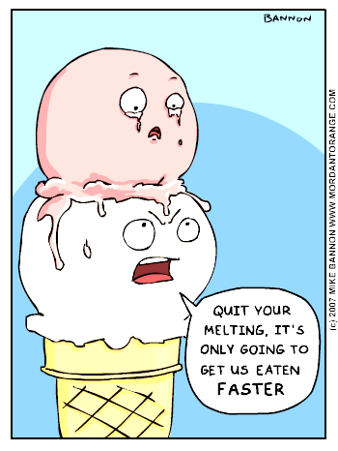**Practice: Change of state from Liquid to Gas**

* What happens to the amount of energy in the particles?
* What happens to the amount of space between the particles?
* What happens to the movement of the particles?
* What happens to the attraction between particles?
* What happens to the volume of the substance?

**THE KMT AND CHANGES OF STATE (CONT.)**

**Try This:** *Describe,**in terms of the KMT, the change in state from Liquid to Solid*

**Homework:** Key Words List: **melting, solidification, evaporation, condensation, sublimation, deposition**

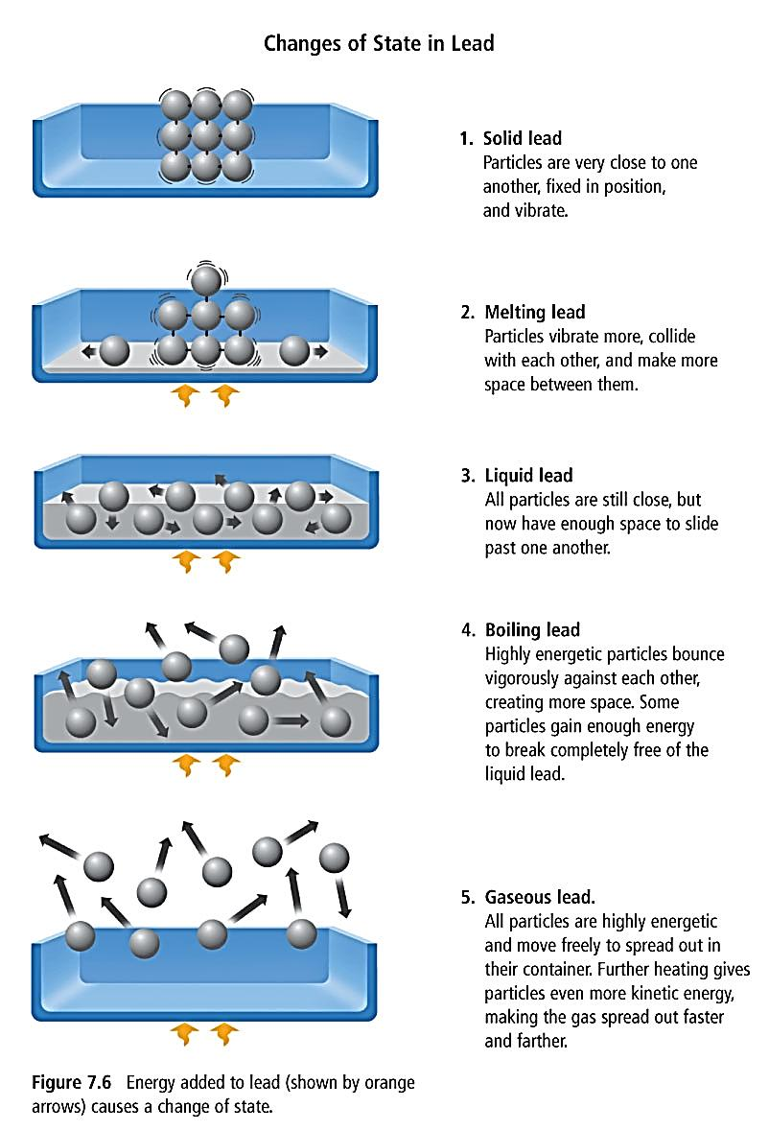

**TRY THIS:**

1. *Label each state of matter*
2. *Label each arrow with the term describing that change in state*
3. *Put up or down arrow(s) beside the changes of state to show* ***how much*** *energy is being added (arrow up) or removed (arrow down)*

