AP Physics Multiple Choice Practice – Thermodynamics

1. The maximum efficiency of a heat engine that operates between temperatures of 1500 K in the firing chamber and 600 K in the exhaust chamber is most nearly   
(A) 33% (B) 40% (C) 60% ( D) 67% (E) 100%

2. An ideal gas is made up of N diatomic molecules, each of mass M. All of the following statements about this gas are true EXCEPT:

(A) The temperature of the gas is proportional to the average translational kinetic energy of the molecules.

(B) All of the molecules have the same speed.

(C) The molecules make elastic collisions with the walls of the container.

(D) The molecules make elastic collisions with each other.

(E) The average number of collisions per unit time that the molecules make with the walls of the container

depends on the temperature of the gas.

Questions 3 – 4

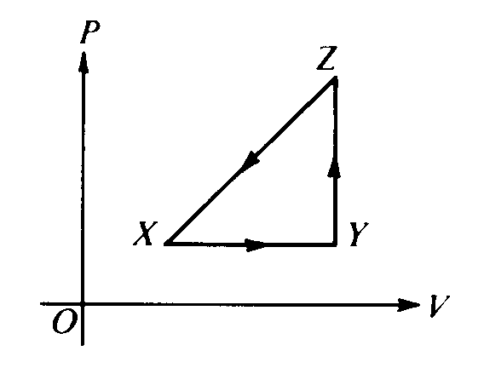

A thermodynamic system is taken from an initial state X along the path XYZX as shown in the PV-diagram.

3. For the process X→Y, ΔU is greater than zero and

(A) Q < 0 and W = 0 (B) Q < 0 and W > 0 (C) Q > 0 and W < 0 (D) Q > 0 and W = 0 (E) Q > 0 and W > 0

4. For the process Y→Z, Q is greater than zero and

(A) W < 0 & ΔU = 0 (B) W = 0 & ΔU < 0 (C) W = 0 & ΔU > 0 ( D) W > 0 & ΔU = 0 (E) W > 0 & ΔU > 0

5. An ideal gas confined in a box initially has pressure p. If the absolute temperature of the gas is doubled and the volume of the box is quadrupled, the pressure is   
(A) p/8 (B) p/4 (C) p/2 (D) p (E) 2p

6. James Joule did much to establish the value of the  
(A) universal gravitational constant (B) speed of light (C) mechanical equivalent of heat   
(D) charge of an electron (E) specific heat capacity of helium

7. An ideal gas in a closed container initially has volume V, pressure P. and Kelvin temper­ature T. If the temperature is changed to 3T, which of the following pairs of pressure and volume values is possible?

(A) 3P and V (B) P and V (C) P and V/3 (D) P/3 and V (E) 3P and 3V

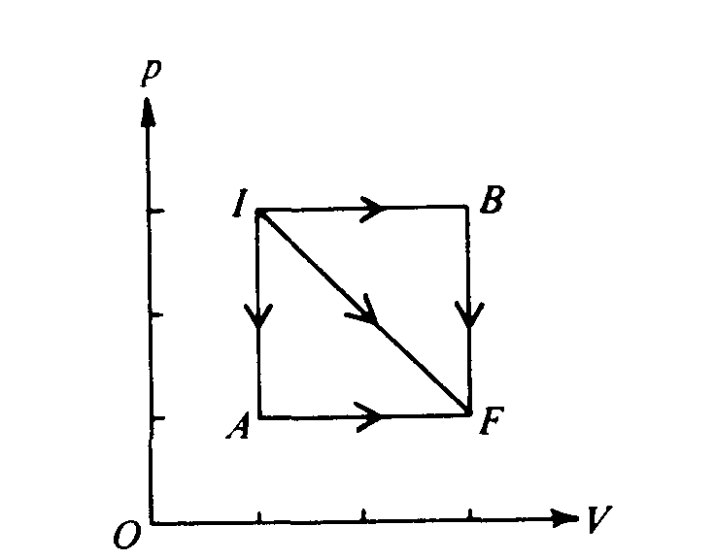

8. If three identical samples of an ideal gas are taken from initial state I to final state F along the paths IAF, IF, and IBF as shown in the pV‑diagram above, which of the following must be true?  
(A) The work done by the gas is the same for all three paths.  
(B) The heat absorbed by the gas is the same for all three paths.  
(C) The change in internal energy of the gas is the same for all three paths.  
(D) The expansion along path IF is adiabatic.  
(E) The expansion along path IF is isothermal.

9. If the average kinetic energy of the molecules in an ideal gas at a temperature of 300 K is E, the average kinetic energy at a temperature of 600 K is  
(A)  (B) *E* (C)  (D) *2E* (E) *4E*

10. A metal rod of length L and cross‑sectional area A connects two thermal reservoirs of tem­peratures T1 and T2. The amount of heat trans­ferred through the rod per unit time is directly proportional to  
(A) A and L (B) A and 1/L (C) 1/A and L (D) 1/A and 1/L (E)  and L2

11. Which of the following is always a characteristic of an adiabatic process?  
(A) The temperature does not change (ΔT = 0). (B) The pressure does not change (Δ P = 0).   
(C) The internal energy does not change (ΔU = 0). (D) No heat flows into or out of the system (Q = 0) (E) No work is done on or by the system (W = 0)

Questions 12 – 13

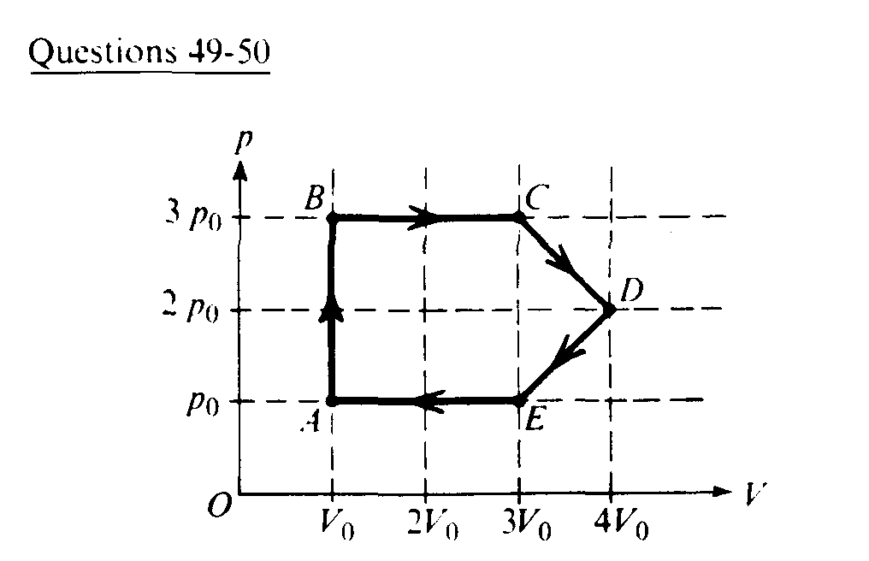

An ideal gas undergoes a cyclic process as shown on the graph above of pressure *p* versus volume V.

12. During which process is no work done on or by the gas?  
(A) AB (B) BC (C) CD (D) DE (E) EA

13. At which point is the gas at its highest temperature?  
(A) A (B) B (C) C (D) D (E) E

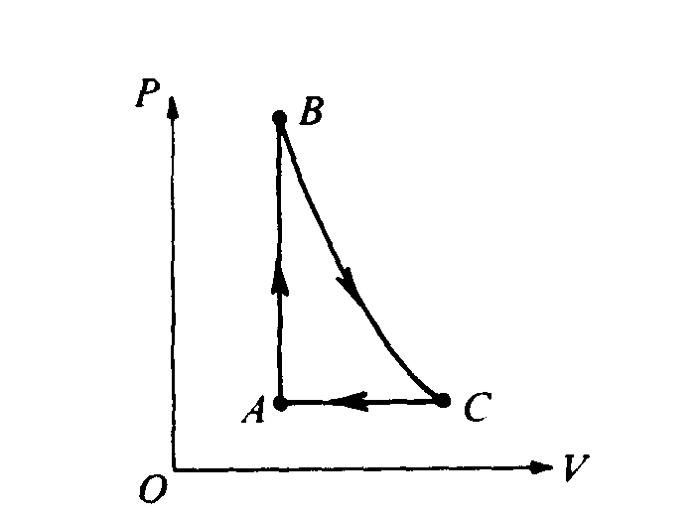

14. Gas in a chamber passes through the cycle ABCA as shown in the diagram above. In the process AB, 12 joules of heat is added to the gas. In the process BC, no heat is exchanged with the gas. For the complete cycle ABCA, the work done by the gas is 8 joules. How much heat is added to or removed from the gas during process CA?  
(A) 20 J is removed. (B) 4 J is removed. (C) 4 J is added. (D) 20 J is added.   
(E) No heat is added to or removed from the gas.

15. If the gas in a container absorbs 275 joules of heat, has 125 joules of work done on it, and then does 50 joules of work, what is the increase in the internal energy of the gas?  
(A) l00 J (B) 200 J (C) 350 J (D) 400 J (E) 450 J

16. In each cycle of a certain Carnot engine, 100 joules of heat is absorbed from the high‑temperature reservoir and 60 joules is exhausted to the low‑temperature reser­voir. What is the efficiency of the engine?  
(A) 40% (B) 60% (C) 67% (D) 150% (E) 167%

# Questions 17 – 18

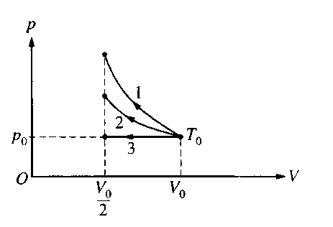

A certain quantity of an ideal gas initially at temper­ature *T0*, pressure *p0*, and volume *V0* is compressed to one‑half its initial volume. As shown above, the process may be adiabatic (process 1), isothermal (process 2), or isobaric (process 3).

17. Which of the following is true of the mechanical work done on the gas?

(A) It is greatest for process 1.

(B) It is greatest for process 3.

(C) It is the same for processes I and 2 and less for process 3.

(D) It is the same for processes 2 and 3 and less for process 1.

(E) It is the same for all three processes.

18. Which of the following is true of the final temperature of this gas?

(A) It is greatest for process 1. (B) It is greatest for process 2.

(C) It is greatest for process 3. (D) It is the same for processes 1 and 2.

(E) It is the same for processes 1 and 3.

19. In a certain process, 400 J of heat is added to a system and the system simultaneously does 100 J of work. The change in internal energy of the system is

(A) 500 J (B) 400 J (C) 300 J (D) –100 J (E) –300 J

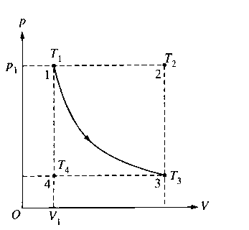

20. An ideal gas is initially in a state that corresponds to point 1 on the graph above, where it has pres­sure *p1*, volume *V1*, and temperature *T1*. The gas undergoes an isothermal process represented by the curve shown, which takes it to a final state 3 at temperature *T3*. If *T2* and *T4* are the tempera­tures the gas would have at points 2 and 4, respec­tively, which of the following relationships is true?

(A) *T1* < *T3* (B) *T1* < *T2* (C) *T1* < *T4* (D) *T1* = *T2* (E) *T1* = *T4*

21. The absolute temperature of a sample of monatomic ideal gas is doubled at constant volume. What effect, if any, does this have on the pressure and density of the sample of gas?

Pressure Density

(A) Remains the same Remains the same

(B) Remains the same Doubles

(C) Doubles Remains the same

(D) Doubles Is multiplied by a factor of 4

(E) Is multiplied by a factor of 4 Doubles

22. Which of the following statements is NOT a correct assumption of the classical model of an ideal gas?

(A) The molecules are in random motion.

(B) The volume of the molecules is negligible com­pared with the volume occupied by the gas.

(C) The molecules obey Newton's laws of motion.

(D) The collisions between molecules are inelastic.

(E) The only appreciable forces on the molecules are those that occur during collisions.

23. A sample of an ideal gas is in a tank of constant volume. The sample absorbs heat energy so that its temperature changes from 300 K to 600 K. If *v1* is the average speed of the gas molecules before the absorption of heat and *v2* is their average speed after the absorption of heat, what is the ratio *v2*/*v1*?

(A) 1/2 (B) 1 (C)  (D) 2 (E) 4

24. Two blocks of steel, the first of mass 1 kg and the second of mass 2 kg, are in thermal equilibrium with a third block of aluminum of mass 2 kg that has a temperature of 400 K. What are the respec­tive temperatures of the first and second steel blocks?

(A) 400 K and 200 K (B) 200 K and 400 K (C) 400 K and 400 K

(D) 800 K and 400 K (E) None of the above

25. An ideal gas may be taken from one state to another state with a different pressure, volume, and temperature along several different paths. Quantities that will always be the same for this process, regardless of which path is taken, include which of the following?

I. The change in internal energy of the gas

II. The heat exchanged between the gas and its surroundings

III. The work done by the gas

(A) I only (B) II only (C) I and III only (D) II and III only (E) I, II, and III

26. A square steel plate with sides of length 1.00 m has a hole in its center 0.100 m in diameter. If the entire plate is heated to such a temperature that its sides become 1.01 m long, the diameter of the hole will be

(A) 0.090 m (B) 0.099 m (C) 0.100 m (D) 0.101 m (E) 0.110 m

27. Which of the following will occur if the average speed of the gas molecules in a closed rigid container is increased?

(A) The density of the gas will decrease. (B) The density of the gas will increase.

(C) The pressure of the gas will increase. (D) The pressure of the gas will decrease.

(E) The temperature of the gas will decrease.

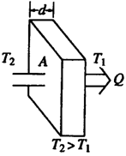

28. In time *t*, an amount of heat *Q* flows through the solid door of area *A* and thickness *d* represented above. The temperatures on each side of the door are *T2* and *T1*, respectively. Which of the following changes would be certain to decrease *Q*?

(A) Increasing *A* only (B) Decreasing *d* only (C) Increasing *d* and *T2 – T1* only   
(D) Decreasing *A* and *T2 – T1* only (E) Increasing *d, A*, and *T2 – T1*

29. A gas with a fixed number of molecules does 32 J of work on its surroundings, and 16 J of heat are transferred from the gas to the surroundings. What happens to the internal energy of the gas?

(A) It decreases by 48 J. (B) It decreases by 16 J. (C) It remains the same. (D) It increases by 16 J.

(E) It increases by 48 J.

30. Which of the following could *NOT* be used to indicate a temperature change? A change in:

(A) color of a metal rod. (B) length of a liquid column. (C) pressure of a gas at constant volume.

(D) electrical resistance. (E) mass of one mole of gas at constant pressure.

31. A mass *m* of helium gas is in a container of constant volume *V*. It is initially at pressure *p* and absolute (Kelvin) temperature *T*. Additional helium is added, bringing the total mass of helium gas to *3m*. After this addition, the temperature is found to be *2T*. What is the gas pressure?

(A) 2/3 *p* (B) 3/2 *p* (C) 2 *p* (D) 3 *p* (E) 6 *p*

32. Which would be the most comfortable temperature for your bath water?

(A) 0ºC (B) 40 K (C) 110ºC (D) 310 K (E) 560 K

33. The theoretical (Carnot) efficiency of a heat engine operating between 600ºC and 100ºC is:

(A) 16.7% (B) 20.0% (C) 42.7% (D) 57.3% (E) 83.3%



34. A gas can be taken from state *a* to *c* by two different reversible processes, *a*⇨*c* or *a*⇨*b*⇨*c*. During the direct process *a*⇨*c*, 20.0 J of work are done by the system and 30.0 J of heat are added to the system. During the process *a*⇨*b*⇨*c*, 25.0 J of heat are added to the system. How much work is done by the system during *a*⇨*b*⇨*c*?

(A) 5.0 J (B) 10.0 J (C) 15.0 J (D) 20.0 J (E) 25.0 J

35. What temperature change on the Kelvin scale is equivalent to a 10 degree change on the Celsius scale?

(A) 283 K (B) 273 K (C) 18 K (D) 10 K (E) 0

36. When an ideal gas is isothermally compressed:

(A) thermal energy flows from the gas to the surroundings.

(B) the temperature of the gas decreases.

(C) no thermal energy enters or leaves the gas.

(D) the temperature of the gas increases.

(E) thermal energy flows from the surroundings to the gas.

37. Which of the following is always true for an isothermal process of an ideal gas?

(A) The internal energy does not change.

(B) No heat flows into or out of the system.

(C) The pressure does not change.

(D) The volume does not change.

(E) No work is done by or on the system.

38. The average speed of the atoms of a gas at 100 K is 200 m/s. What would most nearly be the average speed of the atoms at 300 K?

(A) 67 m/s (B) 140 m/s (C) 200 m/s (D) 350 m/s (E) 600 m/s

39. Which of the following temperatures would be most appropriate to keep milk at inside a refrigerator?

(A) –20ºC (B) 5 K (C) 40ºC (D) 278 K (E) 350 K

40. A heat engine takes in 200 J of thermal energy and performs 50 J of work in each cycle. What is its efficiency?

(A) 50 % (B) 40 % (C) 25 % (D) 20 % (E) 12 %

41. The 1st Law of Thermodynamics is a simple statement of the Law of the Conservation of Energy. It was first announced about the time of

(A) the First World War

(B) the U.S. Civil War

(C) the French Revolution

(D) Christopher Columbus' discovery of the New World

(E) the fall of the Roman Empire

42. A 200 gram sample of copper is submerged in 100 grams of water until both the copper and water are at the same temperature. Which of the following statements would be true?

(A) the molecules of the water and copper would have equal average speeds

(B) the molecules of the water and copper would have equal average momenta

(C) the molecules of the water and copper would have equal average kinetic energies

(D) the water molecules would have twice the average momentum of the copper molecules

(E) the copper molecules would have twice the average speed of the water molecules

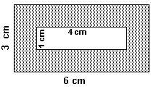

43. A rectangular piece of metal 3 cm high by 6 cm wide has a hole cut in its center 1cm high by 4 cm wide as shown in the diagram at right. As the metal is warmed from 0oC to 1000C, what will happen to the dimensions of the hole?

(A) both height and width will increase

(B) both height and width will decrease

(C) both height and width will remain unchanged

(D) height will decrease while width will increase

(E) height will increase while width will decrease

44. A gas is enclosed in a cylindrical piston. When the gas is heated from 0ºC to 100ºC, the piston is allowed to move to maintain a constant pressure. According to the Kinetic-Molecular Theory of Matter

(A) the mass of the gas will increase

(B) the number of molecules of gas must increase

(C) the size of the individual molecules has increased

(D) the average speed of the molecules has increased

(E) the molecules continue to strike the sides of the container with the same energy

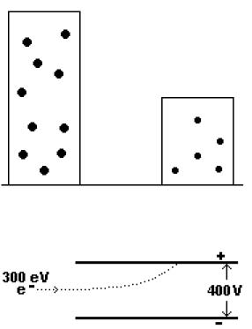

45. Two containers are filled with gases at the same temperature. In the container on the left is a gas of molar mass *2M,* volume *2V,* and number of moles *2n.* In the container on the right is a gas of molar mass *M,* volume *V,* and moles n. Which is most nearly the ratio of the pressure of the gas on the left to the pressure of the gas on the right?

(A) 1:1 (B) 8:1 (C) 2:1 (D) 16:1 (E) 4:1

46. A thermally insulating container has a membrane separating the con­tainer into two equal parts. In one part is a vacuum. In the other part is an ideal gas of temperature *T* and internal energy *U.* The membrane is punctured and the gas rushes into the region which was a vacuum. Af­ter the system has returned to equilibrium, which of the following is NOT true for the gas?

(A) The temperature of the gas is unchanged.

(B) No work is done by the gas on the surroundings.

(C) There is no heat exchanged by the gas with the surroundings.

(D) There is no entropy change of the system.

(E) The internal energy of the gas is unchanged.

47. A fan blows the air and gives it kinetic energy. An hour after the fan has been turned off, what has happened to the kinetic energy of the air?

(A) it disappears (B) it turns into sound energy (C) it turns into potential energy   
(D) it turns into electrical energy (E) it turns into thermal energy

48. According to the kinetic theory of gases, when the absolute temperature of an ideal gas doubles, the average kinetic energy of the molecules of the gas

(A) quadruples (B) doubles (C) stays the same (D) is cut in half (E) is quartered

49. When gas escapes from a pressurized cylinder, the stream of gas feels cool. This is because

(A) work is being done at the expense of thermal energy

(B) of the convection inside the cylinder

(C) pressurized cylinders are good thermal insulators

(D) the gas inside the cylinder is actually frozen

(E) the moisture in the air condenses and cools

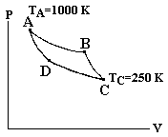

50. A monatomic ideal gas is used as the working substance for the Carnot cycle shown in the figure. Processes A → B and C → D are isothermal, while processes B → C and D → A are adiabatic. During process A → B, there are 400 J of work done by the gas on the surroundings. How much heat is expelled by the gas during process C → D?

(A) 1600 J (B) 800 J (C) 400 J (D) 200 J (E) 100 J

51. Two completely identical samples of the same ideal gas are in equal volume containers with the same pressure and temperature in containers labeled A and B. The gas in container A performs non-zero work W on the surroundings during an isobaric (constant pressure) process before the pressure is reduced isochorically (constant volume) to ½ its initial amount. The gas in container B has its pressure reduced isochorically (constant volume) to ½ its initial value and then the gas performs non-zero work W on the surroundings during an isobaric (constant pressure) process.

After the processes are performed on the gases in containers A and B, which is at the higher temperature?

(A) The gas in container A

(B) The gas in container B

(C) The gases have equal temperature

(D) The value of the work W is necessary to answer this question.

(E) The value of the work W is necessary, along with both the initial pressure and volume, in order to answer the question.

52. The volume of an ideal gas changes as the gas undergoes an isobaric (constant pressure) process starting from temperature 273OC and ending at 546OC What is the ratio of the new volume of the gas to the old volume (Vnew/Vold)?

(A) 2 (B)  (C) 1 (D)  (E) 

1. 53. A frozen hamburger in plastic needs to be thawed quickly. Which of the methods described provides the most rapid thawing of the burger?
2. (A) Place the burger itself in a metal pan at room temperature.
3. (B) Place the burger in its package on the kitchen counter at room temperature.
4. (C) Place the burger in its package in a pot of non-boiling warm water.
5. (D) Place the burger itself on a plastic plate in the refrigerator.
6. (E) Place the burger itself on the ceramic kitchen counter at room temperature.

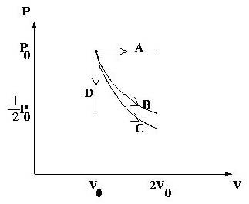

54. The PV diagram shows four different possible reversible processes performed on a monatomic ideal gas. Process A is isobaric (constant pressure). Process B is isothermal (constant temperature). Process C is adiabatic. Process D is isochoric (constant volume). For which process(es) does the temperature of the gas decrease?

(A) Process A only (B) Process C only (C) Only Processes C and D (D) Only Processes B, C and D

(E) All 4 Processes.

55. A new monatomic ideal gas is discovered and named “Wellsium”. A pure 4-mole sample is sitting in a container at equilibrium in a 20.0ºC environment. According to the kinetic theory of gases, what is the average kinetic energy per molecule for this gas?

(A) 4.14 × 10–22 J (B) 3652 J (C) 6.07 × 10–21 J (D) 2.02 × 10–21J   
(E) The molar mass of the gas is needed to answer this question.

1. 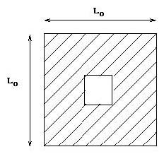
2. 56. A uniform square piece of metal has initial side length L0 . A square piece is cut out of the center of the metal. The temperature of the metal is now raised so that the side lengths are increased by 4%. What has happened to the area of the square piece cut out of the center of the metal?
3. (A) It is increased by 16 % (B) It is increased by 8 % (C) It is increased by 4 % (D) It is decreased by 4 %
4. (E) It is decreased by 8 %
5. 57. A monatomic ideal gas at pressure *P* = 105 Pa is in a container of volume *V* = 12 m3 while at temperature *T* = 50ºC. How many molecules of gas are in the container?
   1. (A) 447 (B) 2888 (C) 6.02 × 1023 (D) 2.69 × 1026 (E) 1.74 × 1027
6. 58. Absolute zero is best described as that temperature at which
7. (A) water freezes at standard pressure.
8. (B) water is at its triple point.
9. (C) the molecules of a substance have a maximum kinetic energy.
10. (D) the molecules of a substance have a maximum potential energy.
11. (E) the molecules of a substance have minimum kinetic energy.
12. 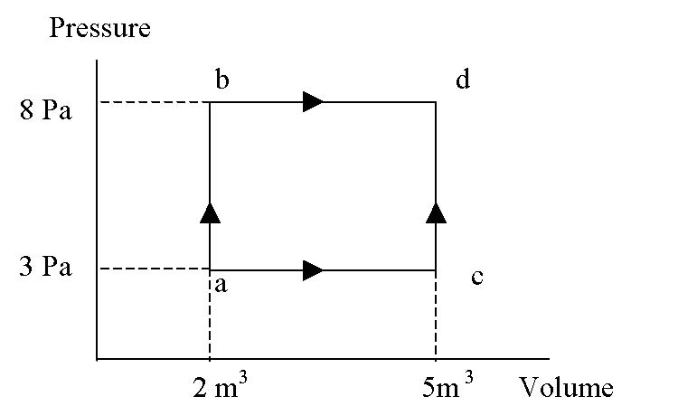
13. 59. In the Pressure versus Volume graph shown, in the process of going from a to b 60 J of heat are added, and in the process of going from b to d 20 J of heat are added. In the process of going a to c to d, what is the total heat added?
    1. (A) 80 J (B) 65 J (C) 60 J (D) 56 J (E) 47 J

60. Which is not true of an isochoric process on an enclosed ideal gas in which the pressure decreases?

(A) The work done is zero. (B) The internal energy of the gas decreases. (C) The heat is zero.

(D) The rms speed of the gas molecules decreases. (E) The gas temperature decreases.

61. One mole of an ideal gas has a temperature of 100°C. If this gas fills the 10.0*m*3 volume of a closed container, what is the pressure of the gas?

(A) 0.821 *Pa* (B) 3.06 *Pa* (C) 83.1 *Pa* (D) 310 *Pa* (E) 1.84 × 1024 *Pa*

62. An ideal gas is enclosed in a container. The volume of the container is reduced to half the original volume at constant temperature. According to kinetic theory, what is the best explanation for the increase in pressure created by the gas?

(A) The average speed of the gas particles decreases, but they hit the container walls more frequently.

(B) The average speed of the gas particles is unchanged, but they hit the container walls more frequently.

(C) The average speed of the gas particles increases as does the frequency with which they hit the container walls.

(D) The average speed of the gas particles increases, overcoming the decreased frequency that they hit the container walls.

(E) The internal energy of the gas increases.

63. A mole of a monatomic ideal gas has pressure *P* , volume *V* , and temperature *T* . Which of the following processes would result in the greatest amount of energy added to the gas from heat?

(A) A process doubling the temperature at constant pressure.

(B) An adiabatic free expansion doubling the volume.

(C) A process doubling the pressure at constant volume.

(D) An adiabatic expansion doubling the volume.

(E) A process doubling the volume at constant temperature.

64. An ideal gas in a closed container of volume 6.0 *L* is at a temperature of 100ºC. If the pressure of the gas is 2.5 atm, how many moles of gas are in the container?

(A) 0.0048 (B) 0.018 (C) 0.49 (D) 1.83 (E) 490

65. A scientist claims to be investigating “The transfer of energy that results from the bulk motion of a fluid.” Which of the following terms best describes the energy transfer method that this scientist is studying?

(A) radiation (B) convection (C) conduction (D) latent heat (E) specific heat

66. An ideal gas undergoes an isobaric expansion followed by an isochoric cooling. Which of the following statements *must* be true after the completion of these processes?

(A) The final pressure is less than the original pressure.

(B) The final volume is less than the original volume.

(C) The final temperature is less than the original temperature.

(D) The total quantity of heat, *Q*, associated with these processes is positive.

(E) The internal energy of the gas is unchanged.

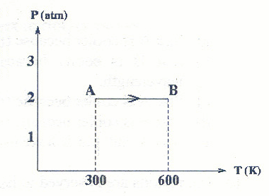

67. Two moles of a monatomic ideal gas undergoes the process from A to B, shown in the diagram above by the solid line. Using the sign convention that work is positive when surroundings do work on the system, how much work is done in the process AB?

(A) 5000 J (B) 1200 J (C) –1200 J (D) –5000 J   
(E) More information is required to determine the amount of work done.

Questions 68 – 69

An engine operates on the cycle shown in the PV diagram below. The working substance of the engine is an ideal monatomic gas. The processes *A* → *B* and *C* → *D* are isobaric, while processes *B* → *C* and *D* → *A* are isochoric.

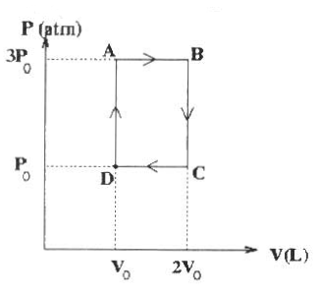

68. What is the efficiency of a Carnot engine operating between the same maximum and minimum temperatures as this engine?

(A) 1/6 (B) 1/3 (C) 1/2 (D) 3/5 (E) 5/6

69. What is the actual efficiency of this engine?

(A) 1/6 (B) 4/21 (C) 5/17 (D) 7/19 (E) 8/15

70. What would be the efficiency of the heat engine diagramed as shown below?

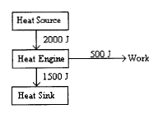

(A) 300 % (B) 133 % (C) 75 % (D) 33 % (E) 25 %

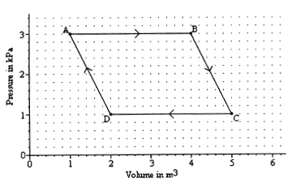

71. A sample of gas is caused to go through the cycle shown in the pV diagram shown above. What is the net work done by the gas during the cycle?

(A) 12,000 J (B) 8000 J (C) 6000 J (D) 4000 J (E) 2000 J

72. A sample of an ideal monatomic gas is confined in a rigid 0.008 m3 container. If 40 joules of heat energy were added to the sample, how much would the pressure increase?

(A) 5 Pa (B) 320 Pa (C) 1,600 Pa (D) 3,333 Pa (E) 5000 Pa

73. Hydrogen gas (H2) and oxygen gas (O2) are in thermal equilibrium. How does the average speed of the hydrogen molecules compare to the average speed of oxygen molecules?   
(A) equal (B) 4 times greater (C) 8 times greater (D) 16 times greater (E) 32 times greater

74. A reversible heat engine works between a high temperature reservoir at 227°C and low temperature reservoir of 27°C. If the engine absorbs an amount of heat *Q* at the high temperature reservoir, how much heat will it exhaust at the low temperature reservoir?   
(A) 227Q/27 (B) 27Q/227 (C) 5Q/3 (D) 3Q/5 (E) 0

75. If an ideal Carnot engine takes in 500 kJ of heat at 1500 K and expels 200 kJ of heat to the low temperature reservoir during each cycle, which of the following would be closest to the temperature of the low temperature reservoir?

(A) 900 K (B) 750 K (C) 600 K (D) 450 K (E) 300 K

76. Hydrogen gas is contained in a rigid container. A second rigid container of equal volume contains oxygen gas. If the average rms velocities of the molecules in each container is the same, which of the following *must* be true?

(A) The oxygen gas would apply the greater pressure.   
(B) The hydrogen gas would apply the greater pressure.  
(C) There would be an equal pressure in each container.   
(D) The oxygen gas would have the higher temperature.   
(E) The temperature of both gasses would be identical.

77. If an idea Carnot heat engine with an efficiency of 30% absorbs heat from a reservoir at 727° C, what must be the exhaust temperature of the engine?

(A) 509°C (B) 427°C (C) 273°C (D) 218°C (E) 0°C

78. A mole of ideal gas at STP is heated in an insulated constant volume container until the average velocity of its molecules doubled. Its pressure would therefore increase by what factor?

(A) 0.5 (B) 1 (C) 2 (D) 4 (E) 8

79. An ideal heat engine takes in heat energy at a high temperature and exhausts energy at a lower temperature. If the amount of energy exhausted at the low temperature is 3 times the amount of work done by the heat engine, what is its efficiency?

(A) 0.25 (B) 0.33 (C) 0.67 (D) 0.9 (E) 1.33

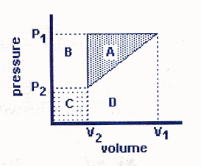

80. A sample of gas was first compressed from *V*1 to *V*2 at a constant pressure of *P*1. The sample was then cooled so that the pressure went from *P*1 to *P*2 while the volume remained constant at *V*2. Finally the sample was allowed to expand from *V*2 back to *V*1 while the pressure increased from *P*2 back to *P*1 as shown in the diagram. Which of the following statements is correct?

(A) The area A represents the energy that is lost by the gas in this cycle.   
(B) The area A + B represents the energy gained by the gas in this cycle.  
(C) The area A + C represents the energy gained by the gas in this cycle.   
(D) The area B + D represents the energy gained by the gas in this cycle.   
(E) There was no energy lost or gained by the gas in this cycle.

81. One end of a metal rod of length *L* and cross-sectional area *A* is held at a constant temperature *T*1. The other end is held at a constant *T*2. Which of the statements about the amount of heat transferred through the rod per unit time are true?

|  |  |
| --- | --- |
| I. | The rate of heat transfer is proportional to 1/(*T*1 - *T*2). |
| II. | The rate of heat transfer is proportional to *A* |
| III. | The rate of heat transfer is proportional to *L*. |

(A) II only (B) III only (C) I and II only (D) I and III only (E) II and III only

82. On all of the pV diagrams shown below the lighter curve represents isothermal process, a process for which the temperature remains constant. Which dark curve best represents an adiabatic process, a process for which no heat enters or leaves the system?

(A) 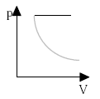 (B) 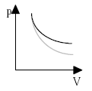 (C) 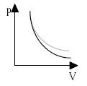 (D) 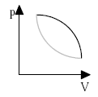 (E) 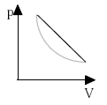

83. Three processes compose a thermodynamic cycle shown in the accompanying *pV* diagram of an ideal gas.

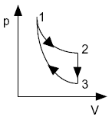

Process 1→2 takes place at constant temperature (300 K). During this process 60 J of heat enters the system.   
Process 2→3 takes place at constant volume. During this process 40 J of heat leaves the system.   
Process 3→1 is adiabatic. *T*3 is 275 K.

What is the change in internal energy of the system during process 3→1?

(A) –40 J (B) –20 J (C) 0 J (D) +20 J (E) +40 J