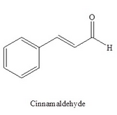 |  |  | Functional Groups-2 |  | Name:  Date:
- Draw and name the cis and trans condensed AND skeletal structure of:
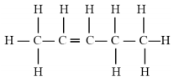

 | cis structure |  |  | trans structure
 | Name: |  |  | Name:
 |  | 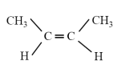
 |  | 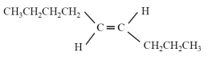
 |  | 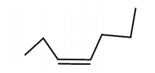
 |  | 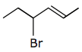
 |  |  |  |  |  | 2-cis-hexene
 |  |  |  |  |  | 2-methyl-3-cis-hexene
 |  | 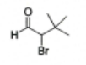
 |  |  |  |  |  | 3-ethylhexanal
 |  |  |  |  |  | 2,2-dimethyl-3-pentanone
 |  |  |  |  |  | 4,4,5-trifluoroheptanal
 |  |  |  |  |  | 5-chloro-4-ethyl-6-methyl-3-octanone

- What is the smallest ketone possible? Explain.

- Determine the errors in the following names and give the correct name
  - 1-butanone

  - 3-pentanal

  - 3-ethyl-2-methylbutanal

