Science 8  Human Vision | Name:  Date:  Block:

Term: | Description/Function:
Cornea
Pupil
Iris
Sclera
Lens
Retina
Optic Nerve

THE FOCUSING SYSTEM

The focusing system consists of:

- Light rays ________________________ as soon as they pass into the _______________________.
- The cornea _________________________________________ and _______________________ the light.
- The lens _________________________________the focus.

By drawing a straight line and writing the name beside it, label the diagram with the following:
- Optic nerve
- Retina
- Lens
- Iris
- Pupil
- Cornea
- Sclera
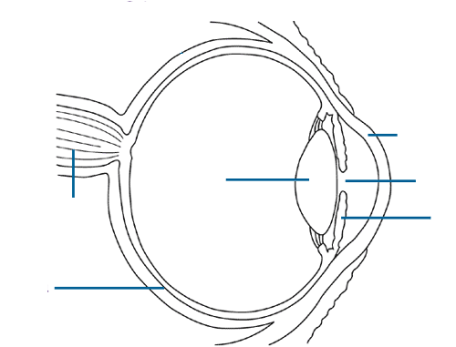

FORMING AN IMAGE

- All light rays travel in ________________________________________________.
- The _______________________ formed by the lens is ___________________________.
- Your brain interprets the ________________________ as being _________________________.
