Organelle | Description  (What it looks like) | Function  (What it does) | Analogy  (It’s like…)
Nucleus
Cytoplasm
Cell Membrane
Mitochondria
Large Vacuole
Cell Wall
Chloroplasts

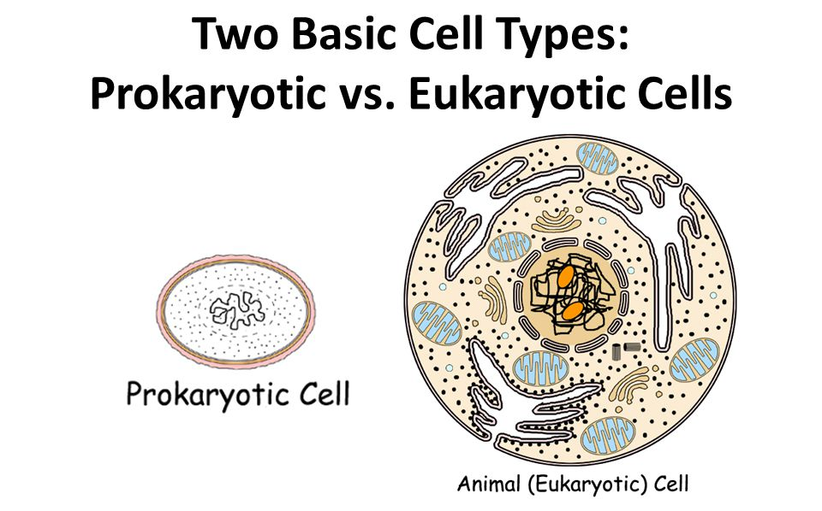
All cells fall into one of two broad categories: prokaryotic and eukaryotic. Only the single-celled organisms of the domains Bacteria and Archaea are classified as prokaryotes—pro means before and kary means nucleus. Animals, plants, fungi, and protists are all eukaryotes—eu means true—and are made up of eukaryotic cells.
Characteristic | Prokaryotic Cell | Eukaryotic Cell
Genetic material in nucleus
Organelles surrounded by membranes
Size and complexity
Can carry out all processes needed to stay alive
Example

