Science 8  Light and Colour Worksheet! | Name:  Date:  Block:

- Explain why you would see all the colours of the rainbow separated after it rains and the sun comes out. Use the word “refraction” in your answer.

The raindrops (water) act as “mini” prisms cause the white light to refract/bend and separate into the individual colours that make up the rainbow.

- An object contains the colours black and white. Why do certain parts of the object appear black and others appear white? Use the words “reflect” and “absorb” in your answer.
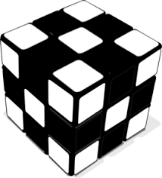
Black absorbs all the light (all colours) that hits the object. Therefore when we see black we see an absence of light.
White reflects all the light (all colours) that hits the object. Therefore when we see white we see all the colours that make up white light.

- The following diagrams show the combination of different colours of light. What colours should appear in positions A and B in the diagram?
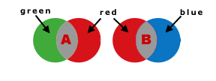
A: | Yellow
B: | Magenta

- Bono, the lead singer of the band U2, is often seen wearing sunglasses that have blue-tinted lenses. List two specific colours that he would see completely differently and explain why.
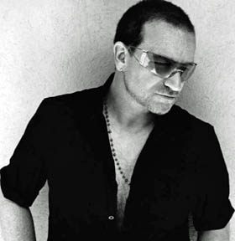

He would see Red and Green completely differently. Red would appear magenta (blue + red = magenta) and green would appear yellow (blue + green = yellow).

