Science 8  Light and Colour Worksheet! | Name:  Date:  Block:

- Explain why you would see all the colours of the rainbow separated after it rains and the sun comes out. Use the word “refraction” in your answer.

- An object contains the colours black and white. Why do certain parts of the object appear black and others appear white? Use the words “reflect” and “absorb” in your answer.
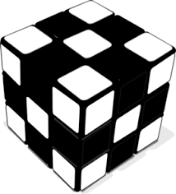

- The following diagrams show the combination of different colours of light. What colours should appear in positions A and B in the diagram?
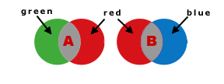
A:
B:

- Bono, the lead singer of the band U2, is often seen wearing sunglasses that have blue-tinted lenses. List two specific colours that he would see completely differently and explain why.
