Science 8  Elements of the Periodic Table | Name:  Date:  Block:
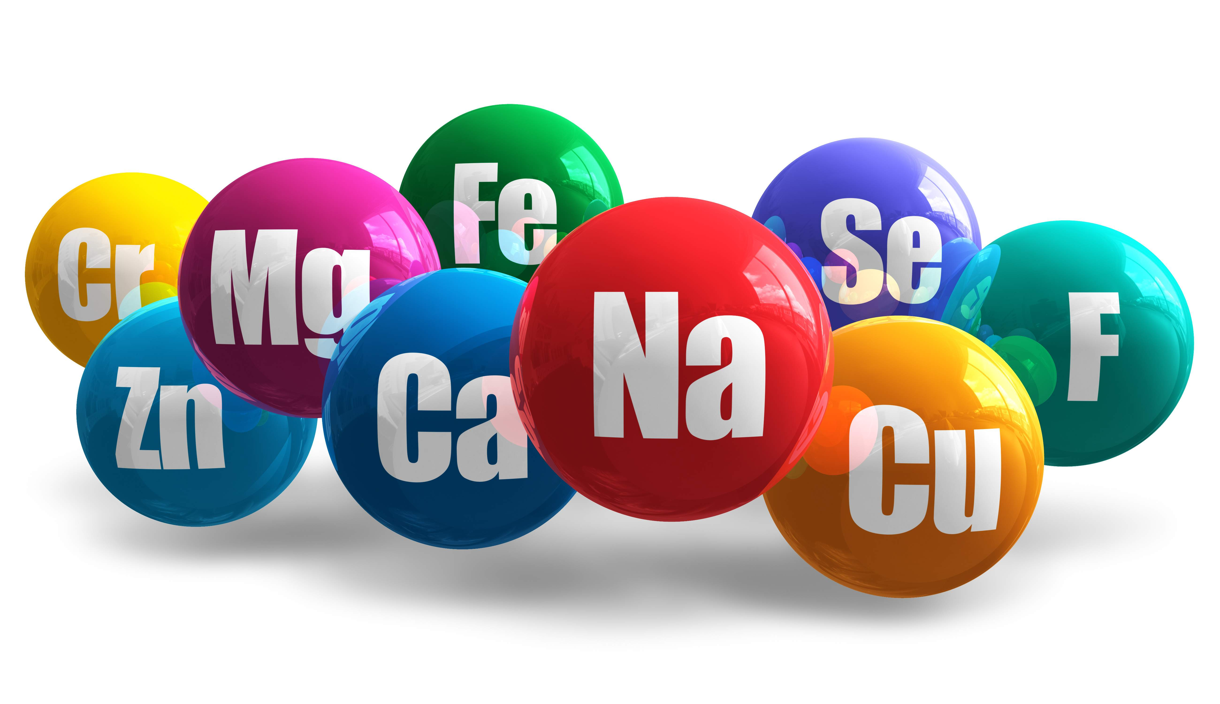
Each element is different and has different properties/characteristics.
It is often said that an element in the flavor of the atom!
Name 5 different elements:
(1) __________________ (2) __________________ (3) __________________ (4) __________________ (5) __________________
A few properties/characteristics are:

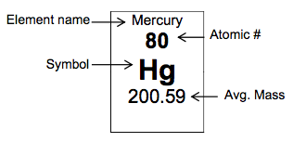
See the back for the Element Hunt!

Element Hunt!
- What is the chemical name for Ga? _______________________________________
- What is the symbol for Palladium? _______________________________________
- What is the atomic number for Yttrium? _______________________________________
- What is the atomic mass for Helium? _______________________________________
- What is the chemical name for W? _______________________________________
- What is the atomic number for Gold? _______________________________________
- What is the atomic mass for Platinum? _______________________________________
- What is the symbol for Copper? _______________________________________
- What is the chemical name for Ba? _______________________________________
- What is the atomic mass for Cerium? _______________________________________
- What is the chemical name for Rh? _______________________________________
- What is the atomic mass for Samarium? _______________________________________
- Who was the element Einsteinium named after? _______________________________________
And now for the… ELEMENT JOKES!
- What do you do with a dead scientist? _______________________________________
- Hey want to hear a joke about Potassium? _______________________________________
Ok so the last joke was BAD…
- Want to hear a joke about Sodium and Hydrogen? _______________________________________
- What do you say when Oxygen, Hydrogen, Sulpher, Sodium and Phosphorous walk into a bad?
_______________________________________
- Oxygen and Potassium went on a date… did you hear how it went? _____________________________________
- I was going to tell you another chemistry joke but all the good ones…. ___________________________________
Ok Ok Mr. Lawson! Stop with the puns…. We've all sulfured enough.

