AP Physics - One Dimensional Kinematics

Velocity and speed are two closely related words. You might think that they are the same thing, but in physics we find that they are very different.

Speed is a measure of how fast something moves. It is a rate. Rates are quantities divided by time. In addition, speed is a scalar quantity.

Velocity is also a rate – the rate that displacement changes with time. The really key thing here is that velocity is a vector. It has magnitude – just as speed does – but it also has a direction. When we talk about speed, we don’t care what about the direction of motion. The car went at a speed of 50 miles per hour. We don’t care if it went south, north, east, west, whatever. With velocity we do care about the direction. Velocity would be the motion of a car that is going south at 35 mph.
A vector is a quantity that has both magnitude and direction.

A toy train traveling around a circular track is moving at a constant speed. It does not have a constant velocity, however, because its direction is constantly changing.

Distance is a scalar – just how far you are from some point. Displacement, on the other hand, is a vector – distance and direction.

Instantaneous velocity is the velocity of an object at any given instant of time. A car traveling from A to B does not always travel at a constant velocity - it stops, speeds up, slows down, &tc. The speedometer on the dashboard reads out the instantaneous speed. At a stop sign it reads 0 mph, later on after the light turns green it might read 36 mph, and so on.

Average velocity is the velocity for an entire trip. It is the total distance divided by the total time.

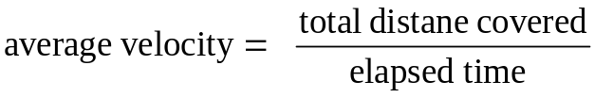

The symbol v is used for velocity (and is also used for speed). Some texts use , where a little bar is placed over the "v" indicating that it is a vector. We won't do that.

Average velocity is defined mathematically as: 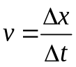

Δx means the change in x, the displacement, Δt is the change in t.

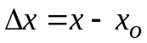

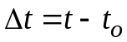

The subscript "o" means initial (it actually stands for “zero”, representing the condition that you begin with). So Δx is the final displacement (or distance) minus the initial displacement. Other conventions can be used; t₂ - t₁, t_{f} – t_{i}, &tc.

If the initial conditions are zero, in other words, the motion started at time = 0 and at distance = 0, then the equation for average velocity can be shortened to:

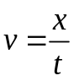 This is also used when an object has a constant velocity.

We end up with three equations for average velocity, but they’re all just variations of the same equation.

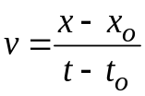 or

It is very common to use other letters for displacement. For example, you might use s for some general displacement. You might use y if the motion is in the y direction. h is sometimes used if the distance is a vertical distance and r might be used if we’re talking about the radius of a circle.

- In the 1988 Summer Olympics, Florence Griffith-Joyner won the 100 m race in a time of 10.54 s. Assuming the distance was laid out to the nearest centimeter so that it was actually 100.00 m, what was her average velocity in m/s and km/h?

- You begin a trip and record the odometer reading. It says 45 545.8 miles. You drive for 35 minutes. At the end of that time the odometer reads 45 569.8 miles. What was your average speed in miles per hour?

- A high speed train travels from Paris to Lyons at an average speed of 227 km/h. If the trip takes 2.00 h, how far is it between the two cities?

All Motion Is Relative: Motion, i.e. velocity, is said to be relative. This is an important concept. What it means is that when we say that something has a given velocity, that velocity is relative to something else (these are called reference frames). So a car traveling to the east at 125 km/h is doing so relative to the earth. One is not moving - has no motion. This is true with respect to the room. However, the room and everything in it is rotating around the center of the earth. Not only that, but the earth itself is moving around the sun in its orbit! The solar system is moving around the center of the galaxy! The galaxy (and everything in it) is also moving away from the center of the universe!

If you are a passenger in an aircraft traveling at 500 mph over the earth, you are moving at 500 mph relative to the earth, but have no motion relative to the plane, unless you get up and go walking in the aisle, then you might have a motion, relative to the plane, of, say, 3 mph. Depending on which way you go, your motion relative to the earth could be 503 mph or 497 mph.

Position vs. Time Graphs: Let’s look at a graph of position vs time:
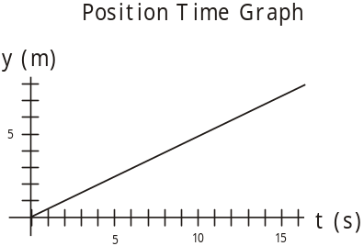
Displacement is plotted on the y axis and time is plotted on the x axis. The curve is a straight line. No doubt you recall that the equation for a straight line is:

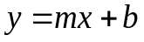

m is the slope and b is the y intercept

The slope is the change in y divided by the change in x. (Otherwise known as “the rise over the run”.)

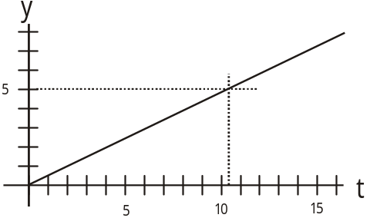
Since we are graphing displacement on the y axis, the change in y is simply the change in displacement, or Δy. We have Δt for the x axis. So the slope is:

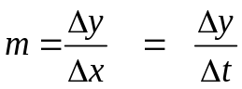
But 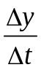 is the velocity v!

Therefore the slope of the displacement Vs time graph is the velocity.

- What is the velocity of the object whose motion is depicted in this graph?

Acceleration: When the velocity of an object is not constant, the rate at which it changes is defined as the acceleration. The symbol for acceleration is a.

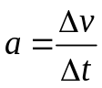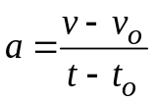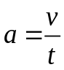

Acceleration is a vector quantity, just like velocity.

- A plane goes from rest to speed of 235 km/h in 15.0 s. Find the acceleration.

4.35 m/s² means that the velocity changes by 4.35 m/s every second. At the end of the first second it is 4.35 m/s, after two seconds it is 8.70 m/s, after three seconds it is 13.0 m/s, after four seconds it would be 17.4 m/s, &tc.

- A car slows from 85.5 m/s to a speed of 33.2 m/s in 1.25 s. Find the acceleration.

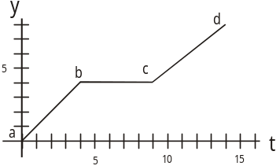
The minus sign means that the acceleration is in the opposite direction from the velocity.

We will always use m/s² for the units for acceleration. This is because things on earth don’t accelerate for long periods of time. Very few things can actually accelerate for more than a few seconds.

Let us now look at another position vs time graph.
In this graph, the slope of the graph changes from section ab to bc and then cd. This means that the velocity has to change along these paths. The object moves at a constant velocity from zero displacement to a displacement of 4 m (this is from a – b). This takes 4 seconds. Its velocity is a constant 1 m/s (the slope, right?). After the 4 seconds the object stops. It remains at rest for five seconds (b – c) and moves with a constant speed from time 9 s to time 14 s (c – d). Its velocity from 10 s to 15 s is:

Here’s another example. This time we’re looking at a velocity Vs time graph. During a baseball game a player runs after a fly ball. What is the player’s acceleration from a to b, b to c, and c to d?

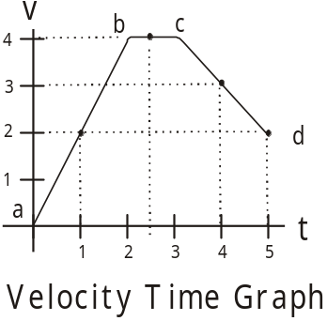
The slope of the curve represents the acceleration.

a to b: 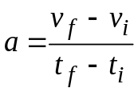 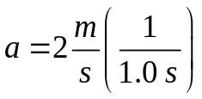

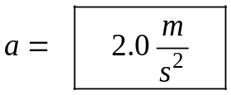

The player is initially at rest, the ball is hit and the player takes off to catch it. He accelerates from rest for four seconds. At the end of the four seconds, his velocity is 4 m/s.

b to c: the slope is zero, so a is zero. The player is moving at a constant speed of 4 m/s for this portion of the graph.

c to d: 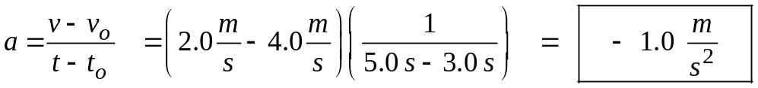

The player is slowing down. He ends up moving at 2 m/s when he finally catches the ball.

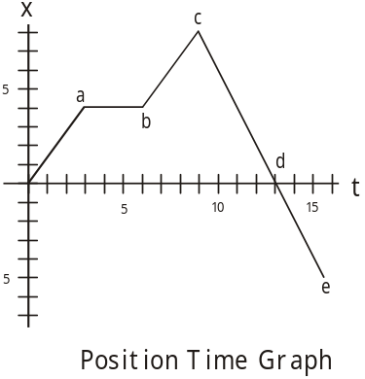
- Here’s another example; look at this graph:

Using this graph, find (a) the velocity from start to a, (b) the velocity from a to b, (c) the velocity from b to c, (d) the velocity from c to d, (e) the velocity from d to e, (f) find the displacement after 7.0 s, (g) make a velocity Vs time graph for this system.

One Dimensional Motion, Constant Acceleration:

If a body is undergoing a constant acceleration, we can analyze the motion and come up with several equations that will describe the motion.

Start with the equation for acceleration:

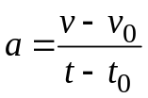 let 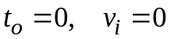 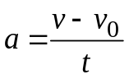 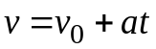

Here are two more important equations:

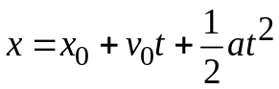

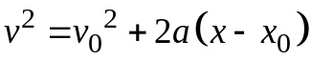

So here are our three kinematic motion equations. These will be provided to you on the AP Physics Test. This is their form on the test equation sheet.

v as function of time

x as a function of time

x as function of velocity

These equations simplify if initial conditions are zero. It is perfectly acceptable to use the simplified equations when solving problems.

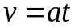

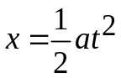

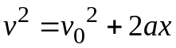 or 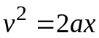

- A car undergoes an average acceleration of 3.55 m/s². If the car is accelerated for 8.50 seconds, how far has it traveled?

- A truck undergoes an average acceleration of 2.50 m/s² as it speeds up. If it starts from rest, and accelerates for a distance of 875 m, how much time did it take to cover the distance?

- A car accelerates at 7.55 m/s². If it accelerates for 4.25 s, what speed does it reach?

- A car accelerates at 9.00 m/s². If its initial velocity was 35.5 m/s and its final velocity is 107 m/s, what distance does it cover during the acceleration?

Dear Doctor Science,
You're driving down the highway behind a vehicle that's doing only 50 mph. When you try to pass this vehicle, it speeds up to keep pace with you. Even if you're now going 100 mph, you still can't seem to pass this car. What's going on?
-- Karin S from Woodland Park, CO

Dr. Science responds:
Every slow moving car emits a force field that extends from the rear bumper of the car back to the car directly behind it. When you accelerate and approach the slow car, you compress the field. DeSoto's Third Law demands that a decrease in bumper force field size be compensated by an increase in axle rotation. So stop blaming the other guy; it's you who's in the driver's seat.

