Photosynthesis and Cellular Respiration
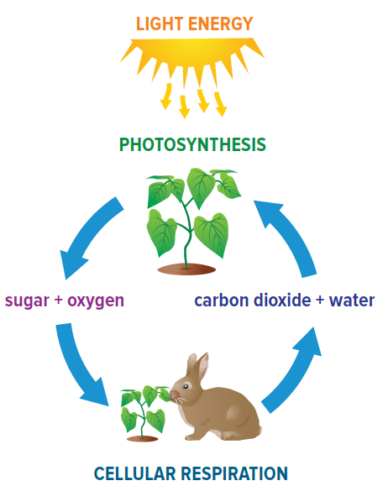
Photosynthesis – the process by which plant cells convert sunlight, carbon dioxide, and water into sugars and oxygen. This occurs in the chloroplast.
6CO₂ + 6H₂O + sunlight (energy) → C₆H₁₂O₆ + 6O₂
carbon dioxide + water + sunlight (energy) → sugar + oxygen
Cellular respiration – how plant and animal cells get their energy. This reaction occurs in the mitochondria.
C₆H₁₂O₆ + 6O₂ → 6CO₂ + 6H₂O + energy
sugar + oxygen → carbon dioxide + water + energy
What do you notice about the two equations above? OPPOSITES!
Complete the table to compare photosynthesis and cellular respiration. Refer to the information and figure above to help you complete the table.
 | Photosynthesis | Cellular Respiration
Type of cell(s) it takes place in | Eukaryotic | Eukaryotic
Type of organelle it is associated with | Chlorplast | Mitochondria
Reactants | CO₂, H₂O | C₆H₁₂O₆, 6O₂
Products | C₆H₁₂O₆, 6O₂ | CO₂, H₂O
Is energy stored or released? | Stored! | Released!
- What are the similarities between cellular respiration and photosynthesis?
Both involve Sugar, Oxygen, Water, and Energy
- Do you see any differences/relationships between photosynthesis and cellular respiration
One creates produces energy, one releases it.
Note: When there is no oxygen present, yeast and bacteria do a process called fermentation in which sugar is converted to carbon dioxide, alcohol and energy. This was the focus of our last lab!
