SECTION C – Geometric Optics

1. The critical angle of a material is the angle of incidence for which the angle of refraction is:  
A) 0° B) 30° C) 45° D) 90° E) 180°

2. An object is located 0.20 meters from a converging lens which has a focal length of 0.15 meters. Relative to the object, the image formed by the lens will be:  
A) real, erect, smaller. B) real, inverted, smaller. C) real, inverted, larger   
D) virtual, erect, larger. E) virtual, inverted, smaller.

3. A plane mirror produces an image that is  
A) real, inverted and larger than the object.   
B) real, upright, and the same size of the object.  
C) real, upright, and smaller than the object.   
D) virtual, inverted, and smaller than the object.  
E) virtual, upright, and the same size as the object.

4. The principle underlying fiber optics is:  
A) diffraction B) dispersion C) interference D) polarization E) total internal reflection

5. A diverging lens produces and image of a real object that is:  
A) real, inverted and larger than the object.  
B) real, upright, and the same size as the object.  
C) virtual, inverted, and smaller than the object.  
D) virtual, upright, and larger than the object.  
E) virtual, upright, and smaller than the object.

6. Light that has a wavelength of 500 nm in air has a wavelength 400 nm in a transparent material. What is the index of refraction of the material?  
A) 0.64 B) 0.80 C) 1.00 D) 1.25 E) 1.56

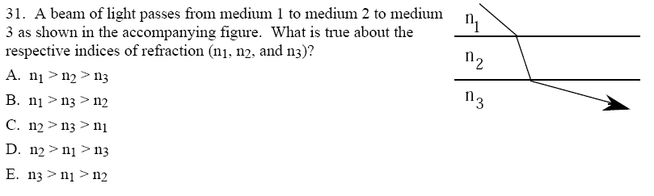

7. A beam of light passes from medium 1 to medium 2 to medium 3 as shown in the accompanying figure. What is true about the respective indices of refraction (n1, n2, and n3)  
A) n1 > n2 > n3 B) n1 > n3 > n2 C) n2 > n3 > n1   
D) n2 > n1 > n3 E) n3 > n1 > n2

8. A laser is embedded in a material of index of refraction n. The laser beam emerges from the material and hits a target. See the accompanying figure for the position parameters of the laser and target. The value of n is:

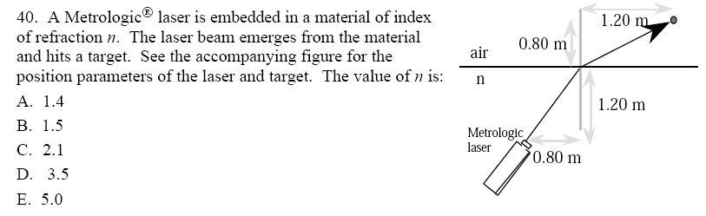

A) 1.4 B) 1.5 C) 2.1 D) 3.5 E) 5.0

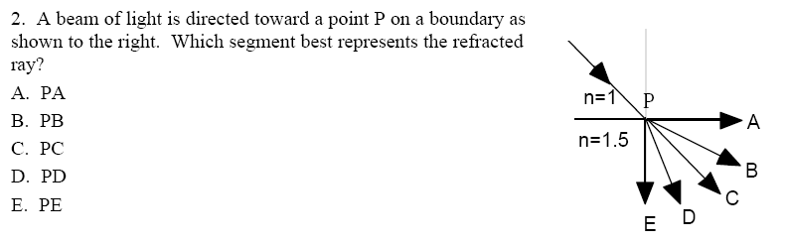9. A beam of light is directed toward point P on a boundary as shown to the right. Which segment best represents the refracted ray?  
A) PA B) PB C) PC D) PD E) PE

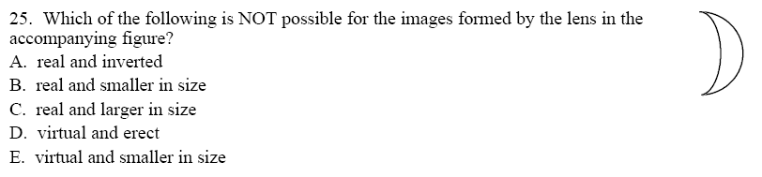10. Which of the following is NOT possible for the images formed by the lens in the accompanying figure?

A) real and inverted  
B) real and smaller in size  
C) real and larger in size  
D) virtual and erect  
E) virtual and smaller in size

11. A narrow beam of monochromatic light enters a lens parallel to the optic axis, as shown in the accompanying diagram. Which arrow best represents the direction of the light after leaving the lens?  
A) A B) B C) C D) D E) E

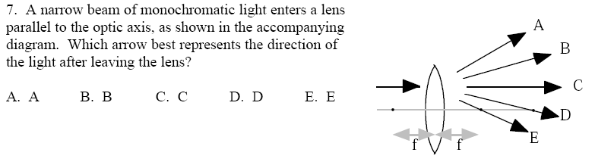

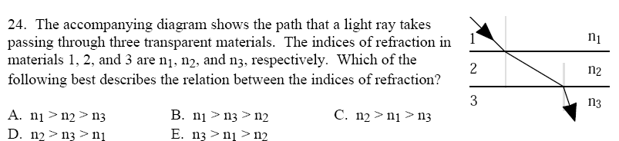12. The accompanying diagram shows the path that a light ray takes passing through three transparent materials. The indices of refraction in materials 1, 2, and 3 are n1, n2, and n3, respectively. Which of the following best describes the relation between the indices of refraction?

A) n1 > n2 > n3 B) n1 > n3 > n2 C) n2 > n1 > n3  
D) n2 > n3 > n1 E) n3 > n1 > n2

13. Which diagram best represents what happens to a ray of light entering air from water? Air is at the top in all diagrams.  
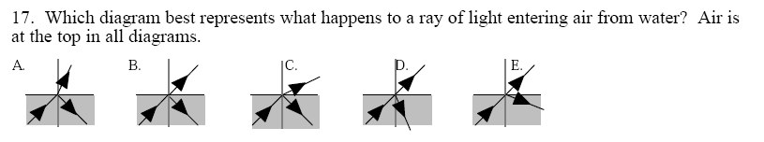

14. In order to produce and enlarged, upright image of an object, you could use a  
A) converging lens more than one focal length from the object.  
B) converging lens less than one focal length from the object.  
C) diverging lens more than one focal length from the object.  
D) diverging lens exactly one focal length from the object.  
E) diverging lens less than one focal length from the object.

15. The critical angle in a transparent substance surrounded by air is 30°. The speed of light in the substance (in multiples of 108 m/s) is most nearly  
A) 1.0 B) 1.5 C) 2.0 D) 3.0 E) 6.0

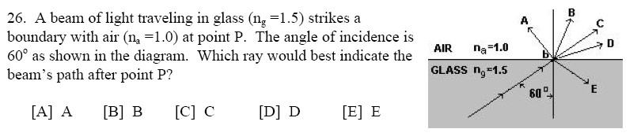16. A beam of light traveling in glass (ng = 1.5) strikes a boundary with air (na = 1.0) at point P. The angle of incidence is 60° as shown in the diagram. Which ray would best indicate the beam’s path after point P?  
A) A B) B C) C D) D E) E

17. A small light bulb is placed 20 cm to the right of a converging lens of focal length 10 cm. Which of the following statements is NOT true about the image of the bulb formed by the lens?  
A) It is virtual  
B) It is inverted  
C) It is the same size as the bulb  
D) It is 20 cm to the left of the lens  
E) It can be projected on a screen

18. An image is formed on a screen by a convergent lens. If the top half of the lens is then covered what will happen to the image?  
A) the image is dimmer but otherwise unchanged  
B) the image becomes half as big  
C) only the top half of the image is produced  
D) only the bottom half of the image is produced  
E) the image becomes half as big and is inverted from its original position.

19. A wave moves from one medium to as second medium with a different index of refraction. Which of the following wave properties would NEVER change?  
A) frequency B) wavelength C) speed D) angle E) all will change

20. Specular reflection occurs whenever light is incident on   
A) a smooth surface  
B) a rough surface  
C) a boundary between high index of refraction and low index of refraction materials  
D) a boundary between low index of refraction and high index of refraction materials  
E) a boundary between any two transparent substances, regardless of index of refraction

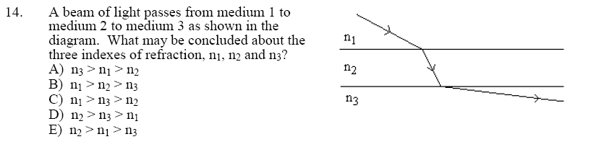21. A beam of light passes from medium 1 to medium 2 to medium 3 as shown in the diagram. What may be concluded about the speed of light in each medium?  
A) v3 > v1 > v2 B) v1 > v2 > v3 C) v1 > v3 < v2   
D) v2 > v3 > v1 E) v2 > v1 > v3

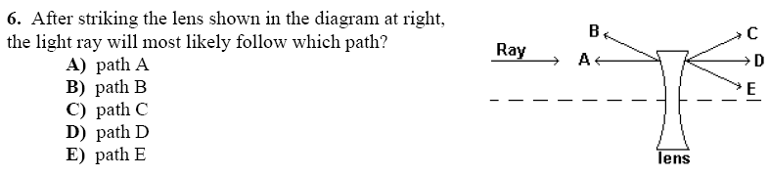

22. After striking the lens shown in the diagram at right, the light ray will most likely follow which path?  
A) A B) B C) C D) D E) E

23. An object is placed 10 cm in front of the center of a concave curved mirror with a radius of curvature of 10 cm. About how far from the mirror will the real image of the object be formed?  
A) 0 cm B) 5 cm C) 10 cm D) 20 cm E) No image is formed

24. Light travels from material X with an index of refraction of n=1.5 to material Y with an index of refraction of n=2.0. If the speed of light in material Y is v, what is the speed of light in material X?  
A) 0.56 v B) 0.75 v C) 1.33 v D) 1.78 v E) 3.0 v

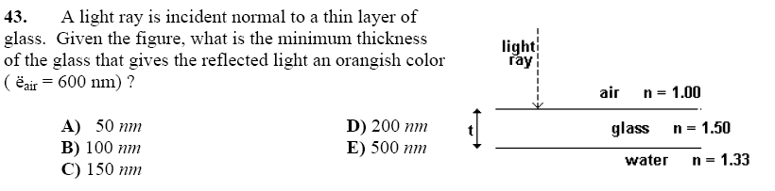25. A light ray is incident normal to a thin layer of glass. Given the figure, what is the minimum thickness of the glass that gives the reflected light an orangish color   
(λ(air) orange light = 600nm)

A) 50 nm

B) 100 nm   
C) 150 nm   
D) 200 nm   
E) 500 nm

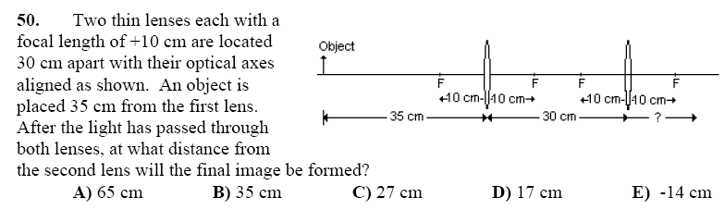26. Two thin lenses each with a focal length of +10 cm are located 30 cm apart with their optical axes aligned as shown. An object is placed 35 cm from the first lens. After the light has passed through both lenses, at what distance from the second lens will the final image be formed?  
A) 65 cm B) 35 cm C) 27 cm D) 17 cm E) –14 cm

27. A jeweler can distinguish between a diamond and a piece of glass by observing the critical angle of light in each material. Glass with an index of refraction of 1.52 has a critical angle of 41.1° while a diamond with an index of refraction of 2.42 would have critical angle of:  
A) 65.4° B) 38.9° C) 25.8° D) 24.4° E) 16.2°

28. What causes chromatic aberration in a glass lens

A) Each wavelength of light reflects from the surface of the lens  
B) Each wavelength of light is refracted a different amount by the lens  
C) White light waves interfere inside the lens  
D) White light waves diffract around the edge of the lens  
E) Chromatic aberration occurs with mirrors, not lenses

29. A converging lens forms a virtual image of a real object that is two times the objects size. The converging lens is replaced with a diverging lens having the same size focal length. What is the magnification of the image formed by the diverging lens?  
A) –1 B) –2/5 C) 2/3 D) 3/2 E) 5/2



30. A beam of light travels through the air and strikes the surface of water at an angle of incidence of 45°. It continues through the water and then strikes the bottom of a glass aquarium. Which of the following would be closest to the angle of refraction after the beam enters the glass. The index of refraction of water is 1.3 and that of glass is 1.5

A) 55° B) 45° C) 38° D) 33° E) 28°.

31. Light shines from air into a clear material. When the light makes an angle of incidence equal to 30°, the light refracts at an angle of 15°. If the light is shone from an angle of incidence of 60°, what is the angle of refraction?  
A) 19.5° B) 26.6° C) 30° D) 45° E) 60°

32. An object is in front of a convex lens, at a distance less than the focal length from the lens. Its image is  
A) virtual and larger than the object.  
B) real and smaller than the object.  
C) virtual and smaller than the object.  
D) real and larger than the object.  
E) virtual and the same size as the object.

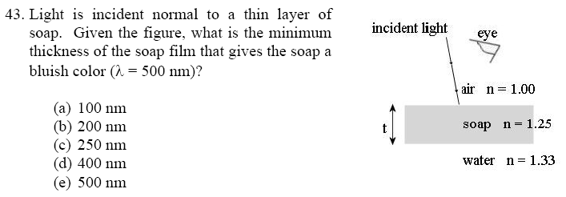33. Light is incident normal to a thin layer of soap. Given the figure, what is the minimum thickness of the soap film that gives the soap a bluish color (λair(blue) = 500 nm)?  
A) 100 nm B) 200 nm C) 250 nm D) 400 nm E) 500 nm

34. If the frequency of a periodic wave is doubled, the period of the wave will be

A) halved B) quartered C) doubled D) quadrupled E) unchanged

1. 35. For which of the following does one obtain an image of increased size from a real object? Take all focus and radius of curvature values as positive.
2. (a) The object is placed at a position outside the radius of curvature for a converging lens.
3. (b) The object is placed at a position outside the radius of curvature for a diverging lens.
4. (c) The object is placed at a position inside the magnitude of the focus for a concave lens.
5. (d) The object is placed at a position between the focus and radius of curvature for a concave mirror.

(e) The object is placed at a position between the focus and the radius of curvature for a convex mirror.

36. A sound wave generated from a tuning fork of single frequency travels from air (with speed of sound 340 m/s) into rock (with speed of sound 1500 m/s). Which statement is true about the wavelength and frequency of the sound as it passes from air to rock?  
A) The frequency of the sound increases and the wavelength increases.  
B) The frequency of the sound increases and the wavelength is unchanged.  
C) The frequency of the sound is unchanged and the wavelength is decreased.  
D) The frequency of the sound is unchanged and the wavelength is increased.  
E) The frequency of the sound decreases and the wavelength is increased.

37. When a beam of white light passes through a prism, the exiting light is seen as a spectrum of visible colors. This phenomenon is known as

(A) diffraction. (B) dispersion. (C) interference. (D) polarization. (E) reflection.

38. Modern telescopes use mirrors, rather than lenses, to form images. One advantage of mirrors over lenses is that the images formed by mirrors are not affected by:

(A) destructive interference (D) spherical aberration

(B) constructive interference (E) atmospheric refraction

(C) chromatic aberration

39. A diverging lens produces an image of a real object. This image is

(A) virtual, larger than the object, and upright.

(B) virtual, smaller than the object, and upright.

(C) virtual, smaller than the object, and inverted.

(D) real, smaller than the object, and inverted.

(E) real, larger than the object, and inverted

40. A light beam passes through the air and strikes the surface of a plastic block. Which pair of statements correctly describes the phase changes for the reflected wave and the transmitted wave?

Reflected wave Transmitted wave

(A) 90° 90°

(B) No phase change 180°

(C) No phase change No phase change

(D) 180° 180°

(E) 180° No phase change

41. The diagram below shows the path taken by a monochromatic light ray traveling through three media. The symbols *v*1,λ1, and *f*1represent the speed, wavelength, and frequency of the light in Medium 1, respectively. Which of the following relationships for the light in the three media is true?



42. A real object is located in front of a convex lens at a distance greater than the focal length of the lens. What type of image is formed and what is true of the image’s size compared to that of the object?

Type of Image Size of Image

(A) Real Larger than object

(B) Real More information is needed

(C) Virtual Smaller than object

(D) Virtual Larger than object

(E) More information is needed More information is needed

43. A thin film of thickness *t* and index of refraction 1.33 coats a glass with index of refraction 1.50 as shown to the right. Which of the following thicknesses *t* will not reflect light with wavelength 640 nm in air?   
A) 160 nm B) 240 nm C) 360 nm D) 480 nm E) 640 nm



44. Which of the following wave properties cannot be demonstrated by all kinds of waves?

A) Polarization B) Diffraction C) Superposition D) Refraction E) Frequency

45. Lenses in fine quality cameras are coated to reduce the reflection from the lenses. If the coating material has an index of refraction between that of air and glass, what thickness of coating will produce the least reflection?   
A) one–quarter of the wavelength in the coating

B) one–third of the wavelength in the coating

C) one–half of the wavelength in the coating

D) one wavelength in the coating

E) the amount of reflection is independent of the thickness of the coating.

46. A beam of light from the air is incident on a transparent block of material. The angle of incidence is 49° while the angle of refraction is 30°. What is the velocity of light in the transparent material?

A) 1.8 x 108 m/s B) 2.0 x 108 m/s C) 2.3 x 108 m/s D) 3.0 x 108 m/s E) 4.5 x 108 m/s

47. Light with a wavelength of 500 nm in a vacuum enters a liquid with an index of refraction of 1.25 at an angle of incidence of 40°. What would be the wavelength of the light in the liquid?

A) 320 nm B) 400 nm C) 500 nm D) 625 nm E) 780 nm

48. Light strikes three different thin films, which are in air, as shown. If *t* denotes the film thickness and λ denotes the wavelength of the light in the film, which films will produce constructive interference as seen by the observer?

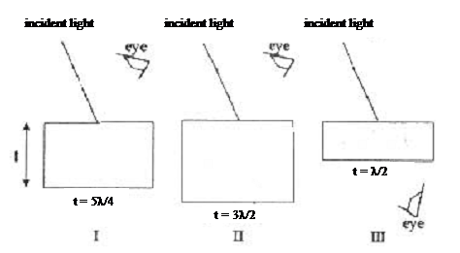

A) I only B) II only C) III only D) II and III only E) I and III only.

49. The critical angle for a transparent material in air is 30°. The index of refraction of the material is most nearly

(A) 0.33 (B) 0.50 (C) 1.0 (D) 1.5 (E) 2.0

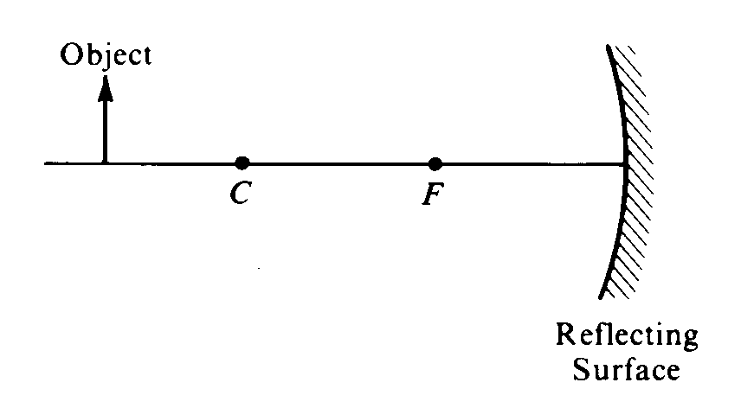

50. An object is placed as shown in the figure above. The center of curvature C and the focal point F of the reflecting surface are marked. As compared with the object, the image formed by the reflecting surface is

(A) erect and larger (B) erect and the same size (C) erect and smaller

(D) inverted and larger (E) inverted and smaller

51. When one uses a magnifying glass to read fine print, one uses a

(A) converging lens to produce a virtual image of the print

(B) converging lens to produce a real image of the print

(C) mirror to produce a virtual image of the print

(D) diverging lens to produce a real image of the print

(E) diverging lens to produce a virtual image of the print

52. Which color of light is associated with the highest speed in a vacuum?

(A) Blue (B) Green (C) Red (D) Violet (E) They are all the same

53. An illuminated object is placed 0.30 meter from a lens whose focal length is –0.15 meter. The image is

(A) inverted, real, and 0.30 meter from the lens on the opposite side from the object

(B) upright, virtual, and 0.30 meter from the lens on the opposite side from the object

(C) upright, real, and 0.10 meter from the lens on the same side as the object

(D) upright, virtual, and 0.10 meter from the lens on the same side as the object

54. Which of the following CANNOT be accomplished by a single converging lens with spherical surfaces?  
(A) Converting a spherical wave front into a plane wave front  
(B) Converting a plane wave front into a spherical wave front  
(C) Forming a virtual image of a real object  
(D) Forming a real upright image of a real upright object  
(E) Forming a real inverted image of a real upright object

55. The image of the arrow is larger than the arrow itself in which of the following cases?

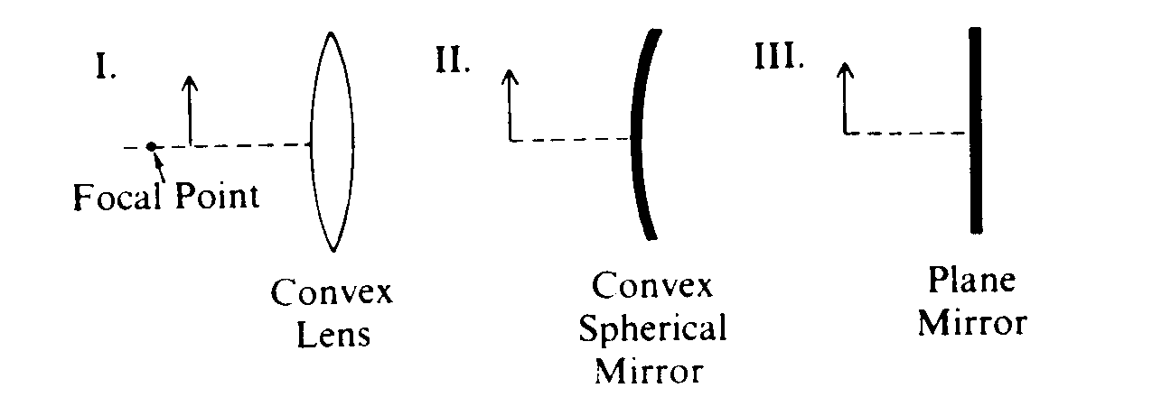

(A) I only (B) II only (C) I and III only (D) II and III only (E) I, II and III

56. A postage stamp is placed 30 centimeters to the left of a converging lens of focal length 60 centimeters. Where is the image of the stamp located?  
(A) 60 cm to the left of the lens (B) 20 cm to the left of the lens   
(C) 20 cm to the right of the lens (D) 30 cm to the right of the lens   
(E) 60 cm to the right of the lens

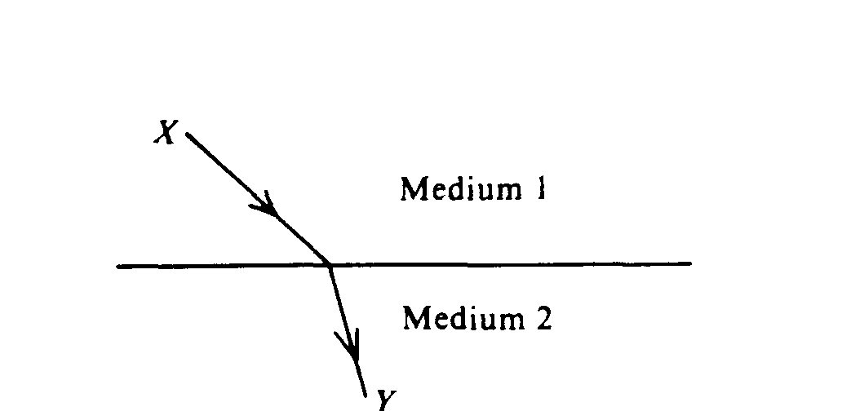

57. Light leaves a source at X and travels to Y along the path shown above. Which of the following statements is correct?  
(A) The index of refraction is the same for the two media.   
(B) Light travels faster in medium 2 than in medium 1.  
(C) Snell's law breaks down at the interface.  
(D) Light would arrive at Y in less time by taking a straight line path from X to Y than it does taking the path shown above.  
(E) Light leaving a source at Y and traveling to X would follow the same path shown above, but in reverse.

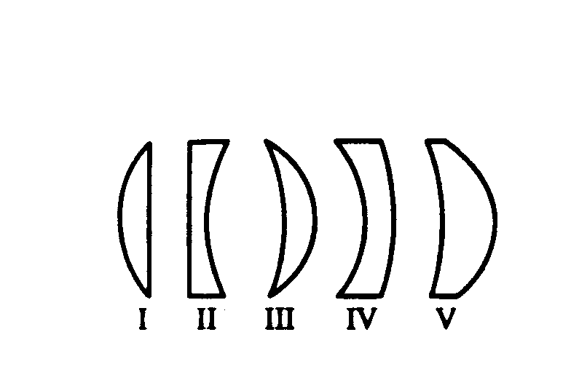

58. Which three of the glass lenses above, when placed in air, will cause parallel rays of light to converge?  
(A) I, II, and III (B) I, III, and V (C) I, IV, and V (D) II, III, and IV (E) II, IV, and V

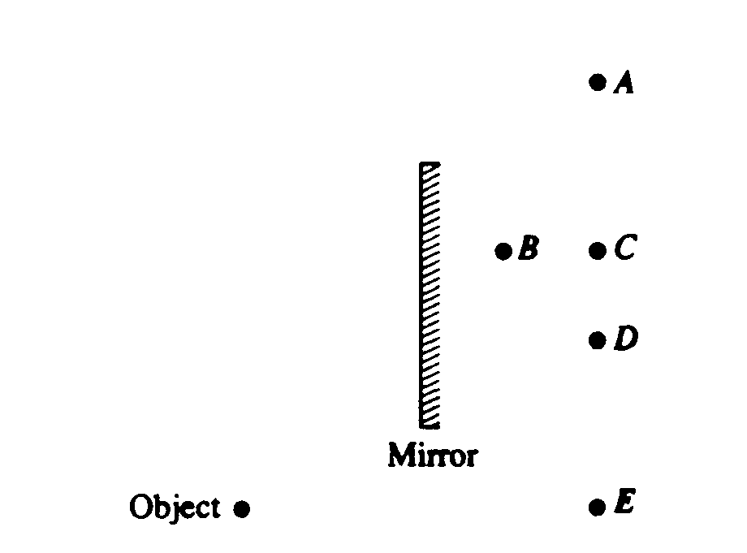

59. An object is placed near a plane mirror, as shown above. Which of the labeled points is the position of the image?  
(A) A (B) B (C) C (D) D (E) E

60. Observations that indicate that visible light has a wavelength much shorter than a centimeter include which of the following?  
 I. The colored pattern seen in a soap bubble  
 II. The colored pattern seen when light passes through a diffraction grating  
 III. The bending of light when it passes from one medium to another medium  
(A) I only (B) III only (C) I and II only (D) II and III only (E) I, II, and III

61. If the object distance for a converging thin lens is more than twice the focal length of the lens, the image is  
(A) virtual and erect (B) larger than the object (C) located inside the focal point  
(D) located at a distance between f and 2f from the lens (E) located at a distance more than f from the lens

62. A concave mirror with a radius of curvature of 1.0 m is used to collect light from a distant star. The distance between the mirror and the image of the star is most nearly

(A) 0.25 m (B) 0.50 m (C) 0.75 m (D) 1.0 m (E) 2.0 m

63. When light passes from air into water, the frequency of the light remains the same. What happens to the speed and the wavelength of light as it crosses the boundary in going from air into water?

Speed Wavelength

(A) Increases Remains the same

(B) Remains the same Decreases

(C) Remains the same Remains the same

(D) Decreases Increases

(E) Decreases Decreases

64. A physics student places an object 6.0 cm from a converging lens of focal length 9.0 cm. What is the magnitude of the magnification of the image produced?

(A) 0.6 (B) 1.5 (C) 2.0 (D) 3.0 (E) 3.6

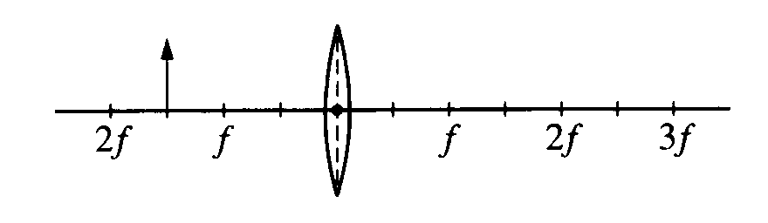65. An object is placed at a distance of 1.5f from a converging lens of focal length f, as shown. What type of image is formed and what is its size relative to the object?

Type Size

(A) Virtual Larger

(B) Virtual Same size

(C) Virtual Smaller

(D) Real Larger

(E) Real Smaller

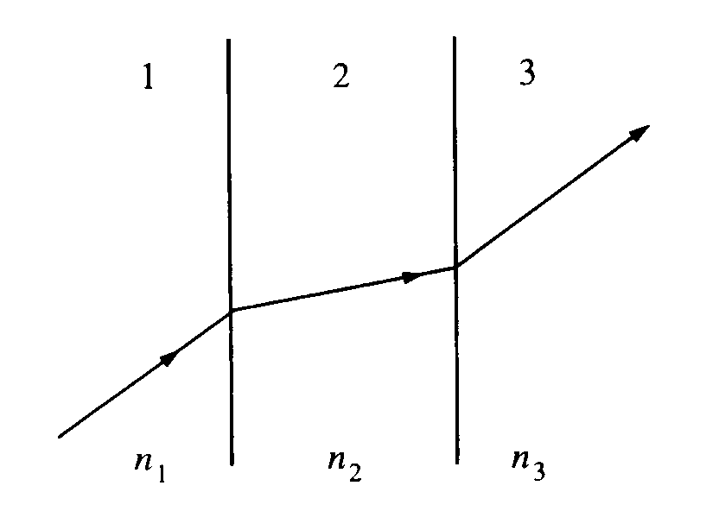

66. A light ray passes through substances 1, 2, and 3, as shown. The indices of refraction for these three substances are n1, n2, and n3, respectively. Ray segments in 1 and in 3 are parallel. From the directions of the ray, one can conclude that

(A) n3 must be the same as n1   
(B) n2 must be less than n1

(C) n2 must be less than n3   
(D) n1 must be equal to 1.00

(E) all three indices must be the same

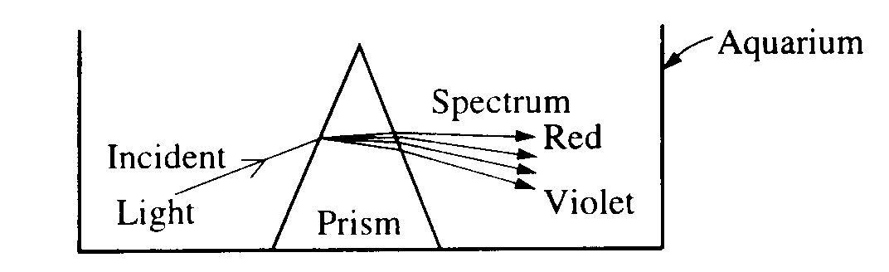67. A beam of white light is incident on a triangular glass prism with an index of refraction of about 1.5 for visible light, producing a spectrum. Initially, the prism is in a glass aquarium filled with air, as shown above. If the aquarium is filled with water with an index of refraction of 1.3, which of the following is true?

(A) No spectrum is produced.

(B) A spectrum is produced, but the deviation of the beam is opposite to that in air.

(C) The positions of red and violet are reversed in the spectrum.

(D) The spectrum produced has greater separation between red and violet than that produced in air.

(E) The spectrum produced has less separation between red and violet than that produced in air.

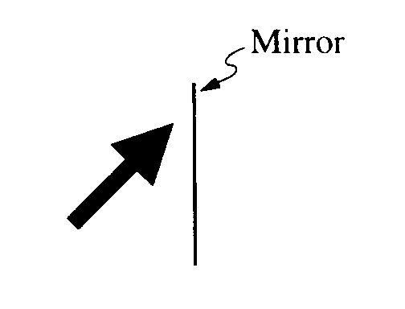

68. An object, slanted at an angle of 45°, is placed in front of a vertical plane mirror, as shown above. Which of the following shows the apparent position and orientation of the object's image?

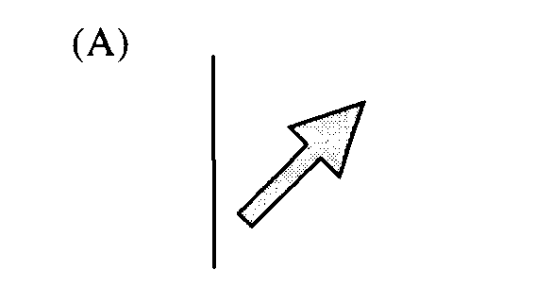 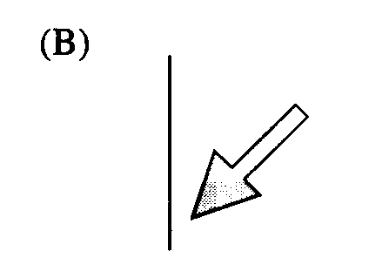 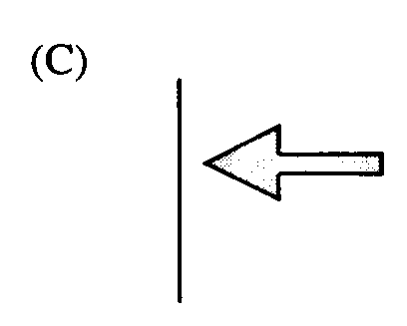 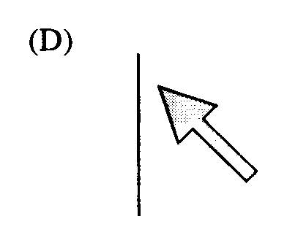 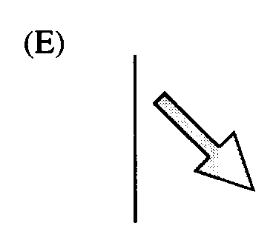



69. The spherical mirror shown has a center of curvature at point c. Which point is nearest to the focal point?

(A) a (B) b (C) c (D) d (E) e

70. An object is placed in front of a converging thin lens at a distance from the center of the lens equal to half the focal length. Compared to the object, the image is

(A) upright and larger

(B) upright and smaller

(C) inverted and larger

(D) inverted and smaller

(E) inverted and the same size

71. Which of the following is characteristic of both sound and light waves?

(A) They are longitudinal waves.

(B) They are transverse waves.

(C) They travel with the same velocity.

(D) They can be easily polarized

(E) They give rise to interference effects

72. A thin film with index of refraction n1 separates two materials, each of which has an index of refraction less than nf. A monochromatic beam of light is incident normally on the film, as shown above. If the light has wavelength λ within the film, maximum constructive interference between the incident beam and the reflected beam occurs for which of the following film thicknesses?

(A) 3λ (B) 2λ (C) λ (D) λ/2 (E) λ/4

Questions 73-74



A light ray R in medium I strikes a sphere of medium II with angle of incidence θ, as shown above. The figure shows five possible subsequent paths for the light ray.

73. Which path is possible if medium I is air and medium II is glass?

(A) A (B) B (C) C (D) D (E) E

74. Which path is possible if medium I is glass and medium II is air?

(A) A (B) B (C) C (D) D (E) E

75. An object is placed on the axis of a converging thin lens of focal length 2 cm, at a distance of 8 cm from the lens. The distance between the image and the lens is most nearly

(A) 0.4 cm (B) 0.8 cm (C) 1.6 cm (D) 2.0 cm (E) 2.7 cm

76. A large lens is used to focus an image of an object onto a screen. If the left half of the lens is covered with a dark card, which of the following occurs

(A) The left half of the image disappears (D) The image becomes dimmer

(B) The right half of the image disappears (E) No image is formed

(C) The image becomes blurred

77. Which of the following statements are true for both sound waves and electromagnetic waves?

I. They can undergo refraction.

II. They can undergo diffraction.

III. They can produce a two-slit interference pattern.

IV. They can produce standing waves.

(A) I and II only (B) III and IV only (C) I, II, and III only

(D) II, III, and IV only (E) I, II, III, and IV



78. As shown, a beam of white light is separated into separate colors when it passes through a glass prism. Red light is refracted through a smaller angle than violet light because red light has a

(A) slower speed in glass than violet light

(B) faster speed in glass than violet light

(C) slower speed in the incident beam than violet light

(D) faster speed in the incident beam than violet light

(E) greater intensity than violet light

79. A ray of light in glass that is incident on an interface with ice, as shown, is partially reflected and partially refracted. The index of refraction *n* for each of the two media is given in the figure. How do the angle of reflection and the angle of refraction compare with the angle of incidence *θ* ?

Angle of Angle of

Reflection Refraction

(A) Same Larger

(B) Same Smaller

(C) Smaller Same

(D) Smaller Smaller

(E) Larger Larger

Questions 80–81:

An object *O* is located at point *P* to the left of a converging lens, as shown in the figure. *F*1 and *F*2 are the focal points of the lens.

80. If the focal length of the lens is 0.40 m and point *P* is 0.30 m to the left of the lens, where is the image of the object located?

(A) 1.2 m to the left of the lens

(B) 0.17 m to the left of the lens

(C) At the lens

(D) 0.17 m to the right of the lens

(E) 1.2 m to the right of the lens

81. Which of the following characterizes the image when the object is in the position shown?

(A) Real, inverted, and smaller than the object

(B) Real, upright, and larger than the object

(C) Real, inverted, and larger than the object

(D) Virtual, upright, and larger than the object

(E) Virtual, upright, and smaller than the object

82. On a day when the speed of sound is 340 m/s, a ship sounds its whistle. The echo of the sound from the shore is heard at the ship 6.0 s later. How far is the ship from the shore?

(A) 56.7 m (B) 113 m (C) 1020 m (D) 2040 m (E) 4080 m

83. A ray of light in air is incident on a 30-°60°-90° prism, perpendicular to face *ab*, as shown in the diagram. The ray enters the prism and strikes face *ac* at the critical angle. What is the index of refraction of the prism?



SECTION C – Geometric Optics

|  |  |  |
| --- | --- | --- |
|  | Solution | Answer |
| 1. | Definition of critical angle. | D |
| 2. | Using the math, 1/f = 1/do+ 1/di, and M = – di / do … di +0.6 M = – 3 … | C |
| 3. | Plane mirrors always makes virtual, same size, upright images. | E |
| 4. | Fiber optics involves reflecting light in a fiber strand as the light carries the signal along the fiber. | E |
| 5. | Fact about diverging lens. | E |
| 6. | Use n1 λ1 = n2 λ2 | D |
| 7. | More–Less dense bend away, Less–More dense bend towards. The more the bend, the bigger the difference in n’s. | D |
| 8. | If you look carefully you can see these are both 3–4–5 triangles and are also the same triangle flipped. The hypotenuse of each is 1.5 m. Using the sides of the triangles, we have  sin θ1 = o/h = 0.8/1.5 for the bottom triangle, and sin θ2 = o/h = 1.2/1.5 for the top triangle. Now use n1 sin θ1 = n2 sin θ2 … n1 (0.8/1.5) = (1) (1.2/1.5) … n1 = 1.2/0.8 = 3/2 =1.5 | B |
| 9. | Less–More bend towards. But it can’t be E because that would only happen if the incoming angle was also 0. | D |
| 10. | The lens shown has thick in the center and thin on the outside which makes a converging lens. In converging lenses, all of the real images are inverted and can be any size, but the virtual images are formed in a magnifying lens scenario and are always larger and upright. | E |
| 11. | A horizontal beam approaching a converging lens bends and converges through the focal point. | E |
| 12. | More–Less dense bend away, Less–More dense bend towards. The more the bend, the bigger the difference in n’s. | E |
| 13. | Assuming total internal reflection didn’t happen, More–Less dense bend away. | C |
| 14. | Need a magnifying glass which is choice B. | B |
| 15. | Use ni sin θc = nr sin (90), nr=1 … ni = 2, then n = c / v to find v. | B |
| 16. | Generally when we go from more–less we should always check the critical angle first rather than assuming the ray will refract and bend away. Choice D might be correct, but not until we first check the critical angle for total internal reflection. Use ni sin θc = nr sin (90), ni=1.5, nr=1 θc = 41.8°. Since our incoming angle (60) is larger than the critical angle, total internal reflection will occur and you will get choice E. | E |
| 17. | Using the math, 1/f = 1/do+ 1/di, and M = – di / do … di +20 M = – 1 … | A |
| 18. | When light from multiple locations pass through a given part of a lens to form an image, only a small portion of a lens is needed to form the image. The more of a lens, the more light rays that can be bent by it to each image location. This simply makes the image brighter. By covering half the lens, all of the incoming rays still bend all the same ways but there are less total rays being bent to given locations on the image so it is dimmer. This can easily be seen by looking at a lens that has only horizontal rays approaching it. All of these rays converge to the focal point; covering a portion of the lens still focuses the rays on the focal point, just less of them. | A |
| 19. | Fact for refraction problems. | A |
| 20. | Fact about specular reflection. | A |
| 21. | More–Less dense bend away, Less–More dense bend towards. The more the bend, the bigger the difference in n’s … this shows that n2 > n1 > n3. More n means less speed so v3 > v1 > v2 | A |
| 22. | It’s a diverging lens so light bends away from what the horizontal path would be without the lens. | C |
| 23. | The focal point is = R/2. Then use the math 1/f = 1/do+ 1/di … and di = 10 | C |
| 24. | From n=c/v. n1 = c/v1 … 1.5 = c / vX … vX = c / 1.5  n2 = c/v2 … 2.0 = c / vY … vY = c / 2  The problem defines vY = v So v = c/2, c = 2v … then subbing that into the vx equation we have vX = (2v) / 1.5 = 1.33 v | C |
| 25. | First find the λin the film. nair λair = nfilm λfilm  … (1)(600) = (1.5) λglass … λglass = 400 nm As the light travels through the two boundaries, you get a ½ λ phase shift (flip) at the first boundary but no shift at the second boundary. Therefore, you need to make another ½ λ of phase difference total by traveling in the film thickness to produce constructive interference to reinforce the orange wavelength. When the glass thickness is ¼ of the λ in the glass, the light will travel up and down to make the extra ½ λ needed. So ¼ of the λ in the glass gives you 100 nm thickness needed. | B |
| 26. | Do the math twice. For the first lens. 1/f = 1/do+ 1/di … di = + 14 cm (real). So this first  ‘pre–image’ is formed 14 cm to the right of the first lens, which means it is 16 cm from the second lens. Now redo the math using this ‘pre–image’ as the object located 16 cm away from the second lens. 1/f = 1/do+ 1/di … di = + 26.67 cm. | C |
| 27. | Use ni sin θc = nr sin (90), diamond into air, so nr=1 … (2.42) sin θc = (1) sin (90) … θc = 24.4° | D |
| 28. | Fact about chromatic aberration. | B |
| 29. | The magnification is M=2. Using M = – d­i­ / do … di = – 2do Lets assume a value of do = 10, then di = – 20, and from 1/f = 1/do+ 1/di, the focal point is 20. Now redo the math with the focal point for the diverging lens being negative and the new di = –6.67, giving a new M=0.67 | C |
| 30. | Use ni sin θi = nr sin θr, air to water and find θr. That θr is the θi for the second water to glass interface. Then do ni sin θi = nr sin θr, water to glass and find θr | E |
| 31. | Use ni sin θi = nr sin θr, air to material to find n of the material. Then redo the problem with θr as the unknown and solve for θr. | B |
| 32. | A convex lens is a converging lens. When the object is in front of the focal point, it acts as a magnifying glass. | A |
| 33. | Similar to question 25, except both boundaries undergo phase shifts, so 1 full extra wavelength is needed using the soap thickness. This requires the thickness to be ½ λsoap giving the answer. | B |
| 34. | Frequency are period are inverses. | A |
| 35. | Draw ray diagrams for each, or make up numbers and do the math for each to see which works. | D |
| 36. | When traveling between mediums, sound behaves opposite from light. As given in the problem the sound travels faster in the denser rock. When the sound speeds up, the wavelength increases and the frequency stays the same. | D |
| 37. | This is a fact. | B |
| 38. | The defect in a lens is chromatic aberration. | C |
| 39. | Diverging lens always produces the same object type no matter what. | B |
| 40. | The transmitted wave never has a phase change, but hitting the more dense block causes the reflection to flip 180 degrees. | E |
| 41. | More–Less dense bend away, Less–More dense bend towards. The more the bend, the bigger the difference in n’s … this shows n2 > n1 > n3. More n means less speed, so v3 > v1 > v2 but this is not a choice. Speed goes with wavelength, the larger the speed the more the λ, so λ3> λ1> λ2 | E |
| 42. | Based on various ray diagrams drawn with the object behind the focal point, the image is always real but its size depends on where it is in location to the focal point. | B |
| 43. | First determine the λfilm. n1 λ1 = nfilm λfilm  … (1)(640) = (1.33) λfilm … λfilm = 481 nm.  When the wave reaches each boundary is undergoes a ½ λ phase shift at each boundary so this essentially cancels out the phase shift. To not reflect any light, we want to have destructive interference. In order to get destructive interference we need to get a total of ½ λ or 1 ½ λ or  2 ½ λ … phase differences from moving in the film thickness. These phase differences require a thickness equal to ¼λfilm , ¾ λfilm , 5/4 λfilm … 360 nm thickness matches the ¾λfilm possibility. | C |
| 44. | Longitudinal waves cannot be polarized | A |
| 45. | For air–film–glass of progressively increasing index, to produce destructive interference we need ¼ of a wavelength in the coating. See question 43 for the reason. | A |
| 46. | First use ni sin θi = nr sin θr To find nr. Then use n = c / v to find v. | B |
| 47. | Use n1 λ1 = n2 λ2 (1)(500) = (1.25) λ2 | B |
| 48. | For all three diagrams, there is a ½ λ phase shift when entering the film but no phase shift when exiting. To produce constructive interference, a total extra phase different of ½ λ from moving in the film thickness is needed so odd multiples of ¼ λ will produce constructive interference. | A |
| 49. | ni sin θc = nr sin (90) ni sin (30) = (1) ni = 2 | E |
| 50. | Draw a ray diagram. | E |
| 51. | A magnifying glass is a lens, and is produced by a converging lens. It is virtual. | A |
| 52. | All light waves are EM and travel at light speed. | E |
| 53. | Using the math, 1/f = 1/do+ 1/di, and M = – di / do … di = – 0.10 m, M = +0.33 | D |
| 54. | Converging lenses make real images but they are always inverted. | D |
| 55. | When in front of the focal point of a converging lens, it acts as a magnifying glass. The other optical instruments can never make larger images. | A |
| 56. | Using the math, 1/f = 1/do+ 1/di, di = –60, since its virtual, the image is on the same side as the object which is why it is in the left. You would look through this lens from the right side. | A |
| 57. | A fact about refraction problems, the angles going one way would be the same as the angles going to other way assuming total internal reflection does not occur. | E |
| 58. | Converging lenses have centers that are thick and top and bottom parts that are thinner. | B |
| 59. | In flat (plane) mirrors, the image is simply flipped to the other side of the mirror. | E |
| 60. | Choice I. is true because a soap bubble is a thin film. The colors produced are due to the reinforcement of different λ colors due to variations in the thickness of the soap bubble. In order to see these interference results, the thickness of the film must be similar in magnitude to the wavelength of the light. Since the film is so small, this shows that light has a very small wavelength. Choice II. also shows light has a very small wavelength because a diffraction grating has very tiny slits in it and to produce the pattern seen the wavelength of the light has to be on a similar scale as the size of the openings. Choice III. is not true because all waves regardless of their wavelength bend and it does not reflect on their wavelength size. | C |
| 61. | From practicing ray diagrams, this should be known. Or a sample could be done to determine it. Mathematically this can be shown by using an extreme example. Suppose do = 1000, and f = 10. Using the lens equation, di = 10.1. Then decrease do down to 20 and di = 20. So for the range of values of do larger than 20, the image distance will fall between 10–20 which is between f and 2f. | D |
| 62. | Light from a distant star is assumed to be all horizontal. Horizontal light hitting a concave mirror will all converge at the focal point to form an image of the star directly on the focal point. With a radius of curvature = 1m, the focal point is 0.5 m. | B |
| 63. | When light goes in higher indices of refraction, it slows down. Since v = f λ and f remains constant, when v decreases λ decrease with it. | E |
| 64. | Using the math, 1/f = 1/do+ 1/di, di = –18 … then M = – di / do … M = 3 | D |
| 65. | Draw the ray diagram, or makeup some numbers and do the math. | D |
| 66. | If the angle in equals the angle out in a 3 tier medium arrangement, then the substances on the outsides must be the same. | A |
| 67. | The larger the difference between n’s the more the rays bend. When the water is added, the difference between n’s is less so the amount of bending is less. | E |
| 68. | In a flat mirror, the image can be found by flipping the object to the other side, basically folding it over the mirror onto the other side. | D |
| 69. | The focal point is half the center of curvature. | B |
| 70. | When an object is placed in front of the focal point of a converging lens, the lens acts as a magnifying glass. | A |
| 71. | All waves demonstrate interference. | E |
| 72. | The film has a higher n compared to both sides, such as soap surrounded by air. So as the light ray hits the first boundary it makes a ½ λ phase flip, but does not make the flip at the second boundary. To be constructive, we need to cover a total of ½ λ extra phase shift due to traveling in the film thickness. So the thickness should be ¼ λfilm. | E |
| 73. | Medium I (air) is surrounding the sphere on both sides. As it enters the sphere, it goes less–more so bends towards the normal line (leaving D or E as the possibly answers). When the ray reaches the far edge of the sphere, it goes from more–less so should bend away from the normal line. Note the normal line drawn below. | E |
| 74. | This should be the opposite of the scenario in the last question. | A |
| 75. | Using the math, 1/f = 1/do+ 1/di, di = 2.67. | E |
| 76. | Same as question 18. | D |
| 77. | All waves demonstrate the listed choices. | E |
| 78. | Bending of a wave (refraction) is due to the speed change at an angle. The more the speed change, the more the bending. Hence, the violet bends more so must have a larger speed change (more slowing), so the red is faster. *Additionally, we can note that since the violet slows and bends more, the index of refraction in glass for a violet light is higher than the index for a red light.* | B |
| 79. | Based on the law of reflection, the angle of reflection must be the same as the incoming angle. When the light enters the ice it is going more–less so bends away from the normal. This means that θr is larger than θi. | A |
| 80. | Using the math, 1/f = 1/do+ 1/di, di = –1.2. Its virtual so its on the same side as the object, which puts the image on the left side of the lens. | A |
| 81. | This is a magnifying glass, which can be memorized or the math can be done to prove the answer. | D |
| 82. | The time for the sound to travel the one way distance to the shore is half of the total time  (6/2 =3 sec). Then use v= d /t to determine the distance. | C |
| 83. | From the diagram, the angle at the bottom of the small top triangle is 30° so when we draw the normal line on that slanted interface, the angle of incidence there is 60°. We are told this is the critical angle which means the angle of refraction of the scenario is 90°. Now we use  ni sin θc = nr sin (90) … ni sin(60) = (1)(1) … ni = 1/ sin 60 … ni =  Rationalizing gives us the answer. | C |
|  |  |  |