AP Physics Multiple Choice Practice –Waves and Optics

SECTION A – Waves and Sound

1. Which of the following statements about the speed of waves on a string are true?  
I. The speed depends on the tension in the string  
II. The speed depends on the frequency  
III. The speed depends on the mass per unit length of the string.

A) II only B) I and II only C) I and III only D) II and III only E) I, II and III

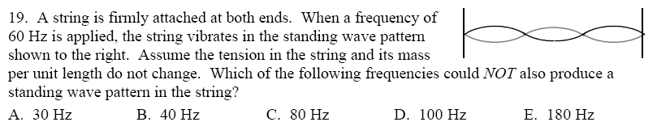2. A string is firmly attached at both ends. When a frequency of   
60 Hz is applied, the string vibrates in the standing wave pattern shown. Assume the tension in the string and its mass per unit length do not change. Which of the following frequencies could NOT also produce a standing wave pattern in the string?

A) 30 Hz B) 40 Hz C) 80 Hz D) 100 Hz E) 180 Hz

3. Which is not associated with a sound wave?  
A) amplitude B) period C) polarization D) velocity E) wavelength

4. A wave has a frequency of 50 Hz. The period of the wave is:  
A) 0.010 s B) 0.20 s C) 7 s D) 20 s E) 0.020 s

5. If the frequency of sound is doubled, the wavelength:  
A) halves and the speed remains unchanged  
B) doubles and the speed remains unchanged  
C) is unchanged and the speed doubles  
D) is unchanged and the speed halves  
E) halves and the speed halves

6. The standing wave pattern diagrammed to the right is produced in a string fixed at both ends. The speed of waves in the string is 2 m/s. What is the frequency of the standing wave pattern?

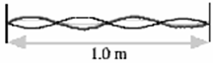

A) 0.25 Hz B) 1 Hz C) 2 Hz D) 4 Hz E) 8 Hz

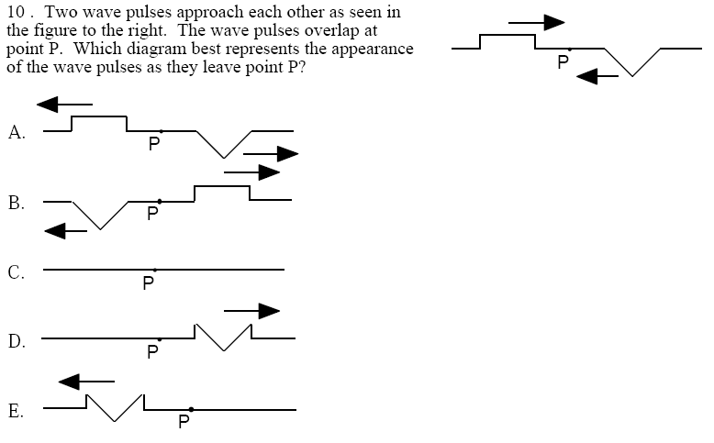7. Two waves pulses approach each other as seen in the figure. The wave pulses overlap at point P. Which diagram best represents the appearance of the wave pulses as they leave point P?





8. If the speed of sound in air is 340 m/s, the length of the organ pipe, open at both ends, that can resonate at the fundamental frequency of 136 Hz, would be:  
A) 0.625 m B) 0.750 m C) 1.25 m D) 2.5 m E) 3.75 m

9. String L and string H have the same tension and length. String L has mass m and string H has mass 4m. If the speed of the waves in string L is v, the speed of the waves in string H is  
A) v/2 B) v C) 1.4 v D) 2v E) 4v

10. An observer hears a sound with frequency 400 Hz. Its wavelength is approximately  
A) 0.85 m C) 1.2 m C) 2.75 m D) 13.6 m E) 44 m

11. As sound travels from steel into air, both its speed and its:  
A) wavelength increase B) wavelength decrease C) frequency increase   
D) frequency decrease E) frequency remain unchanged

12. When a train is at rest, both a passenger on the train and a ticket seller at the station agree that the trains whistle produces sound at a frequency of 120 Hz. When the train is moving away from the station at 15 m/s, the passenger hears a frequency of ___ Hz and the ticket seller hears a frequency of ____ Hz.  
A) 120, 125 B) 115, 120 C) 120, 120 D) 115, 115 E) 120, 115

13. A pipe that is closed at one end and open at the other resonates at a fundamental frequency of 240 Hz. The next lowest/highest frequency it resonates at is most nearly.  
A) 60 Hz B) 80 Hz C) 120 Hz D) 480 Hz E) 720 Hz

14. Assume that waves are propagating in a uniform medium. If the frequency of the wave source doubles then  
A) The speed of the waves doubles B) the wavelength do the waves doubles C) the speed of the waves halves  
D) the wavelength of the waves halves E) none of the above

Questions 15–16: A natural horn (trumpet with no valves) is similar to a pipe open at both ends. A musician plans to create a fundamental frequency of 256 Hz (middle C) using the horn.

15. If sound travels at 350 m/s, what must be the length of this horn?  
A) 0.34 m B) 0.68 m C) 0.78 m D) 1.36 m E) 1.46 m

16. A talented musician can produce a number of overtones on this natural horn. What would be the frequency of the fourth overtone produce when the musician is playing a middle C fundamental?  
A) 512 Hz B) 768 Hz C) 1024 Hz D) 1280 Hz E) 1536 Hz

17. One stereo loudspeaker produces a sound with a wavelength of 0.68 meters while the other speaker produces sound with a wavelength of 0.65 m. What would be the resulting beat frequency?  
A) 3 Hz B) 23 Hz C) 66.5 Hz D) 500 Hz E) 11333 Hz

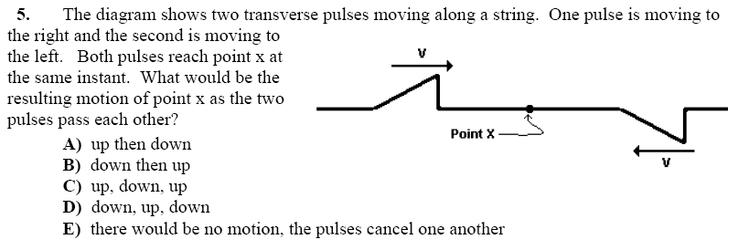18. The diagram shows two transverse pulses moving along a string. One pulse is moving to the right and the second is moving to the left. Both pulses reach point x at the same instant. What would be the resulting motion of point x as the two pulses pass each other?

A) up then down  
B) down then up  
C) up, down, up  
D) down, up, down  
E) there would be no motion, the pulses cancel one another

Question 19–20:   
The diagrams below represent 5 different standing sound waves set up inside of a set of organ pipes 1 m long

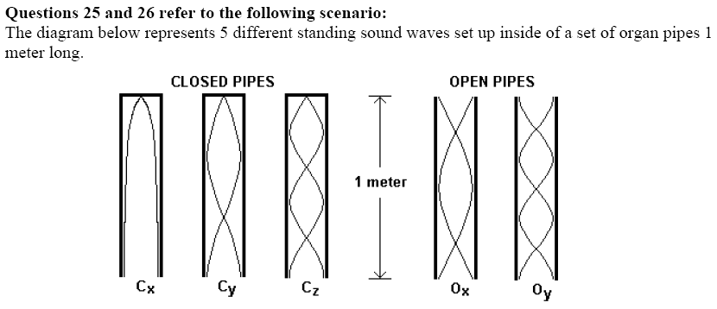

19. What is the length of the longest wavelength shown?  
A) 0.5 m B) 0.75 m C) 1 m D) 2 m E) 4m

20. Which organ pipe(s) shows a standing wave which has twice the frequency of one of the other waves shown?  
A) Cy B) Cz C) Ox D) Oy E) Cy , Cz, Ox, Oy

Question 21–22: The graph below was produced by a microphone in front of a tuning fork. It shows the voltage produced from the microphone as a function of time.

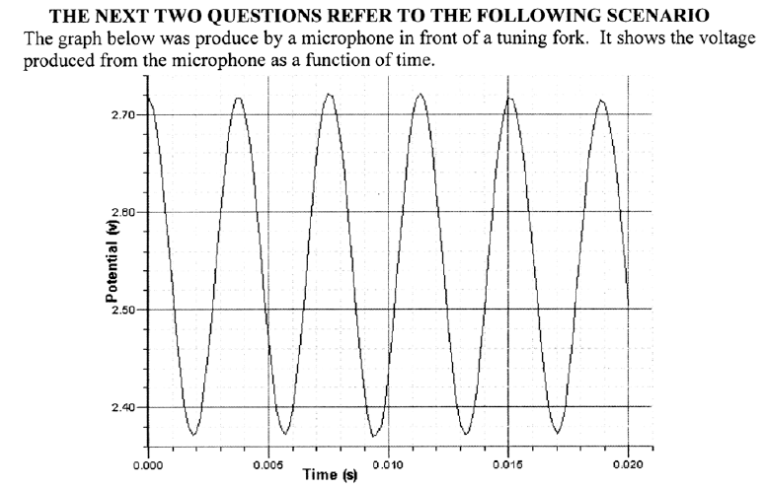

21. The frequency of the tuning fork is (approximately)  
A) 0.0039 s B) 0.020 s C) 2.55 Hz D) 50 Hz E) 256 Hz

22. In order to calculate the speed of sound from the graph, you would also need to know  
A) pitch B) volume C) frequency D) wavelength E) length of tube

23. A metal bar is vibrating with a frequency of 200 Hz. The resulting period of oscillation would be  
A) 200 s B) 141 s C) 0.007 s D) 0.002 s E) none of the above

24. A tube is open at both ends with the air oscillating in the 4th harmonic. How many displacement nodes are located within the tube?  
A) 2 B) 3 C) 4 D) 5 E) 6

1. 25. Two separate strings of the same thickness are stretched so that they experience the same tension. String B is twice as dense as String A. String A, of length *L*,is vibrated at the fundamental frequency. How long is String B if it has the same fundamental frequency as String A?

(a) ½ L (b)  (c) *L* (d)  (e) 2*L*

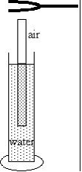

26. A resonance occurs with a tuning fork and an air column of size

39 cm. The next highest resonance occurs with an air column of

65 cm. What is the frequency of the tuning fork? Assume that the

speed of sound is 343 m/s.

(a) 329.8 Hz

(b) 527.7 Hz

(c) 659.6 Hz

(d) 879.5 Hz

(e) 1319 Hz

27. A place of zero displacement on a standing wave is called

(a) an antinode.

(b) a node.

(c) the amplitude.

(d) the wavenumber.

(e) the harmonic.

28. A person vibrates the end of a string sending transverse waves down the string. If the person then doubles the rate at which he vibrates the string while maintaining the same tension , the speed of the waves

(a) doubles and the wavelength is unchanged

(b) doubles and the wavelength doubled

(c) doubles while the wavelength is halved

(d) is unchanged while the wavelength is doubled

(e) is unchanged while the wavelength is halved.

29. A tube of length *L1* is open at both ends. A second tube of length *L2* is closed at one end and open at the other end. This second tube resonates at the same fundamental frequency as the first tube. What is the value of *L2* ?

A) 4L1 B) 2L1 C) L1 D) ½ L1 E) ¼ L1

30. For a standing wave mode on a string fixed at both ends, adjacent antinodes are separated by a distance of 20*cm*. Waves travel on this string at a speed of 1200 *cm/s*. At what frequency is the string vibrated to produce this standing wave?

(A) 120 *Hz* (B) 60 *Hz* (C) 40 *Hz* (D) 30 *Hz* (E) 20 *Hz*

31. What would be the wavelength of the fundamental and first two overtones produced by an organ pipe of length L that is closed at one end and open at the other?

A) L, ½ L, ¼ L B) ½ L, ¼ L, 1/6 L C) 2L, L, ½ L D) 4L, 2L, L E) 4L, 4/3 L, 4/5 L

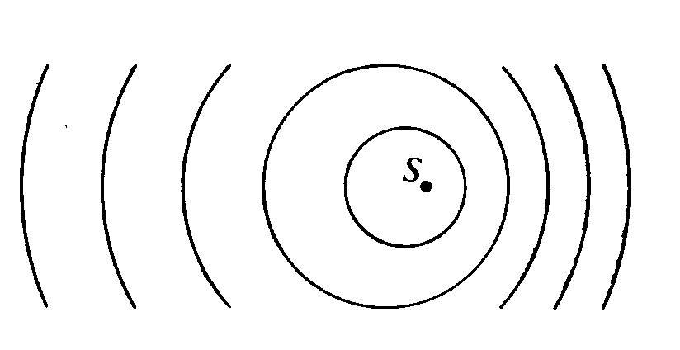

32. A small vibrating object S moves across the surface of a ripple tank producing the wave fronts shown above. The wave fronts move with speed v. The object is traveling in what direction and with what speed relative to the speed of the wave fronts produced?

Direction Speed

(A) To the right Equal to v

(B) To the right Less than v

(C) To the right Greater than v

(D) To the left Less than v

(E) To the left Greater than v

33. A cord of fixed length and uniform density, when held between two fixed points under tension T, vibrates with a fundamental frequency f. If the tension is doubled, the fundamental frequency is

(A) *2f*  ( B) (C) *f* ( D)  (E)

34. A vibrating tuning fork sends sound waves into the air surrounding it. During the time in which the tuning fork makes one complete vibration, the emitted wave travels

(A) one wavelength   
(B) about 340 meters

(C) a distance directly proportional to the frequency of the vibration

(D) a distance directly proportional to the square root of the air density

(E) a distance inversely proportional to the square root of the pressure

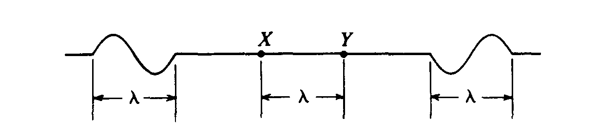35. Two wave pulses, each of wavelength λ, are traveling toward each other along a rope as shown. When both pulses are in the region between points X and Y, which are a distance λ apart, the shape of the rope is

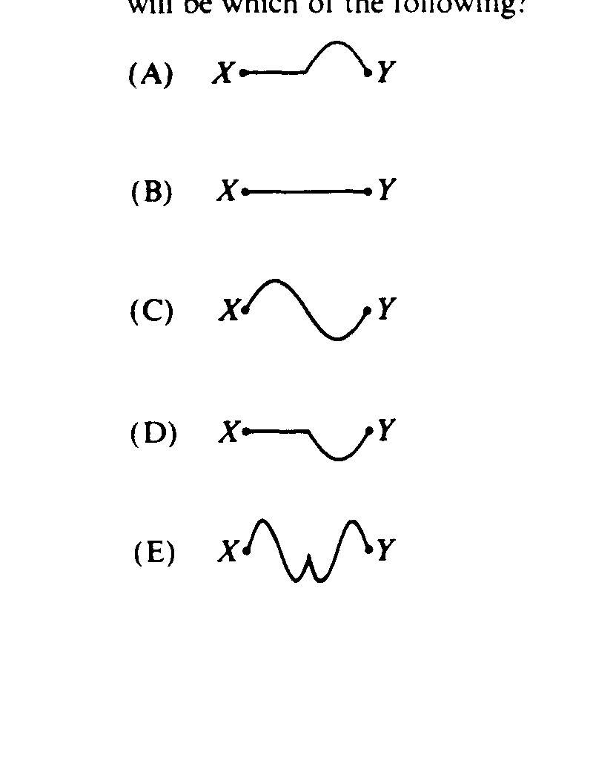

36. A train whistle has a frequency of 100 hertz as heard by the engineer on the train. Assume that the veloc­ity of sound in air is 330 meters per second. If the train is approaching a stationary listener on a wind­less day at a velocity of 30 meters per second, the whistle frequency that the listener hears is most nearly  
(A) 90 Hz (B) 110 Hz (C) 120 Hz (D) 240 Hz (E) 300 Hz

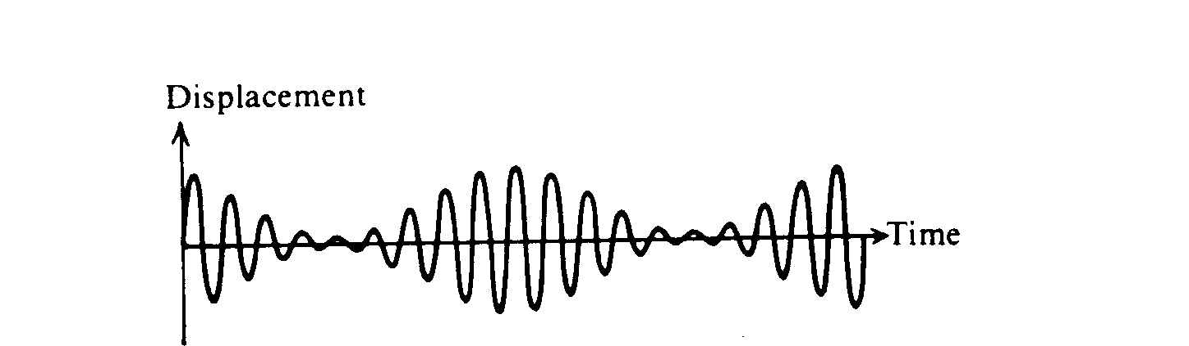

37. Two sinusoidal functions of time are combined to obtain the result shown in the figure above. Which of the following can best be explained by using this figure?  
(A) Beats (B) Doppler effect (C) Diffraction (D) Polarization (E) Simple harmonic motion

Questions 38‑39

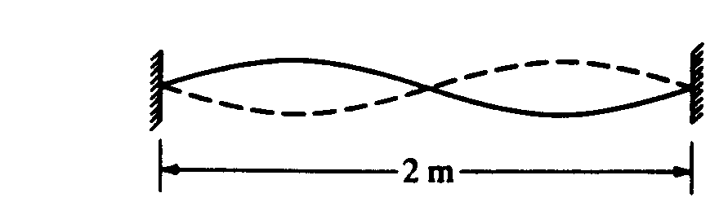

A standing wave of frequency 5 hertz is set up on a string 2 meters long with nodes at both ends and in the center, as shown above.

38. The speed at which waves propagate on the string is  
(A) 0.4 m/s (B) 2.5 m/s (C) 5 m/s (D) 10 m/s (E) 20 m/s

39. The fundamental frequency of vibration of the string is  
(A) I Hz (B) 2.5 Hz (C) 5 Hz (D) 7.5 Hz (E) 10 Hz

40. Sound in air can best be described as which of the following types of waves?  
(A) Longitudinal (B) Transverse (C) Torsional (D) Electromagnetic (E) Polarized

41. In the Doppler effect for sound waves, factors that affect the frequency that the observer hears include which of the following?  
 I. The speed of the source   
 II. The speed of the observer   
 III. The loudness of the sound  
(A) I only (B) III only (C) I and II only (D) II and III only (E) I, II, and III

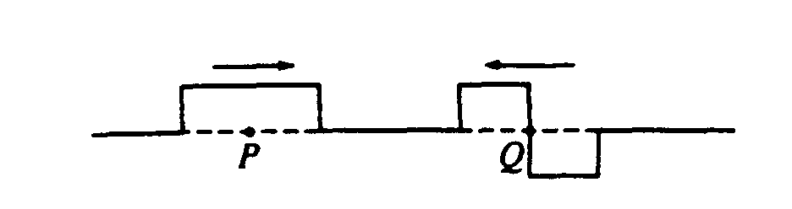

42. The figure above shows two wave pulses that are approaching each other. Which of the following best shows the shape of the resultant pulse when the centers of the pulses, points P and Q coincide?

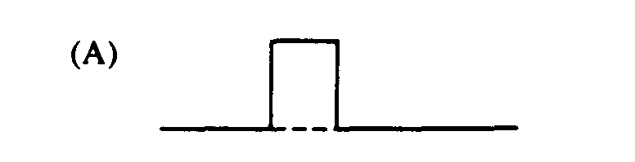 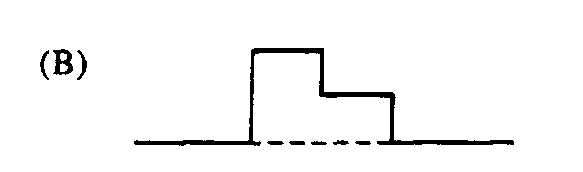 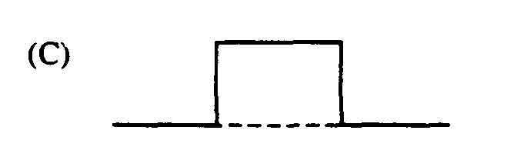 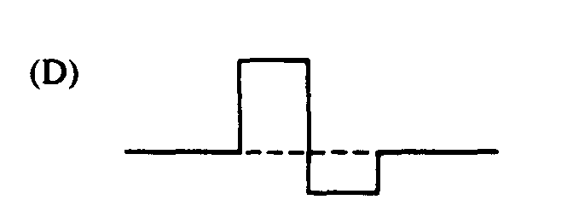 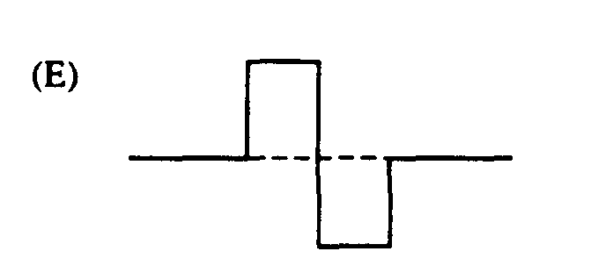

43. One end of a horizontal string is fixed to a wall. A transverse wave pulse is generated at the other end, moves toward the wall as shown and is reflected at the wall. Properties of the reflected pulse include which of the following?

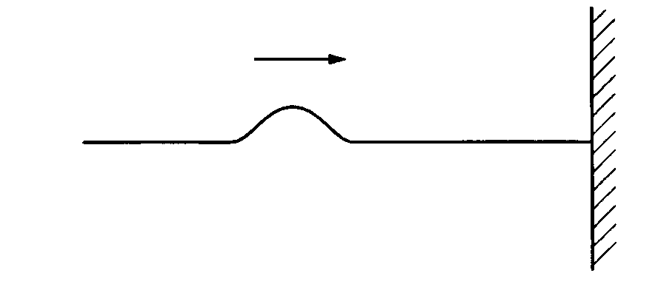

I. It has a greater speed than that of the incident pulse.

II. It has a greater amplitude than that of the incident pulse.

III. It is on the opposite side of the string from the incident pulse.

(A) I only (B) III only (C) I and II only (D) II and III only (E) I, II, and III

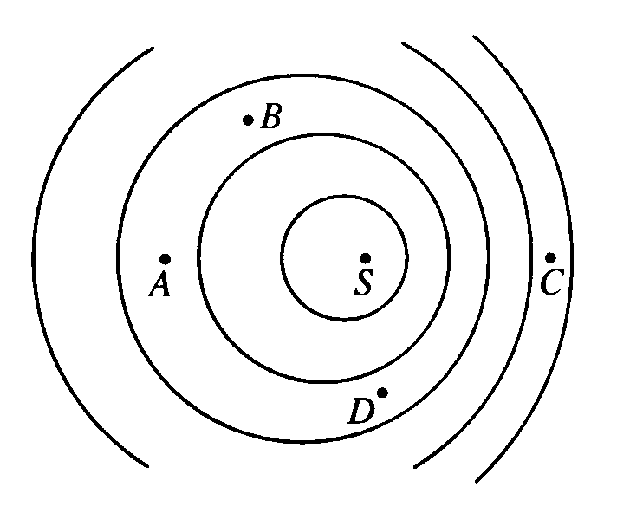

44. A small vibrating object on the surface of a ripple tank is the source of waves of frequency 20 Hz and speed 60 cm/s. If the source *S* is moving to the right, as shown, with speed 20 cm/s, at which of the labeled points will the frequency measured by a stationary observer be greatest?

(A) A (B) B (C) C   
 (D) D (E) It will be the same at all four points.

45. The frequencies of the first two overtones (second and third harmonics) of a vibrating string are f and 3f/2 .What is the fundamental frequency of this string?

(A) f/3 (B) f/2 (C) f (D) 2f (E) 3f

46. Two fire trucks have sirens that emit waves of the same frequency. As the fire trucks approach a person, the person hears a higher frequency from truck X than from truck Y. Which of the following statements about truck X can be correctly inferred from this information

I. It is traveling faster than truck Y

II. It is close to the person than the truck Y

III. It is speeding up, and truck Y is slowing down.

(A) I only (B) III only (C) I and II only (D) II and III only (E) I, II and III

Questions 47–48:



The figure above shows a transverse wave traveling to the right at a particular instant of time. The period of the wave is 0.2 s.

47. What is the amplitude of the wave?

(A) 4 cm (B) 5 cm (C) 8 cm (D) 10 cm (E) 16 cm

48. What is the speed of the wave?

(A) 4 cm/s (B) 25 cm/s (C) 50 cm/s (D) 100 cm/s (E) 200 cm/s

49. A standing wave pattern is created on a guitar string as a person tunes the guitar by changing the tension in the string. Which of the following properties of the waves on the string will change as a result of adjusting only the tension in the string?

I. Speed of the traveling wave that creates the pattern

II. Frequency of the standing wave

III. Wavelength of the standing wave

(A) I only (B) II only (C) I and II only (D) II and III only (E) I, II, and III

50. A tuning fork is used to create standing waves in a tube open at the top and partially filled with water. A resonance is heard when the water level is at a certain height. The next resonance is heard when the water level has been lowered by 0.5 m. If the speed of sound is equal to 340 m/s, the frequency of the tuning fork is

(A) 170 Hz (B) 226 Hz (C) 340 Hz (D) 680 Hz (E) 2450 Hz

AP Physics Multiple Choice Practice – Waves and Optics – ANSWERS

SECTION A – Waves and Sound

|  |  |  |
| --- | --- | --- |
|  | Solution | Answer |
| 1. | Based on the formula | C |
| 2. | The given diagram is the 3rd harmonic at 60 Hz. That means the fundamental is 20Hz. The other possible standing waves should be multiples of 20 | A |
| 3. | A fact, sound cannot be polarized since its longitudinal | C |
| 4. | Use T = 1/f | E |
| 5. | Frequency and wavelength are inverses | A |
| 6. | From diagram, wavelength = 0.5 m. Find the frequency with v = f λ | D |
| 7. | After waves interfere they move along as if they never met | B |
| 8. | For an open–open pipe the harmonic frequency is given by. with n=1 | C |
| 9. | Based on  4x the mass gives ½ the velocity | A |
| 10. | Speed of sound is 340, use v = f λ | A |
| 11. | When sound travels into less dense medium, its speed decreases (unlike light) … however, like all waves when traveling between two mediums, the frequency remains constant. Based on  v = f λ, if the speed decreases and the frequency is constant then the λ must decrease also. | B |
| 12. | Doppler effect. Since the passenger is on the train moving with the sound, the frequency is unaltered, but since the sound is moving away from the station, people at the station should hear a lower frequency. | E |
| 13. | Open–closed pipes only have odd multiples of harmonic so next f is 3x f1 | E |
| 14. | For a given medium, speed is constant. Doubling the frequency halves the wavelength | D |
| 15. | Using  with n = 1, solve for L | B |
| 16. | The fourth overtone is the fifth harmonic, 5 x the fundamental. | D |
| 17. | Determine each separate frequency using the speed of sound as 340 and v = f λ. Then subtract the two frequencies to get the beat frequency. | B |
| 18. | Step the two pulses through each other a little bit at a time and use superposition to see how the amplitudes add. At first the amplitude jumps up rapidly, then the amplitude moves down as the rightmost negative pulse continues to propagate. At the very end of their passing the amplitude would be all the wave down and then once they pass the point will jump back up to equilibrium | C |
| 19. | Cx is only ¼ of a wavelength. To make a full wavelength you would need 4x the current length | E |
| 20. | Wavelengths of each are (dist/cycle) … 4L, 4/3 L, 4/5 L, L, 2/3 L …  Frequencies are f = v/ λ.  v/4L, 3v/4L, 5v/4L, v/L, 3v/2L … Oy is 2x Cy | D |
| 21. | f = cycles / seconds | E |
| 22. | To use v = f λ, you also need the λ | D |
| 23. | T = 1/f | E |
| 24. | To produce pipe harmonics, the ends are always antinodes. The first (fundamental) harmonic is when there are two antinodes on the end and one node in-between. To move to each next harmonic, add another node in the middle and fill in the necessary antinodes. (ex, 2nd harmonic is ANANA … So the 4th harmonic would be ANANANANA and have four nodes. *Alternative solution … if you know what the harmonics look like you can draw them and manually count the nodes.* | C |
| 25. | The Fundamental is given by  (n=1), and the velocity is given by .  2x the density means 2x the m/L so that the velocity of the second string is smaller compared to the first string by v2 = v1 / √2. The first string length is L1 = 2f/v1, the second string length is  L2=2f/(v1 / √2). So comparing the two we have L2 = L1 / √2 | B |
| 26. | This is an open–closed pipe. Look at the harmonics shown below. Since the same tuning fork is used in each case, the frequency for all of them is the same, and since they all travel at the same speed with equal frequencies, the wavelength of each wave is also the same (though each has a different number of wavelengths fitting in the tube, the ‘wavelength’ of each is same). But, the lengths of the tubes vary using the water to make each successive harmonic and fit the necessary numbers of wavelengths in each tube.  Looking at the diagrams, we can see that each harmonic is ½ a wavelength longer than the next, regardless of which ones we are looking at. We don’t have to know which harmonics we are looking at if we know the difference between any two of them because each harmonic has the same difference of ½ λ. So the difference in length between any two consecutive harmonics is equal to ½ the wavelength of the wave. ∆L = ½ λ. Using this relationship, we have:  (65 cm – 39 cm) = ½ λ  λ = 52 cm    Now using v = f λ we have 343 = f (0.52) 🡪 the frequency of the wave is 659.6 Hz. | C |
| 27. | Definition of a node | B |
| 28. | Since the medium stays the same the speed remains constant. Based on v = f λ, for constant speed, f and λ change as inverses. | E |
| 29. | Similar to problem 26, we should look at the harmonic shapes open–open vs open–closed.  L1 L2  Comparing the fundamental harmonic of the open–open pipe to the closed–open pipe. The closed–open pipe should be half as long as the open–open pipe in order to fit the proper number of wavelengths of the same waveform to produce the given harmonic in each. | D |
| 30. | Two antinodes by definition will be ½ λ apart. So 20 cm = ½ λ, and the λ = 40 cm. Then using  v = f λ we have 1200 = f (40) | D |
| 31. | This is similar to question 26, except now the length of the tube remains constant and the wave is changing within the tube to make each successive waveform (this would be like using different tuning forks each time for the same tube). The diagrams would look like this now:  5 3 1    Each λ is given by λ = dist / cycleSo  λ1 = 4L  λ3 = 4/3 L  λ5 = 4/5 L | E |
| 32. | Doppler effect. The waves at right are compressed because the object is moving right. However, the waves are moving faster than the object since they are out in front of where the object is. | B |
| 33. | The Fundamental is given by  (n=1), and the velocity is given by .  Doubling the tension, changes the speed to √2 v comparatively, and makes the frequency increase by the same amount. | B |
| 34. | The time to make 1 cycle, is also the time it takes the wave to travel 1 λ. | A |
| 35. | Superpose the two waves on top of each other to get the answer. | B |
| 36. | Use the Doppler equation  where v = vsnd and we use the top signs of the denominator and numerator equation since we are moving towards the observer. The observer is not moving so Vobs = 0    f’ = 100Hz (330)/(330-30) = 110 Hz | B |
| 37. | This diagram is associated with beats. The increasing and decreasing amplitude caused by interference oscillates the volume up and down which creates the beat sound. | A |
| 38. | Based on the diagram, the λ is clearly 2m. Plug into v = f λ. | D |
| 39. | The diagram shows the second harmonic in the string. Since harmonics are multiples, the first harmonic would be half of this. | B |
| 40. | Simple fact | A |
| 41. | A fact about the Doppler effect. Can also be seen from the Doppler equation. | C |
| 42. | Use superposition and overlap the waves to see the resultant. | A |
| 43. | When hitting a fixed boundary, some of the wave is absorbed, some is reflected inverted. The reflected wave has less amplitude since some of the wave is absorbed, but since the string has not changed its properties the speed of the wave should remain unchanged. | B |
| 44. | Clearly at point C the waves are compressed so are more frequent. | C |
| 45. | Harmonics are multiples of the fundamental so the fundamental must be f/2. | B |
| 46. | Based on the Doppler effect, only speed matters. The faster a vehicle is moving, the closer together the sound waves get compressed and the higher the frequency. Take the case of a very fast vehicle traveling at the speed of sound; the compressions are all right on top of each other. So faster speed means closer compressions and higher frequencies. Choice I must be true because X is a higher frequency so must be going faster. Distance to the person affects the volume but not the pitch so choice II is wrong. III seems correct but its not. It doesn’t matter whether you are speeding up or slowing down, it only matters who is going faster. For example, suppose truck X was going 5 mph and speeding up while truck Y was going 50 mph and slowing down, this is an example of choice III but would not meet the requirement that X has a higher frequency because only actual speed matters, not what is happening to that speed. | A |
| 47. | By inspection. | A |
| 48. | By inspection, the λ is 10 cm. f = 1 / T = 5, Then use v = f λ. | C |
| 49. | Based on , the tension changes the speed. Then based on , this resulting speed change will effect the frequency also. But since the frequency increases in direct proportion to the speed, and v = f λ, the λ should remain unchanged. | C |
| 50. | This is the same as question 26. The length change corresponds to a ½ λ increase in length. ∆L = ½ λ … 0.5 = ½ λ … λ = 1 … then use v = f λ and solve for f. | C |
|  |  |  |
|  |  |  |
|  |  |  |