Science 8  Cell Unit Review | Name:  Date:  Block:

Are you Beginning, Developing, or Accomplished at each of the following learning goals? Go through the check list and mark each row as “B”, “D”, or “A” based on your level of understanding. Use the “B”s as areas to focus on when you’re studying!
KNOW
B | D | A | LEARNING GOAL
 |  |  | I can name the characteristics of living things
 |  |  | I can describe the three principles of the cell theory
 |  |  | I can explain the main differences between prokaryotic & eukaryotic cells
 |  |  | I can describe the functions of eukaryotic (plant & animal) cell structures
 |  |  | I can describe how to focus a microscope by referring to specific parts
 |  |  | I can define the term microorganism
 |  |  | I can define pathogen and give examples of different microorganisms that are pathogens (or not)
 |  |  | I can describe how pathogens spread
 |  |  | I can explain what the first, second, and third lines of defense are in the body
 |  |  | I can describe the difference between a vaccine and an antibiotic
 |  |  | I can describe the difference between an epidemic and a pandemic

DO
B | D | A | LEARNING GOAL
 |  |  | I can identify if something is living or non-living using the characteristics of living things
 |  |  | I can identify if a cell is prokaryotic or eukaryotic if given its characteristics
 |  |  | I can identify cell structures on diagrams of plant, animal, and bacterial cells
 |  |  | I can compare and contrast the structure of plant, animal, and bacterial cells
 |  |  | I can focus a microscope & calculate total magnification with a given objective lens
 |  |  | I can compare the first and second lines and third lines of defense
 |  |  | I can explain how pathogens, antigens, antibodies, and white blood cells interact as part of the immune response

- List the 5 characteristics of living things.

- An explorer from another galaxy has arrived on Earth and believes cars are living things.
  - Which characteristic(s) of a living thing would a car show?

  - How would you explain that a car is not a living thing?

- The coarse focus knob on a microscope should be used with which objective lens(es)?

- Label the parts of the microscope.
a. _______________________________________  b. _______________________________________  c. _______________________________________  d. _______________________________________  e. _______________________________________  f. _______________________________________  g. _______________________________________ | 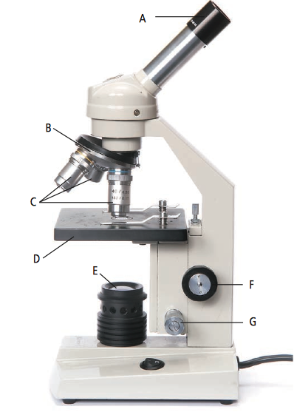

- Animal cell vs. plant cell.
  - Which two organelles do plants have that animals do not?

  - What are their functions?

- Summarize the 3 key points of the cell theory.

- What is the difference between a prokaryotic and eukaryotic cell?

- Describe one difference between bacteria and viruses.

- Animal cells do not have chloroplasts. Explain why.

- What is a pathogen?

- What is the difference between epidemic and pandemic?

- Antibodies are produced in response to antigens. What are anitgens and antibodies and where do they come from?

- What is a vaccine and what is an antibiotic?

- Identify the follow cells as either a plant or animal cell and then label the organelles.
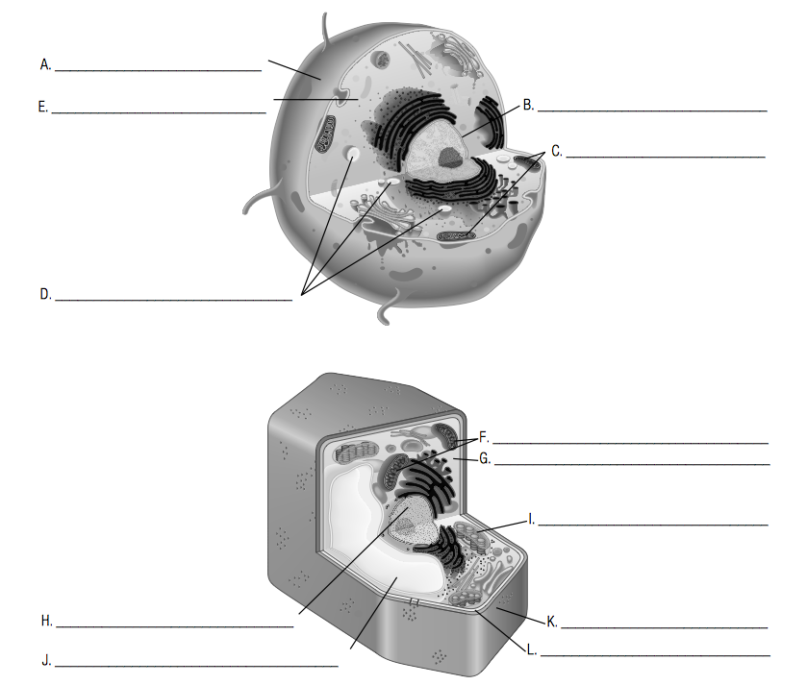

- What are the body defenses?

  - Primary (first) –

  - Secondary (second) –

  - Tertiary (third) –

