Science 8 – Unit 2 - Optics Study Guide Name:_________________________ Block: _______
- What is the difference between transparent, translucent and opaque?
How light is transmitted through a material.
Transparent – complete transmittance
Translucent – partial transmittance
Opaque – not transmittance

- List the 7 regions of waves found in the electromagnetic spectrum:
Radio Waves, Microwaves, Infrared, Visible Light, Ultraviolet, X-Ray, Gamma Ray

  - Which one can we see? Visible
  - Put them in order from highest to lowest frequency

Gamma Ray, X-Ray, UV, Visible Light, Infrared, Microwaves, Radio Waves

  - Put them in order from largest to smallest wavelength

Radio Waves, Microwaves, Infrared, Visible Light, Ultraviolet, X-Ray, Gamma Ray

  - What is the relationship between frequency and wavelength in the electromagnetic spectrum?
Inverse! As Frequency goes up, Wavelength goes down and VICE VERSA
- List the visible colours from lowest to highest frequency

Red, Orange, Yellow, Green, Blue, Indigo, Violet

- What is the difference between the wave model and the ray model of light?
The Ray Model states that light moves in straight lines and uses ray diagrams to explain things like how lenses focus light and how mirrors reflect light.
The wave model describes how light propagates much like how ocean waves move through the water and takes into account wavelength and frequency. As the Wave Model incorporates wavelength it can be used to explain colours.
- Identify each of the following on the following diagram: amplitude, trough, crest, rest position and wavelength:
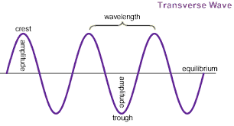
- What is frequency and what unit is it measured in?
Frequency measure how fast a wave oscillates. It is measure in the number of cycles per second.
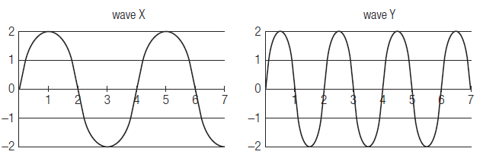
- Which of the following has high frequency and which one has a higher wavelength.

- For each diagram (above) determine the wavelength and the amplitude (the units are in metres).

Wave X: Amp = 2 m Wavelength = 4 m Wave Y: Amp = 2 m Wavelength = 4 m

- What is reflection?
When light “bounces” off an object

- Label the following diagram:

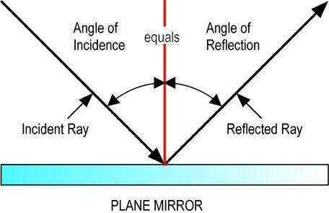
- What is the physical difference between a plane mirror, convex mirror and concave mirror. (include diagrams)
Plane | Convex | Concave
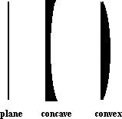
Plane mirrors are flat, Concave bend in and Convex bend out
- What is refraction?

The “bending” of light when it is transmitted from one medium to another.

- Label the diagram to the right:
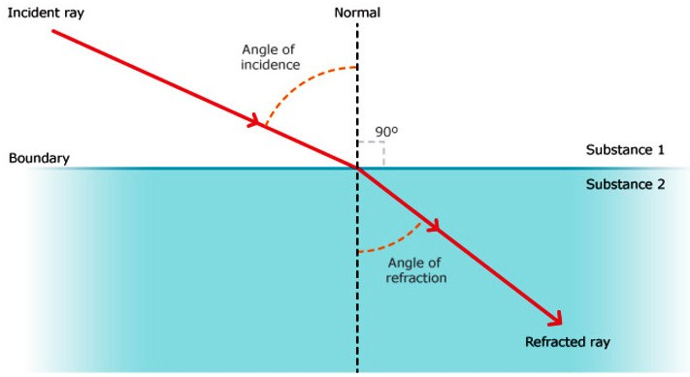
- What is the difference between refraction and reflection?
Bending through (Refraction) vs. Bouncing back (Reflection)
- What is the difference between a lens and a mirror?
Refraction/Bending (Lens) vs. Reflection/Bouncing (Mirror)
- What happens to the speed and direction of light as it travels from a dense material to less dense material?
Light rays speed up AND bend away from the normal.
- When looking at a fish under water, why does it appear to be in a different location than it actually is?
The light from the fish bends as it moves from the two mediums (water light)
- Compare and contrast convex and concave lenses:
1st Draw a diagram of light hitting a: (make sure to label the focal point for the Convex Lens)
2nd List some uses of each
Convex Lens  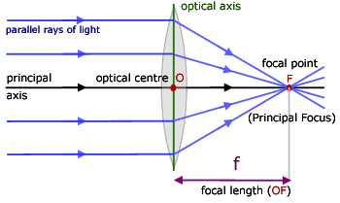 | Concave Lens  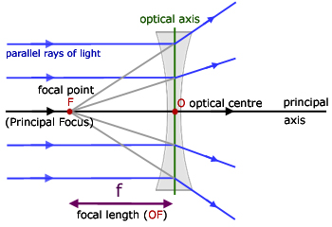
Uses  Telescopes/binoculars, The human eye, Focusing light in photovoltaic cells | Uses  Flashlights, Glasses, Camera’s, Lasers

If you complete this whole document and then read it over and quiz yourself – you should do very well on the unit test.

