**Waves (Light)**

1 – Interference, Diffraction and Double/Single Slit Experiment

When waves of light occupy the same space, at the same time _________________________.

|  |  |
| --- | --- |
| 1.jpg | 3.jpg |
|  |  |

**Constructive Interference**: When the wavelengths are ***in phase***. (When crest meets crest and trough meets trough)

**Destructive Interference**: When the wavelengths are _________________________ by ½ λ, or 180o the result is no wave. (When crest meets trough)

***Simulation! Loughborough Wave Lab!***

**Diffraction**

|  |  |  |
| --- | --- | --- |
| Single Slit | Single Slit with a Screen | Double Slit with a Screen |
| 12.jpg | 13.jpg | 14.jpg |

The result of diffraction is interference (both destructive and constructive) on the screen.

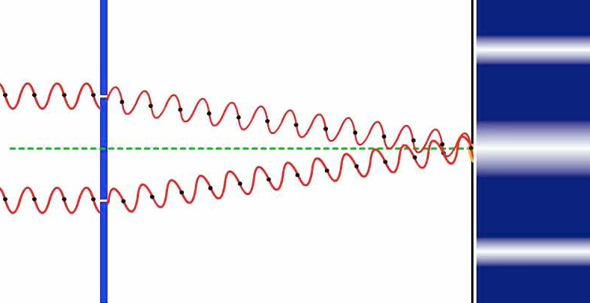

We call the place where the waves *constructively interfere* ______________________.

We call the place where the waves *destructively interfere* _______________________.

**Young’s Double Slit Interference**

**Question:** What is the path difference between the two rays of light?

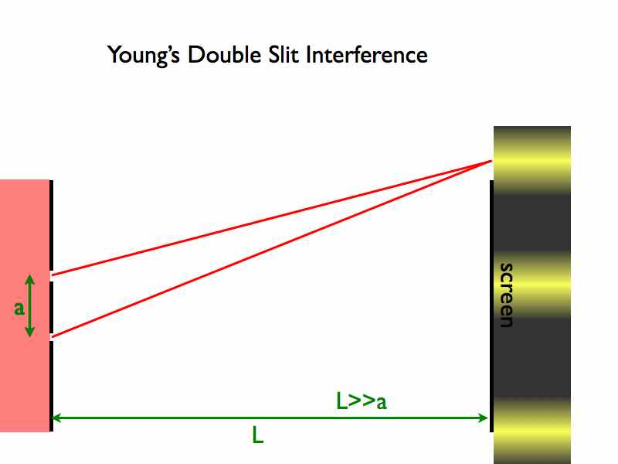

|  |
| --- |
| Where: ΔL = path difference (m)  λ = Wavelength of light (m)  m = an integar (0,1,2,3) |
| Where: d = Distance between the center of the slits  Sin(θ) = angle  λ = Wavelength of light (m)  m = an integar (0,1,2,3) |

**Small Angle Approximation**: 

|  |
| --- |
| Where: L = Distance from slits to screen (m)  λ = Wavelength of light (m)  d = Distance between the slits (m)  y = Distance between the maxima or minima (m)  m = maxima |
|  |

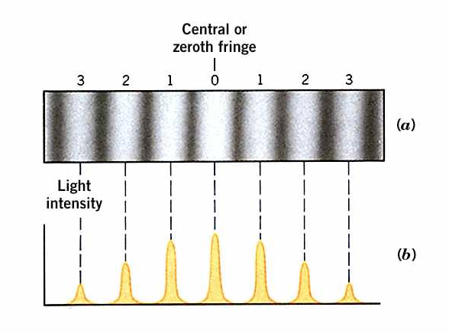

***How does Single Slit Interference compare***?



1. Sketch two graphs of the ***intensity of light as a function of position*** for the pattern formed on a distant screen. How do the light intensities compare?

|  |  |
| --- | --- |
| **Single** | **Double** |
| 2.png | 3.png |

1. Light of wavelength 5.0 x 10–7 meter in air is incident normally (perpendicularly) on a double slit. The distance between the slits is 4.0 x 10–4 meter, and the width of each slit is negligible. Bright and dark fringes are observed on a screen 2.0 meters away from the slits. ***Calculate the distance between two adjacent bright fringes on the screen***.

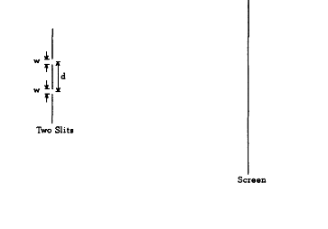

1. Coherent monochromatic light of wavelength λ in air is incident on two narrow slits, the centers of which are 2.0 mm apart, as shown above. The interference pattern observed on a screen 5.0 m away is represented in the figure by the graph of light intensity I as a function of position x on the screen.
   1. What property of light does this interference experiment demonstrate?
   2. At point P in the diagram, there is a minimum in the interference pattern. Determine the path difference between the light arriving at this point from the two slits.
   3. 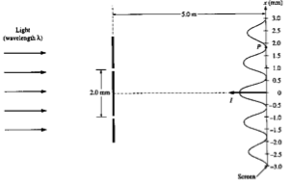Determine the wavelength, λ, of the light.