YOULearn #3 – Balancing and Identifying Types of Chemical Reactions Name: _______________

- Balancing Chemical Reactions:

  - Balance atoms that are alone first if possible.
  - Leave the balancing of Hydrogen and Oxygen atoms to the end.
  - If the Same polyatomic ions appear on both the reactant and product sides of a reaction, leave the polyatomic ion as one Unit.
  - List all the atom/polyatomic ion from the skeletal equation below the arrow
  - Remember you can only list a polyatomic if it appears on BOTH sides of the equation
  - Tally the total of each atoms/polyatomic ions from the left and right side of the equation
  - When you change the coefficients, change the number of atoms/polyatomic ions until they are equal on both sides

Example: 2Al_{(s)} + 6HBr_{(aq)} 2AlBr_{3(aq)} + 3H_{2(g)}

Example: 3Pb(NO₃)_{2(aq)} + Al₂(SO₄)_{3(aq)} 3PbSO_{4(s)} + 2Al(NO₃)_{3 (aq)}

Example: 3Zn(OH)_{2(aq)} + 2H₃PO_{4(aq)} Zn₃(PO₄)_{2(aq)} + 6H₂O_{(l)}

Write the following word equations into chemical equations and balance each equation.

- hydrogen gas + oxygen gas water

2H₂ + O₂ 2H₂O

- iron + sulphur iron (II) sulphide (note: Sulpher is found as S₈ in nature)

8Fe + S₈ 8FeS

- sodium chloride + silver nitrate silver chloride + sodium nitrate

NaCl + AgNO₃ AgCl + NaNO₃

- carbon + oxygen gas carbon dioxide

C + O₂ CO₂

- calcium hydroxide + carbon dioxide calcium carbonate + water

Ca(OH)₂ + CO₂ CaCO₃ + H₂O

- zinc + copper (II) sulfate zinc sulfate + copper

Zn + CuSO₄ ZnSO₄ + Cu

- sodium + water sodium hydroxide + hydrogen gas

2Na + 2H₂O 2NaOH + H₂

- aluminum + iron (III) oxide aluminum oxide + iron

2Al + Fe₂O₃ Al₂O₃ + 2Fe

- Zinc and lead (II) nitrate react to form zinc nitrate and lead.

Zn + Pb(NO₃)₂ Pb + Zn(NO₃)₂

- Aluminum bromide and chlorine gas react to form aluminum chloride and bromine gas.

2AlBr₃ + 3Cl₂ 2AlCl₃ + 3Br₂

- Sodium phosphate and calcium chloride react to form calcium phosphate and sodium chloride.

2Na₃PO₄ + 3CaCl₂ Ca₃(PO₄)₂ + 6NaCl

- Calcium hydroxide and phosphoric acid react to form calcium phosphate and water.

3Ca(OH)₂ + 2H₃PO₄ Ca₃(PO₄)₂ + 6H₂O

- Copper and sulfuric acid react to form copper (II) sulfate and water and sulfur dioxide.

Cu + 2H₂SO₄ CuSO₄ + SO₂ + 2H₂O

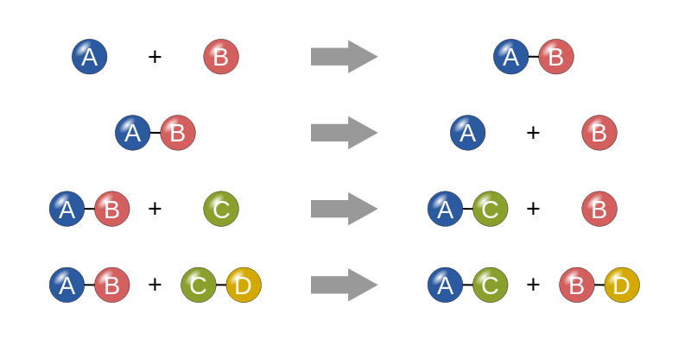
- Types of Reactions:

Compound XY Atom X + Atom Y

  - Decomposition

Atom X + Atom Y Compound XY

  - Synthesis

Ionic Compound AB + Atom M Ionic Compound MB + Atom A

  - Single Replacement

Ionic compound CD + Ionic Compound EF Ionic compound CF + Ionic Compound ED

  - Double Replacement

HX + YOH H₂O + YX
(note: HX represents a standard acid/YOH a standard base)

  - Acid Base Neutralization

C_{x}H_{y} + O_{2(g)} CO_{2(g)} + H₂O_{(g)}

  - Combustion

Ionic Compound AB + water Ion A⁺ _{(aq)} + Ion B⁻_{(aq)}

  - ___________Dissociation___________

Predicting Products and Identifying Chemical Reactions

Identify the products for the following word equations. Change the word equations into chemical equations and identify the type of reaction. YOU DO NOT NEED TO BALANCE

- sodium chloride + hydrogen carbonate Double Replacement

2NaCl + H₂CO₃ Na₂CO₃ + 2HCl

- mercury (II) oxide Decomposition

HgO Hg + O₂

- potassium + water Single Replacement

2K + H₂O K₂O + H₂

- zinc + hydrogen chloride Single Replacement

Zn + 2HCl ZnCl₂ + H₂

- copper(II) + chlorine gas Synthesis

Cu + Cl₂ CuCl₂

- bromine gas + water Single Replacement

2Br₂ + 2H₂O 4HBr + O₂

- manganese (II) + oxygen gas Synthesis

2Mn + O₂ 2MnO

- H₃PO₄ + Mg(OH)₂ AB Neutralization

2H₃PO₄ + 3Mg(OH)₂ Mg₃(PO₄)₂ + 6H₂O

- ammonium sulfide + zinc chloride Double Replacement

(NH₄)₂S + ZnCl₂ 2NH₄Cl + ZnS

- barium phosphate + sodium sulfate Double Replacement

Ba₃(PO₄)₂ + 3Na₂SO₄ 2Na₃PO₄ + 3BaSO₄

- iron (III) chloride + water Double Replacement

FeCl₃ + 3H₂O 3HCl + Fe(OH)₃

- tricarbon octahydride + oxygen gas Combustion

C₃H₈ + 5O₂ 3CO₂ + 4H₂O

- hydrogen phosphate + calcium hydroxide AB Neutralization

2H₃PO₄ + 3Ca(OH)₂ Ca₃(PO₄)₂ + 6H₂O

- copper (I) + hydrogen sulfate Single Replacement

2Cu + H₂S Cu₂S + H₂

- iron (III) chloride + sodium carbonate sodium chloride + iron (III) carbonate
Double Replacement
2FeCl₃ + 3Na₂CO₃ Fe₂(CO₃)₃ + 6NaCl

- aluminum sulphate + water Double Replacement

Al₂(SO₄)₃ + 6H₂O 2Al(OH)₃ + 3H₂SO₄

- iron(III) + water Single Replacement

Fe + 3H₂O Fe(OH)₃ + 3H₂

