YOULearn #3 – Balancing and Identifying Types of Chemical Reactions Name: _______________

- Balancing Chemical Reactions:

  - Balance atoms that are alone first if possible.
  - Leave the balancing of Hydrogen and Oxygen atoms to the end.
  - If the Same polyatomic ions appear on both the reactant and product sides of a reaction, leave the polyatomic ion as one Unit.
  - List all the atom/polyatomic ion from the skeletal equation below the arrow
  - Remember you can only list a polyatomic if it appears on BOTH sides of the equation
  - Tally the total of each atoms/polyatomic ions from the left and right side of the equation
  - When you change the coefficients, change the number of atoms/polyatomic ions until they are equal on both sides

Example: Al_{(s)} + HBr_{(aq)} AlBr_{3(aq)} + H_{2(g)}

Example: Pb(NO₃)_{2(aq)} + Al₂(SO₄)_{3(aq)} PbSO_{4(s)} + Al(NO₃)_{3 (aq)}

Example: Zn(OH)_{2(aq)} + H₃PO_{4(aq)} Zn₃(PO₄)_{2(aq)} + H₂O_{(l)}

Write the following word equations into chemical equations and balance each equation.

- hydrogen gas + oxygen gas water

- iron + sulphur iron (II) sulphide (note: Sulpher is found as S₈ in nature)

- sodium chloride + silver nitrate silver chloride + sodium nitrate

- carbon + oxygen gas carbon dioxide

- calcium hydroxide + carbon dioxide calcium carbonate + water

- zinc + copper (II) sulfate zinc sulfate + copper

- sodium + water sodium hydroxide + hydrogen gas

- aluminum + iron (III) oxide aluminum oxide + iron

- Zinc and lead (II) nitrate react to form zinc nitrate and lead.

- Aluminum bromide and chlorine gas react to form aluminum chloride and bromine gas.

- Sodium phosphate and calcium chloride react to form calcium phosphate and sodium chloride.

- Calcium hydroxide and phosphoric acid react to form calcium phosphate and water.

- Copper and sulfuric acid react to form copper (II) sulfate and water and sulfur dioxide.

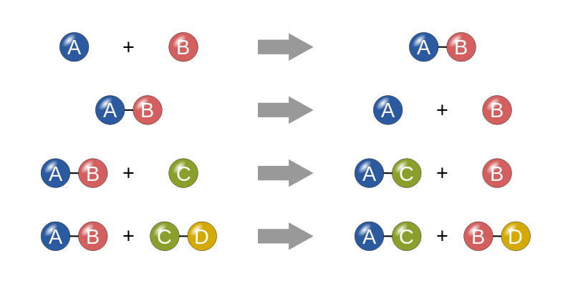
- Types of Reactions:

Compound XY Atom X + Atom Y

  - _________________________________

Atom X + Atom Y Compound XY

  - _________________________________

Ionic Compound AB + Atom M Ionic Compound MB + Atom A

  - _________________________________

Ionic compound CD + Ionic Compound EF Ionic compound CF + Ionic Compound ED

  - _________________________________

HX + YOH H₂O + YX
(note: HX represents a standard acid/YOH a standard base)

  - __________________________________

C_{x}H_{y} + O_{2(g)} CO_{2(g)} + H₂O_{(g)}

  - __________________________________

Ionic Compound AB + water Ion A⁺ _{(aq)} + Ion B⁻_{(aq)}

  - ___________Dissociation___________

Predicting Products and Identifying Chemical Reactions

Identify the products for the following word equations. Change the word equations into chemical equations and identify the type of reaction. YOU DO NOT NEED TO BALANCE

- sodium chloride + hydrogen carbonate

- mercury (II) oxide

- potassium + water

- zinc + hydrogen chloride

- copper(II) + chlorine gas

- bromine gas + water

- manganese (II) + oxygen gas

- H₃PO₄ + Mg(OH)₂

- ammonium sulfide + zinc chloride

- barium phosphate + sodium sulfate

- iron (III) chloride + water

- tricarbon octahydride + oxygen gas

- hydrogen phosphate + calcium hydroxide

- copper (I) + hydrogen sulfate

- iron (III) chloride + sodium carbonate sodium chloride + iron (III) carbonate

- aluminum sulphate + water

- iron(III) + water

