Total Internal Reflections

When light travels from one media with an index of refraction of n₁, into another media with an index of refraction of n₂, the incident ray of light and the refracted ray of light are normal (perpendicular) to the interface between the two materials, and lie in the same plane. The angle of refracted light ray θ₂, is related to the angle of the incident light ray θ₁, by:

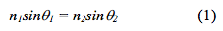

We can experimentally measure the index of refraction of a material by measuring the angles of the incident and refracted light rays, with the second media being air, which has an index of refraction of one (ie: n₂ = n₁). In this way we can calculate n₁ as:

This is another way of writing Snell’s Law. This relationship visualized in figure (a), for light traveling from water to air.

When the angle of incidence increases, the angle of refraction also increases. When the angle of incidence reaches a certain critical value θ_{c}, the angle of refraction becomes 90°. At this point the refracted light rays point along the surface of the media (parallel to the media boundary). This is shown in Figure (b). When the incident angle exceeds the critical angle, there is no refracted light, and the incident light is reflected back onto the medium. This phenomenon is called total internal reflection. This is shown in Figure (c).

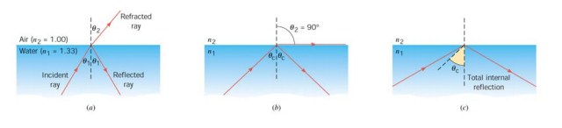
- Derive a formula for the Critical Value for the incident angle θ_{c} below:
- Find the critical value for the incident angle when light travels from Quartz Crystal to Obsidian.

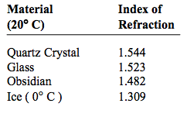

- 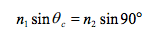
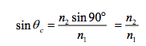
If the second medium is air n₂ = 1.00
