Worksheet – Electronic Configuration Name: ________________

- The electron configuration for phosphorus, written in core notation, is [Ne] 3s2 3p3. What two things does Hund’s rule tell us about the three electrons in the 3p sublevel?
Hund’s rule tells us that one electron is filled into each degenerate (equal energy orbital) before a second electron is added to one of the orbitals. One electron in each of the p_{x} , p_{y} , and p_{z} . Hunds rule also tells us that each of those electrons is spinning in the same direction (either up or down).
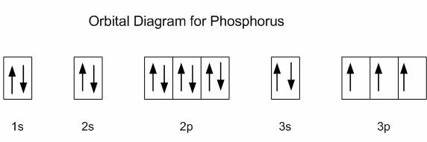
- Use the periodic table to complete the following table:
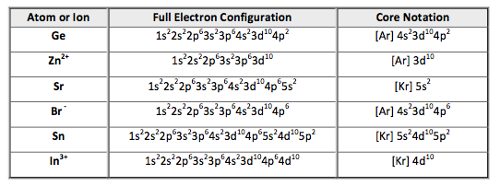
- (a) Use the periodic table to identify the neutral atoms having the following electron configurations:
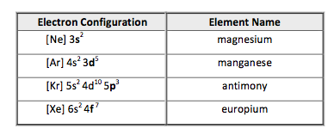
(b) Notice where each of these elements is located on the periodic table. Look at the highest energy sublevel being filled (bold type) in each of the atoms in the table, and identify the four different sections of the periodic table associated with each of these four sublevels.
Each of the four elements in the above table is located in a different position of the periodic table corresponding to a different highest energy sublevel being filled in the element. The “s-block” is located on the far left side of the periodic table, the “d-block” is located in the center of the table, the “p-block” is located on the far right side of the table and the “f-block” is located in the bottom region of the periodic table.

- Consider the following six stable ions: N 3–, O 2–, F–, Na+, Mg 2+, and Al 3+.
(a) How many electrons are present in each ion?
Each possesses 10 electron. Ions and atoms with the same electronic configuration are said to be isoelectronic.
(b) Write a single electron configuration representing all of the ions.
1s²2s²2p⁶
(c) Which neutral atom possesses this electron configuration? What does this suggest about a possible reason for some ion formation?
Neon possesses a complete stable valence octet in its outer shell.
- (a) Complete the following table for some elements in two families of the periodic table.
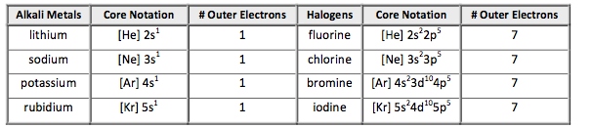
(b) Consider the numbers of outer electrons present and suggest a reason why elements belonging to the same chemical family demonstrate similar chemical behaviour.
All the members of a chemical family demonstrate similar chemical behavior because they all have the same number of outer or valence electrons. Chemistry is essentially about the transfer and exchange of valence electrons

(c) What change occurs in the atoms as we move down each chemical family?
As we move down a chemical family we increase the total number of electrons, atoms become larger

