Worksheet – Electronic Configuration Name: ________________

- The electron configuration for phosphorus, written in core notation, is [Ne] 3s2 3p3. What two things does Hund’s rule tell us about the three electrons in the 3p sublevel?

- Use the periodic table to complete the following table:
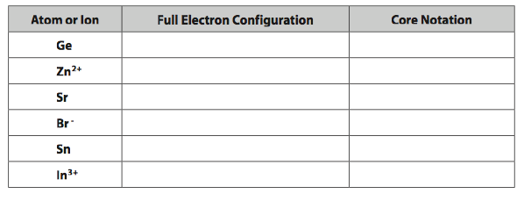
- (a) Use the periodic table to identify the neutral atoms having the following electron configurations:
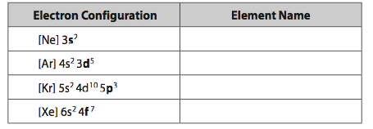
(b) Notice where each of these elements is located on the periodic table. Look at the highest energy sublevel being filled (bold type) in each of the atoms in the table, and identify the four different sections of the periodic table associated with each of these four sublevels.

- Consider the following six stable ions: N 3–, O 2–, F–, Na⁺, Mg 2+, and Al 3+.
(a) How many electrons are present in each ion?

(b) Write a single electron configuration representing all of the ions.

(c) Which neutral atom possesses this electron configuration? What does this suggest about a possible reason for some ion formation?

- (a) Complete the following table for some elements in two families of the periodic table.
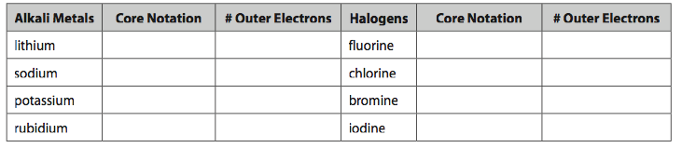
(b) Consider the numbers of outer electrons present and suggest a reason why elements belonging to the same chemical family demonstrate similar chemical behaviour.

(c) What change occurs in the atoms as we move down each chemical family?

