Worksheet 8.1 - Magnetic Fields

- You are experimenting with two identical permanent magnets. One magnet is coloured blue, and the other is coloured red. If the blue magnet attracts the red magnet with the force of 75.0 N, what is the force of attraction between the red and the blue magnet?

- If four compasses are arranged around a magnet as shown in the diagram below, in what direction will the north end of each compass needle point? Draw the needles in the diagram.
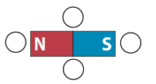
- What will happen to the suspended magnet as a second magnet is brought close?

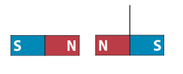
- Draw the direction the compass needle will point when the compass is placed on the current-carrying conductor in each diagram below.
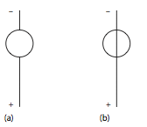

- Draw the direction of the magnetic field inside the loops and outside the loops in the figure below.
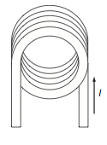
- A 25.0 cm solenoid has 1800 loops and a diameter of 3.00 cm. Calculate the magnetic field in the air core of the solenoid when a current of 1.25 A is flowing.

- An air core solenoid is 25 cm long and carries a current of 0.72 A If the magnetic field in the core is 2.1x10⁻³T how many turns does this solenoid have?

- An air core solenoid is 30.0 cm and has 775 turns. If the magnetic field in the core is 0.100 T what is the current flowing through this solenoid?
- What is the magnetic field near the centre of a .30m long solenoid that has 800 turns of wire if it carries a electric current of 2.0 A?

Answers:

- 75 N
- 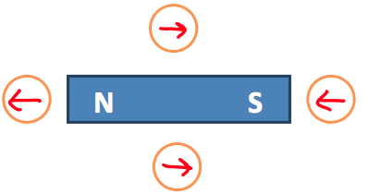
- It will repel, and the magnet will move to the right and up (due to tension in the rope)
- a. Since the reading is ABOVE the wire = b. Since the reading is BELOW the wire
- Inside the loop coming out of the page; outside the loop into the page
- (1.13x10⁻²T)
- (580)
- (31 A)
- (6.7x10⁻³T)

