Worksheet – Types of Bonds Name: _________________

- Identify the attractive forces associated with…

  - Ionic Bonds:

Attractive electrostatic forces between negative charged ion and adjacent positively charged ion

  - Covalent Bonds:

Electrostatic forces between negatively charged electrons and adjacent positively charged nucleus

- Identify two similarities between ionic and covalent bonds

- Both involve valence electron clouds
- Both involve electrostatic attractions between oppositely charged species
- The formation of bond bonds begins with the valence electrons of two atoms experiencing the attractive force of adjacent positive nuclei
- Both Ionic and Covalent bonds are strong

- Identify two difference between ionic and covalent bonds

- Ionic Bonds involve the transfer of valance electrons forming ions whereas covalent bonds involve the sharing of valence electrons with no ion formation
- Ionic bonds form only between metals and non-metals whereas covalent bonds usually (but not always) form between two non-metals
- Ionic bonding does not result in molecule formation whereas covalent bonding usually does
- The attractive forces associated with covalent bonds are the electrostatic forces between negatively charged electrons and adjacent positively charged nuclei

- Complete the following table by writing formulas of the compounds formed from the pairs of elements.

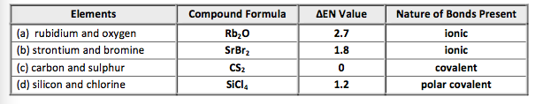
- Magnesium is a metal and sulphur is a non-metal. Compare the ΔEN value for these elements in MgS to ΔEN value for the non-metal hydrogen and oxygen in water (H₂O). Which of the two compounds possesses a greater amount of ionic character in its bond?

ΔEN for MgS = 1.3
ΔEN for H₂0 = 1.4
We see that the bonds in water actually possess slightly more ionic character than those in magnesium sulphide even though the former compound contacts two non-metals and the latter compound contains a metal and a non-metal

