PERIODIC TRENDS on the PERIODIC TABLE
(Chemistry 11)

- The Periodic Table is organized according to what number? _________________________________
- The columns on a periodic table are called the _____________________________________________
- The rows on a periodic table are called the ________________________________________________
- The most reactive metallic family is the _________________________________________________
- The most reactive non-metallic family is the _____________________________________________
- The family which has no reactive elements is the _________________________________________

- Define the following terms: atomic radius and ionic radius. Describe the periodic trend for each one.

- Define Z_{eff} (effective nuclear charge). How does this property affect radii of atoms as you move from left to right in a period? Does it affect atomic radius as you move down a group?

- Arrange the following atoms in order of increasing radius: N, Sb, P, Bi, As, O, Ne

- Define the phrase isoelectronic series. Describe how sizes of ions change as you move from the most positively charged ion to the most negatively charged ion in an isoelectronic series.

- Arrange the following ions in order of increasing radius: F⁻, Na⁺, O²⁻, Mg²⁺, N³⁻

- Define: ionization energy (write a chemical equation to demonstrate this) and electronegativity.

- Show the direction in which each trend from #8 increases. Use the periodic table below to draw arrows of increasing value for ionization energy and electronegativity.

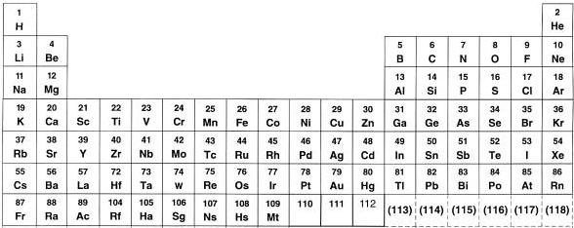

- Arrange the following atoms in order of increasing first ionization energy: Ba, Ca, Be, Sr, Mg, Cs

- Arrange the following atoms in order of increasing electronegativity: Br, Sb, I, Te, Cl, Xe

Answers:

- Atomic Number
- Families/Groups
- Periods
- Alkai Metals
- Halogens
- Non-Metals

- Atomic radius measures half the distance between the nuclei of two adjacent atoms. (Since the orbital boundaries of atoms are not absolutely defined, atomic radius cannot be measured for a single atom.) Ionic radius is defined similarly but for ions in an ionic compound. Both periodic trends increase going down a group. Atomic radius generally decreases going from left to right across the periodic table. Ionic radius also decreases left to right but jumps in size at the transition between cations and anions.

- Effective nuclear charge defines strength of the attraction between protons and electrons. As you move from left to right in across the periodic table, the number of protons increases, but the valence electrons are in the same shell.

- Ne < O < N < P < As < Sb < Bi

- Isoelectronic means ions that have the same electron configuration. Sizes of ions increase as you move from the most positively charged ion to the most negatively charged ion in a series.

Example: S²⁻ has 18 e⁻ and 16 p⁺; Ca²⁺ has 18 e⁻ and 20 p⁺. Ca has more protons to pull in its electrons and results in a smaller ion.

- Mg²⁺ < Na⁺ < F⁻ < O²⁻ < N³⁻

- Ionization energy is the amount of energy required to remove an electron from an element: El El⁺ + e⁻
Electronegativity is a measure of the amount “pull” an atom exerts on electrons within a bond.

- Both trends increase going up a group and from left to right across the periodic table.

- Cs < Ba < Sr < Ca < Mg < Be

- Sb < Te < I < Xe < Br < Cl

