Stoichiometry Preview Worksheet

- Balance the following reactions on a separate piece of paper:
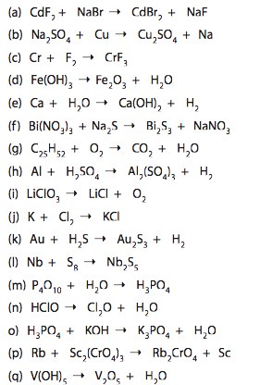
- Return to Question 1 and classify (to the left) each reaction as either synthesis (S), decomposition (D), combustions, single replacement (SR), double replacement (DR), or neutralization (N).

- Classify each of the following reactions, using the following Key: synthesis (S), decomposition (D), combustions, single replacement (SR), double replacement (DR), or neutralization (N). Complete the equation and balance them on a separate piece of paper. (SKIP: b, d, e, f, p, and s)
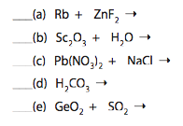
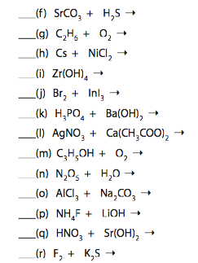

- Classify each of the following chemical changes. Write balanced formula’s for each on a separate piece of paper. (SKIP i)

  - A piece of magnesium ribbon on a stock shelf reacts over time with nitrogen gas in the air to form a black coating.
  - Phosphoric acid solution removes iron (III) hydroxide stains from an old bath tub.
  - Butane has is combusted in a disposable lighter.
  - A zinc strip placed in a solution of copper (II) sulphate becomes coated with brownish solid.
  - Sulphur dioxide emitted from industrial plamts combines with water vapour to form acid rain.
  - Calcium carbonate in marble structures is eroded over time by nitric acid in acid rain.
  - Nickle (III) hydroxide reacts with cadmium anode in a prototype rechargeable battery.
  - Solutions of gold (III) nitrate and sodium carbonate are combined.
  - Potassium chromate solution indicates the endpoint in a potato chip experiment with a standard silver nitrate solution.
  - Methanol (CH₃OH) is combusted in race car engines.
  - A bright yellow pigment once used in paints is formed from the reaction of lead (II) nitrate and sodium iodide solution.
  - Iron (III) oxide and water combine to form a basic compound often called rust.

