Dilution and Ion Concentration Calculation Worksheet Name: ________________

Dilution Calculations

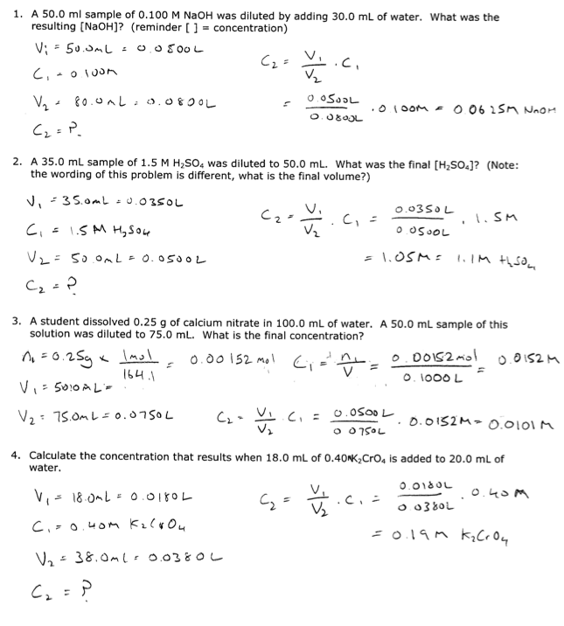

Concentration of Ions in Solution

