What are invasive species?

What are Invasive/Foreign Species?

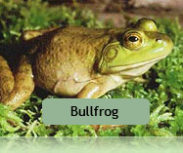
The ISC defines the term “invasive species” as any non-native organism that cause economic or environmental harm and can spread quickly to new areas of BC. The International Union for Conservation of Nature (IUCN), which developed the list of the 100 world’s worst invasive species, defines them as “animals, plants or other organisms introduced by man into places out of their natural range of distribution, where they become established and disperse, generating a negative impact on the local ecosystem and species.” These invasive species are almost impossible to remove once introduced because they have almost no natural predators. Once introduced, the invasive species encroach on the niches with local species, in some cases causing the extirpation of the local species, and the proliferation of the invasive species.

What are Invasive Plants?

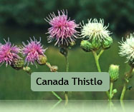
The ISC defines the term "invasive plant" as any invasive plant species that has the potential to pose undesirable or detrimental impacts on people, animals or ecosystems. Invasive plants can establish quickly and easily on both disturbed and un-disturbed sites, and causing widespread negative economic, social, and environmental impacts. Many invasive plants have been introduced to BC without their natural predators and pathogens that would otherwise keep their populations in check in their countries of origin. For this reason, invasive plants also commonly referred to as "alien", "non-native", "exotic" or "introduced" plant species.

