Waves and SHM: Sound and The Doppler Effect

/5

Make sure to INCLUDE UNITS!

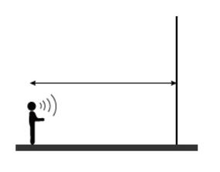
- Carl accidentally locked himself in the 25 meter long, freezer warehouse at his job. The thermometer in the freezer appears to be broken, but he wants to find out how cold the air in the freezer really is. He remembers from science class that the speed of sound (331.4 m/s at 0º C) changes with temperature by 0.6 m/s per degree. He says, "Ha!" at one end of the freezer warehouse, and his echo is reflected back to him in 0.153 seconds. How cold is it in the freezer warehouse?

Answers:

- Carl accidentally locked himself in the 25 meter long, freezer warehouse at his job. The thermometer in the freezer appears to be broken, but he wants to find out how cold the air in the freezer really is. He remembers from science class that the speed of sound (331.4 m/s at 0º C) changes with temperature by 0.6 ºC per degree. He says, "Ha!" at one end of the freezer warehouse, and his echo is reflected back to him in 0.153 seconds. How cold is it in the freezer warehouse?

