**Waves and SHM: Wave Properties**

/5

**Make sure to INCLUDE UNITS!**

1. Sound waves traveling at 350m/s are made by a tuning fork that vibrates 431 times each second.
   1. What is the Period of vibration?
   2. What is the wavelength of the sound waves produced?

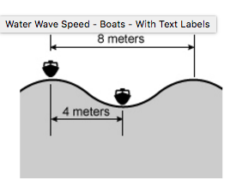

1. Two boats are anchored 4.0 meters apart. They alternately bob up and down, returning to the same up position every 6.8 seconds. There are never any wave crests between the boats. Calculate the speed of the waves.

Answers:

1. Sound waves traveling at 350m/s are made by a tuning fork that vibrates 431 times each second.
   1. What is the Period of vibration?





* 1. What is the wavelength of the sound waves produced?







1. Two boats are anchored 4.0 meters apart. They alternately bob up and down, returning to the same up position every 6.8 seconds. There are never any wave crests between the boats. Calculate the speed of the waves.

