Unit 5 – Waves: Quiz 5c

/5

- Sherlock Holmes examines a clue by holding his magnifying glass at arm’s length and 10.0 cm away from an object. The magnifying glass has a focal length of 15.0 cm. The height of the object is 1.00 cm. Find the image distance, height, and the magnification. Describe the image that he observes. Draw a ray diagram to confirm your results.
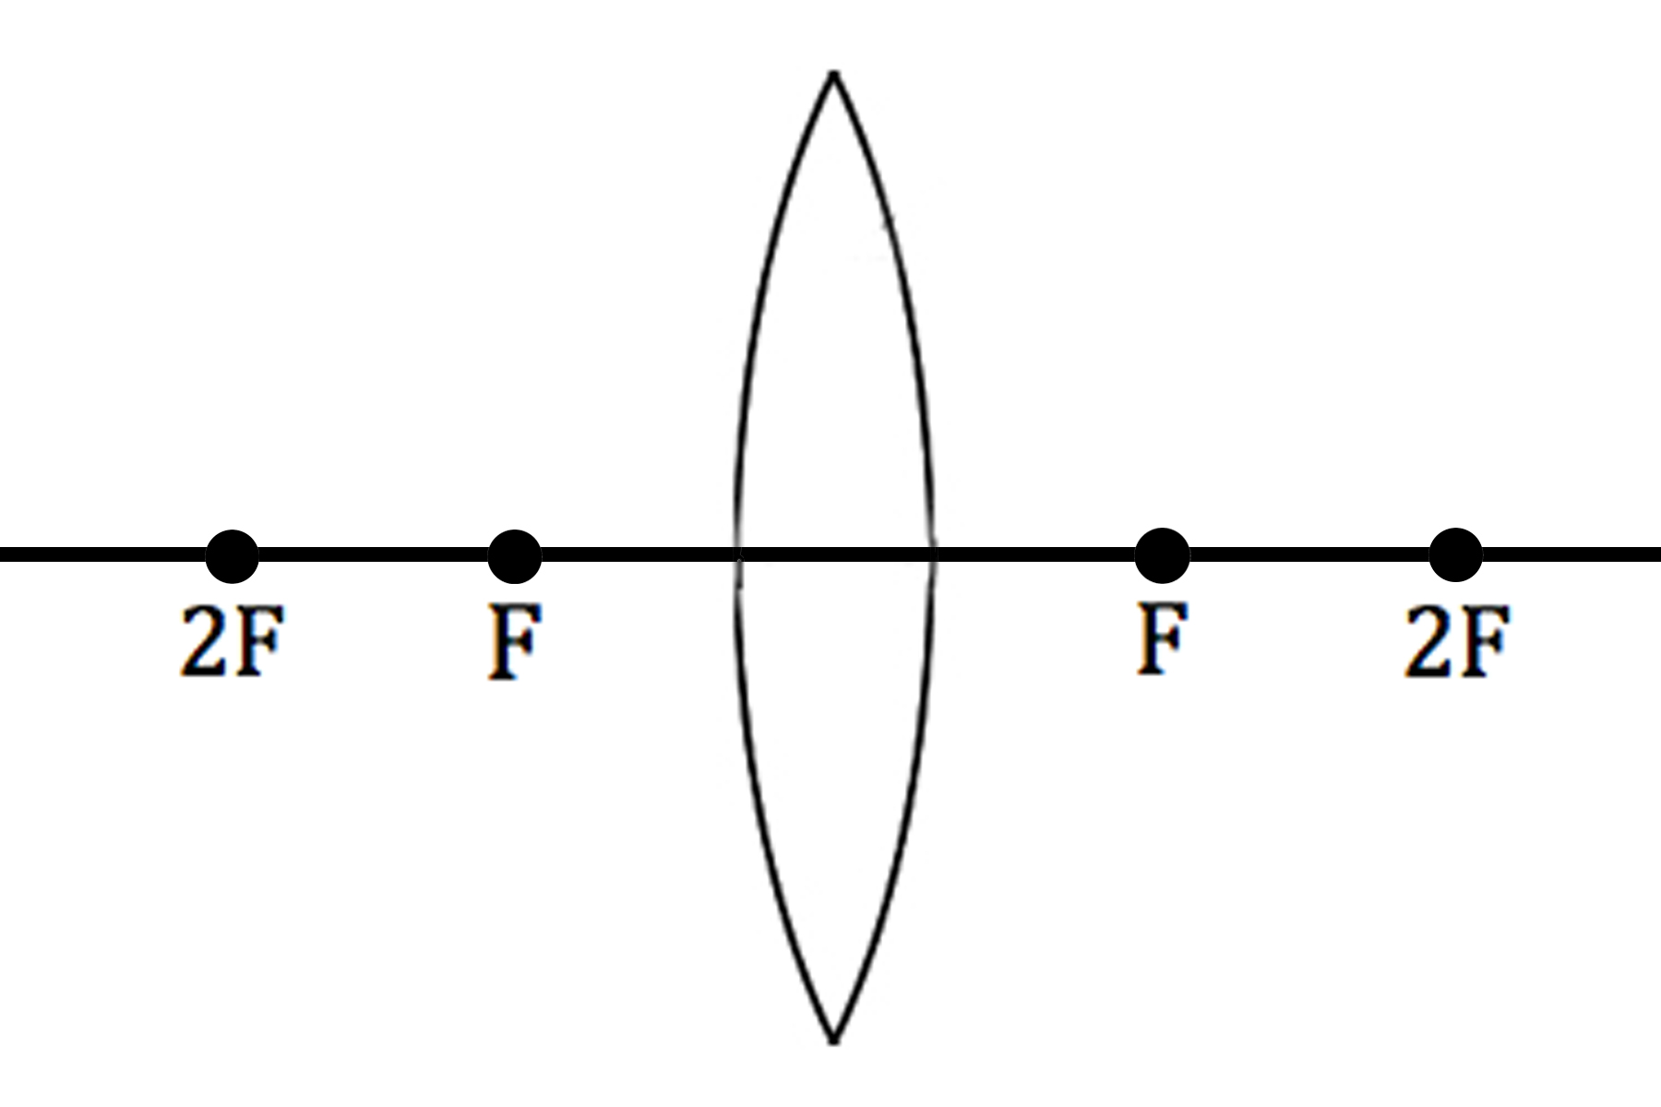

ANSWERS:

- s_{i} = -30.0 cm; h_{i} = 3.00 cm; M = 3.00; virtual; upright

