Unit 5 – Waves: Quiz 5b

/5

- Find the image distance and magnification of a concave mirror, whose focal length is 10.0 cm, when the object distance is 5.00 cm. Is the image real or virtual? Is the image inverted or upright? Draw a ray diagram to confirm your result.

Answers:

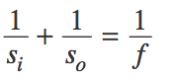 | 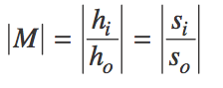

i = image s_{o} = object s_{i} = distance h = height M = magnification f = focal length

- s_{i} = -10.0 cm, M = 2.00, virtual, upright

