**Unit 5 – Waves: Quiz 4a**

/5

1. What wavelength of light would be reflected from a soap bubble when the thickness of the soapy water is 126 nm? ***Include a diagram!***

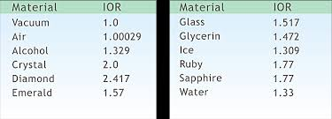

Answers:

1. What wavelength of light would be reflected from a soap bubble when the thickness of the soapy water is 126 nm? ***Include a diagram!***



