Unit 5 – Waves: Quiz 2b

/5

- Monochromatic light from a single slit illuminates two, narrow parallel slits. The centres of the two slits are 0.800 mm apart. An interference pattern forms on a screen 50.0 cm away. The fringe separation on the screen is 0.304 mm. Find the wavelength λ of the light.

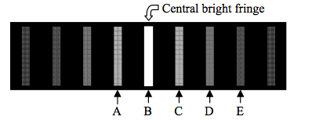
Use the image above to answer the next two questions:

- Which fringe is the third order maximum?
A, B, C, D, or E
- Which one of the following phenomena would be observed if the distance between the slits were increased?

  - The fringes would become brighter.
  - The central bright fringe would change position.
  - The separation between the dark fringes would decrease.
  - The distance between dark fringes would increase.
  - The distance between bright fringes would increase.

Answers:

- Monochromatic light from a single slit illuminates two, narrow parallel slits. The centres of the two slits are 0.800 mm apart. An interference pattern forms on a screen 50.0 cm away. The fringe separation on the screen is 0.304 mm. Find the wavelength λ of the light.

- Which fringe is the third order maximum?
A, B, C, D, or E

- Which one of the following phenomena would be observed if the distance between the slits were increased?

- The fringes would become brighter.
- The central bright fringe would change position.
- The separation between the dark fringes would decrease.
- The distance between dark fringes would increase.
- The distance between bright fringes would increase.

